

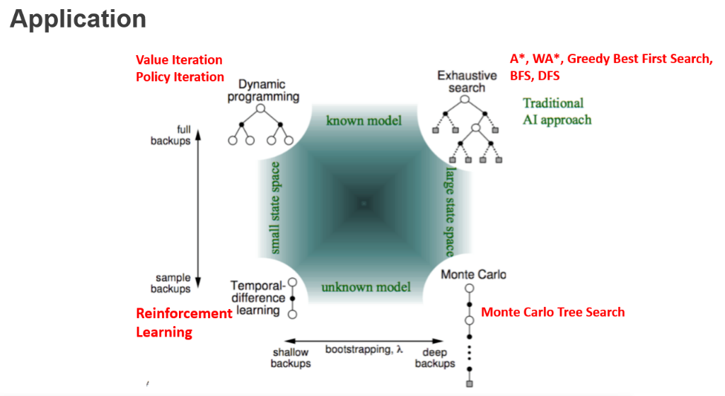

目录

Lecture 2: Search Algorithm 3

Search Terminology 3

What is Search State? 4

What is Search Node? 4

Criteria for evaluating search strategy 4

Blind Search v.s. Informed Search 4

Blind Search Strategy 4

Heuristic Function 5

Informed Systematic Search 5

Local Search 6

Lecture 3: How to Describe Arbitrary Search Problems 6

Model 6

Languages 7

Strips: A Basic Language for Classical Planning 7

PDDL: planning deterministic domain language 8

Lecture 4: Generating Heuristic Functions 9

What is relaxing? 9

How to relax? 9

property 9

e.g.: 10

What if R is not efficiently constructible? (majority R is efficient) 10

What if R is not efficiently computable? (many R is efficient) 10

How to Relax During Search 10

Lecture 5: Delete Relaxation Heuristics 11

Definition 11

Relaxed Plan 11

E.g.: 12

State Dominance 12

Greedy Relaxed Plan 13

Greedy Relaxed planning algorithm 13

Generate a Heuristic Function by Greedy Relaxed planning algorithm 13

Optimal Relaxed Plan 14

h+: The Optimal Delete Relaxation Heuristic 14

The Additive and Max Heuristics 15

Definition 15

Property 15

Bellman-Ford Algorithm 16

Relaxed Plan 18

Relaxed Plan Extraction Algorithm 18

Best-Supporter Functions 19

The Relaxed Plan Heuristic 19

Lecture 6: Width Based Planning 20

Novelty 20

Definition 20

E.g.: 21

Iterated Width (IW) 21

Serialized Iterated Width (SIW) 21

SIW and IW 21

Algorithm 21

Best-First Width Search (BFWS) 22

Algorithm 22

Simulated BFWS 22

Classical Planning with Simulators 23

Lecture 7: Plan & Goal Recognition 23

A Theory of Common Sense 23

Plan and Goal Recognition in Artificial Intelligence 24

Formalizing GR as a Multi-Agent Task 24

Components of GR task 24

Lecture 8&9: Markov Decision Processes (MDPs) 28

formulation of MDPs: *Discounted-Reward* Markov Decision Process 29

Solutions for MDP problems: policies 29

Bellman equations (Discounted-Reward MDPs) 29

Value iteration 30

Policy iteration 30

Policy iteration V.S. value iteration 30

Lecture 10: Monte Carlo Tree Search 31

Lecture 11: Reinforcement learning (TD) 34

Comparison 34

RL 35

Q learning 35

SARSA 36

Q-learning vs. SARSA 37

Which to be used? 38

weakness 39

Lecture 12: Faster Reinforcement Learning 39

Linear function approximation 39

Q-value 40

Update rule 41

Neural network 41

Strength & limitation 41

Reward shaping 42

What is it? 42

How to do it? 42

Technique - Potential-based Reward Shaping 43

Q-function initialization 44

Lecture 13: n-step temporal difference learning 44

Discounted reward G 44

n-step TD 45

E.g.: 46

Lecture 14 Game Theory 46

Normal form game: 46

Assumption: 47

Dominant strategy 47

Nash Equilibrium 47

Randomization and Mixed Strategies 48

e.g.: 解题思路 49

Mixed and pure equilibria can both exists 49

Extended form game 50

# Lecture 2: Search Algorithm

## Search Terminology

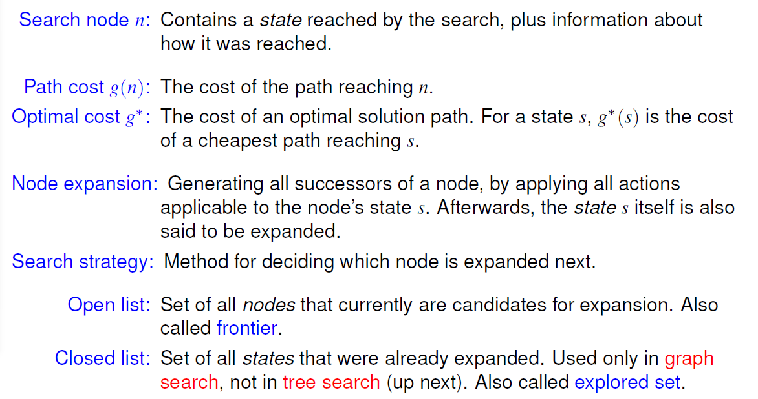

## What is Search State?

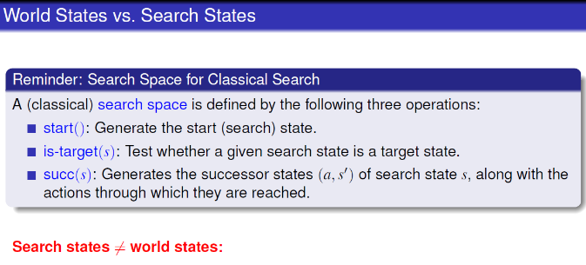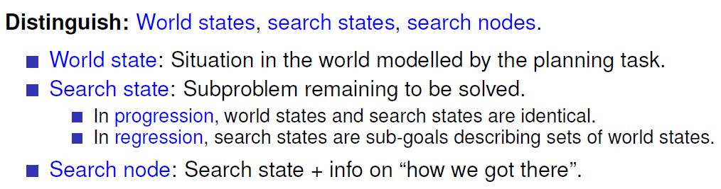

## What is Search Node?

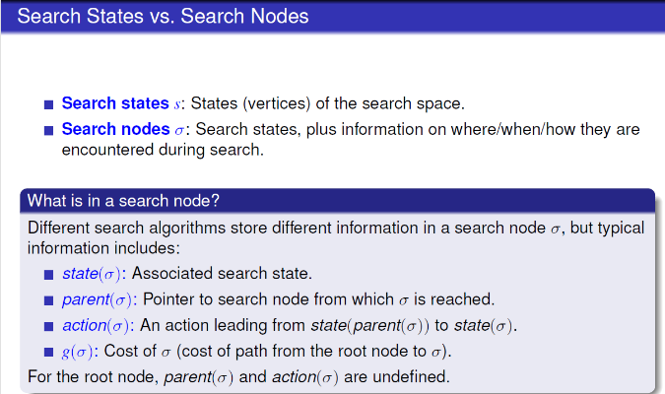

## Criteria for evaluating search strategy

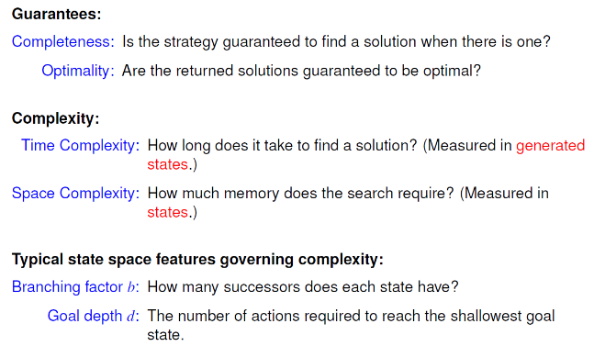

## Blind Search v.s. Informed Search

|  |  |  |
| --- | --- | --- |
|  | Blind Search | Informed Search |
| pro | Easy to program | Much More efficient in most of the problem |
| con | Same expansion order regardless the difference of problems → inefficient | Good heuristic function is difficult to come up with |

## Blind Search Strategy

|  |  |  |  |
| --- | --- | --- | --- |
|  | BFS | DFS | IDS |
| Adv | Time complexity | Space complexity | Combine adv of both two |
|  |  |  |  |
| Completeness | Yes | No | Yes |
| Optimality | Yes, if uniform action cost | No, may trapped by infinite loop | Yes, if uniform action cost |
| Time Complexity | O(bd) since b+b2+b3+…+bd | ∞ | O(bd) since |
| Space Complexity | O(bd) since keep all nodes in memory | O(bm), m: max depth reached | O(bd) |

## Heuristic Function

Heuristic function h: cost to the goal

h*: real cost to the goal

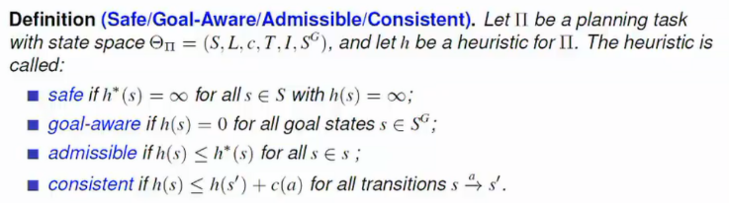

Consistent & goal-aware => admissible

Admissible => goal-aware

Admissible => safe

## 

## Informed Systematic Search

|  |  |  |  |  |
| --- | --- | --- | --- | --- |
|  | Greedy first | A* （A star） | Weighted A* | ID A* |
|  |  |  |  |  |
|  |  |  |  |  |
|  | f(n) = h(s) | f(n) = h(s) + g(n), n: node | f(n) = w*h(s) + g(n) |  |
| Complete | Yes,  if safe h & duplicate detection | Yes,  if safe h & duplicate detection | Yes,  if safe h & duplicate detection |  |
| Optimal | No | Yes,  If admissible h |  |  |
| Time |  | O(bd) | O(bd) | O(bd) |
| Space |  | O(bd) | O(bd) | O(bd) |

## Local Search

|  |  |  |
| --- | --- | --- |
|  | Hill Climb | Enforced Hill Climb |
|  |  |  |
|  |  |  |
|  | 走一步，取最小的 | 每走一步，做一下bfs，找到比当前小的再以此开始下一个loop |
| Complete | No | No |
| Optimal | No | No |
| Time | Positive Infinite |  |
| Complete | O(b) |  |

Different： global search contains all nodes in frontier while local only has children in frontier

# Lecture 3: How to Describe Arbitrary Search Problems

## Model

**Ambition**: Write one program that can solve all classical search problems.

|  |  |  |  |  |
| --- | --- | --- | --- | --- |
|  | Classic Planning  Basic State Model | ~~Conformant Planning~~  (Uncertainty but No Feedback) | Markov Decision Processes  (special class of uncertainty) | Partially Observable MDPs (POMDPs) |
| State | state space S | ←← |  | ← |
| Initial |  |  |  |  |
| Goal |  | ←← | ←← |  |
| Action |  | ←← | ←← | ←← |
|  |  |  |  |  |
|  |  |  | ←← |  |
| Soln | a sequence of actions that maps S0 into SG  **optimal** if it minimizes **sum of action costs** (e.g., # of steps) | an **action sequence** but must achieve the goal for **any**  **possible initial state and transition** | **functions (policies)** mapping states into actions  **Optimal** solutions minimize **expected cost** to goal | policies that map belief states into actions  **Optimal** policies minimize **expected** cost to go from b0 to G |

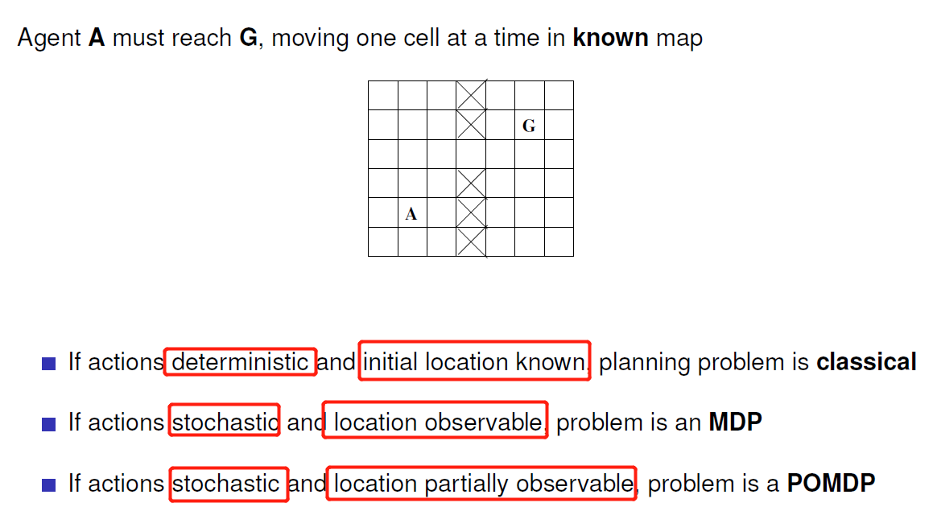

## Languages

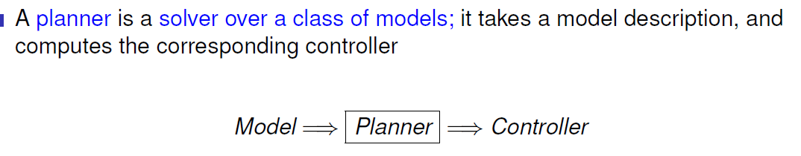



### Strips: A Basic Language for Classical Planning

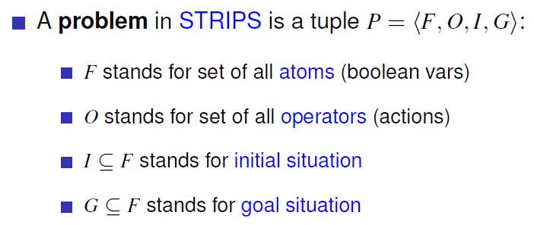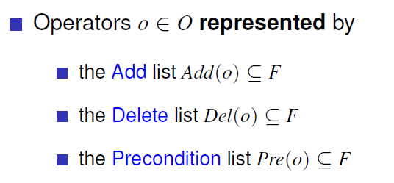operation: operate on F

|  |  |  |
| --- | --- | --- |
|  | Classic Planning  Basic State Model | STRIPS problem P = <*F, O, I, G*> determines **state model** S(P) |
| State | state space S | whrer F is True or False, aka propositions,  e.g. onTable(x), on (x,y) |
| Initial |  | I |
| Goal |  | G |
| Action |  | Add:: make var True  Delete: make var False  Precondition: var needed to be True if take step |
|  |  |  |
|  |  | C(a, s) = 1 |
| Soln | a sequence of actions that maps S0 into SG  **optimal** if it minimizes **sum of action costs** (e.g., # of steps) | (Optimal) **Solution** of P is (optimal) **solution** of S(P) |

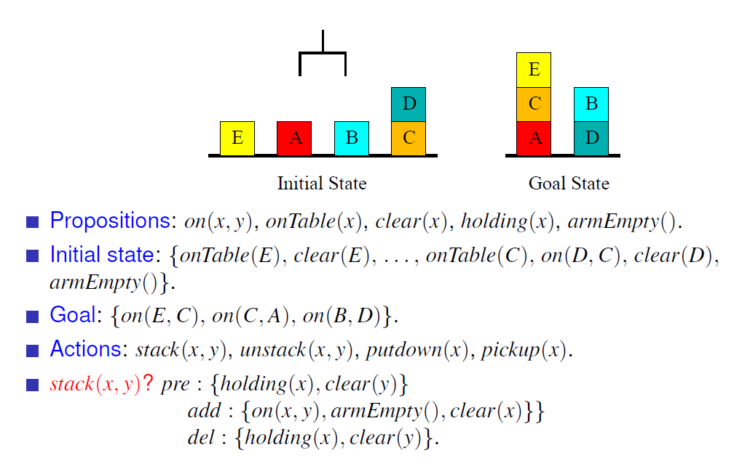

### PDDL: planning deterministic domain language

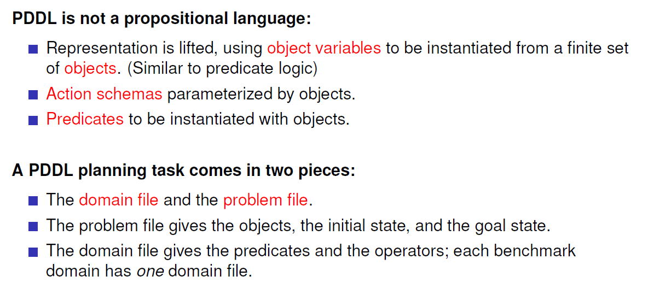

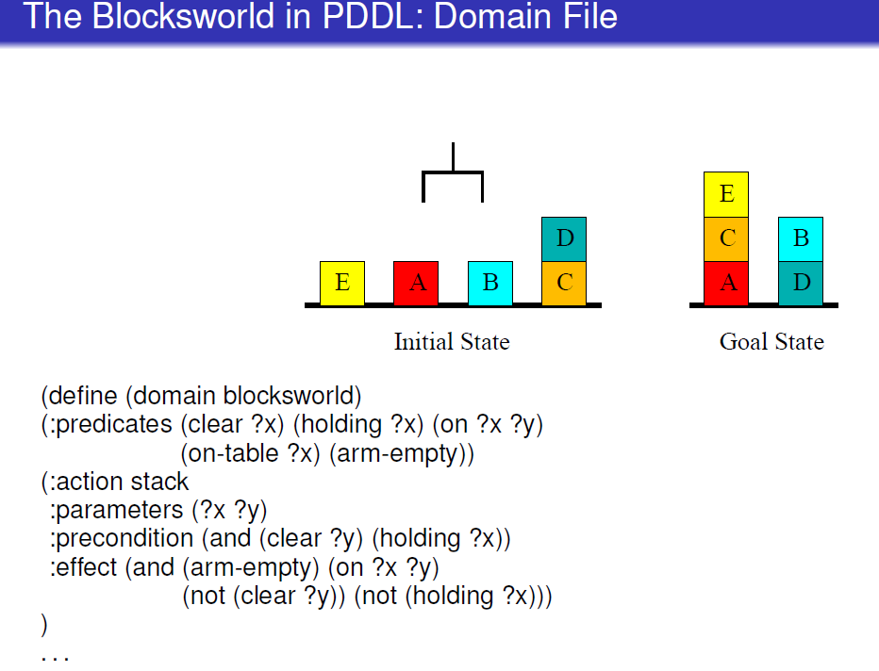 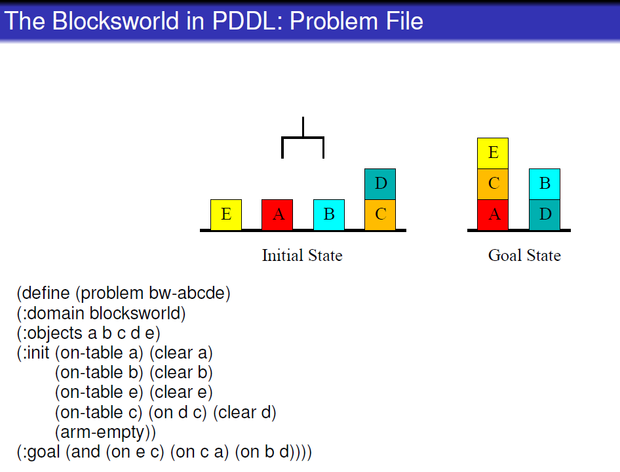

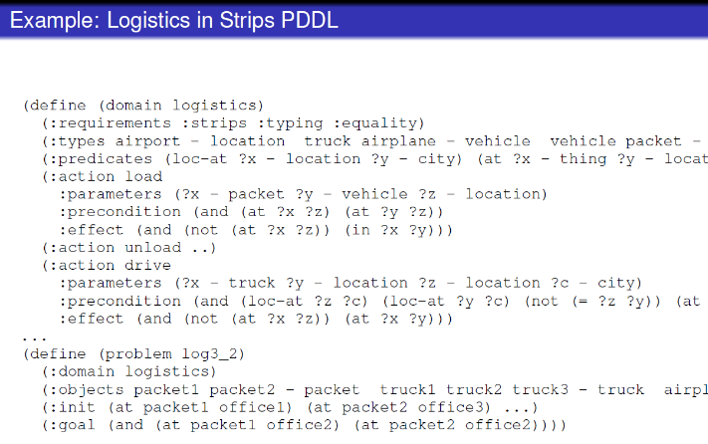

Classical search problems require to find a path of actions leading from an initial state to a goal state.

They assume a single-agent, fully-observable, deterministic, static environment. Despite this, they are ubiquitous in practice.

Heuristic search planning has dominated the International Planning Competition (IPC). We focus on it here.

STRIPS is the simplest possible, while reasonably expressive, language for our purposes. It uses Boolean variables (facts), and defines actions in terms of precondition, add list, and delete list.

Plan existence (bounded or not) is **PSPACE**-complete to decide for STRIPS.

PDDL is the de-facto standard language for describing planning problems.

TODO tutorial 04 Modeling in STRIPS and PDDL

# Lecture 4: Generating Heuristic Functions

## What is relaxing?

a methodology to construct heuristic functions

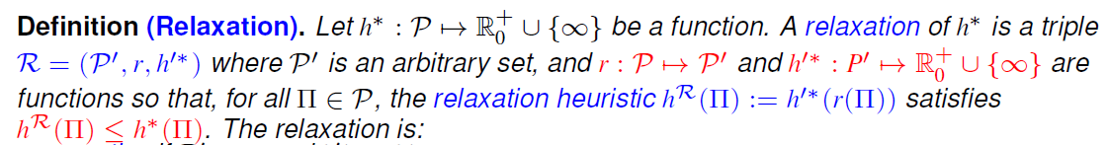 < some terminology here

## How to relax?

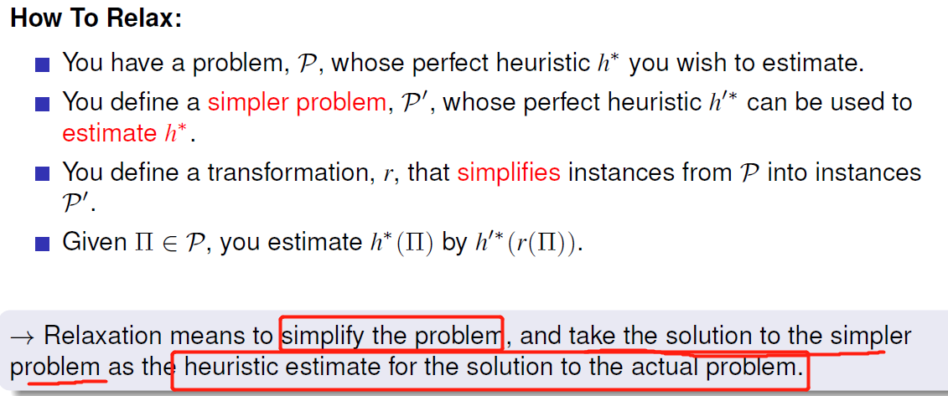

## property

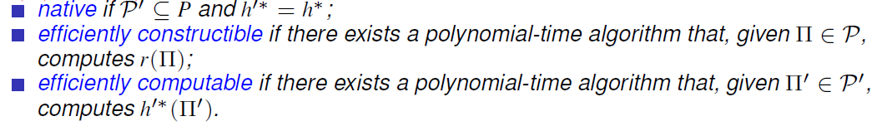

## e.g.:

|  |  |  |
| --- | --- | --- |
|  | **Uninformative** |  |
|  |  |  |
|  |  |  |
|  |  |  |
|  |  |  |

## What if R is not efficiently constructible? (majority R is efficient)

(a) approximate r

(b) design r in a way so that it will typically be feasible,

(c) just live with it and hope for the best.

## What if R is not efficiently computable? (many R is efficient)

(a) approximate h’*, or

(b) design h’* in a way so that it will typically be feasible, or

(c) just live with it and hope for the best.

## How to Relax During Search

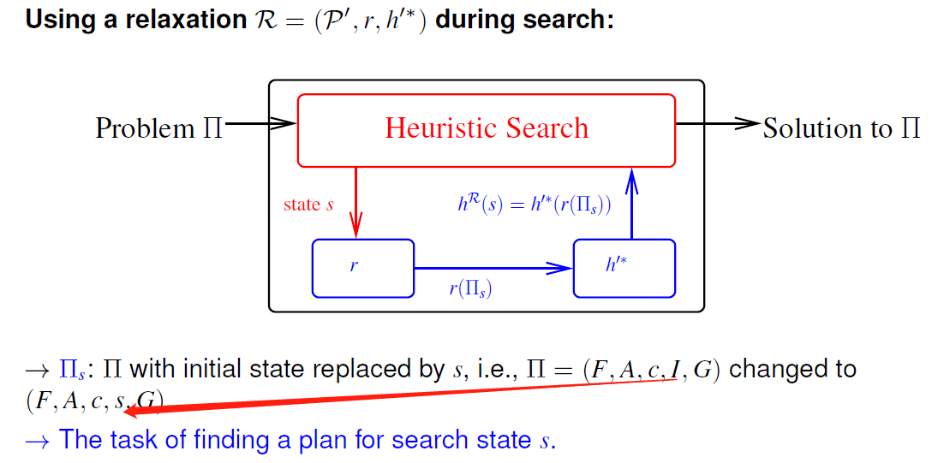use soln for the relaxed planning problem as the heuristic for the state in the original problem

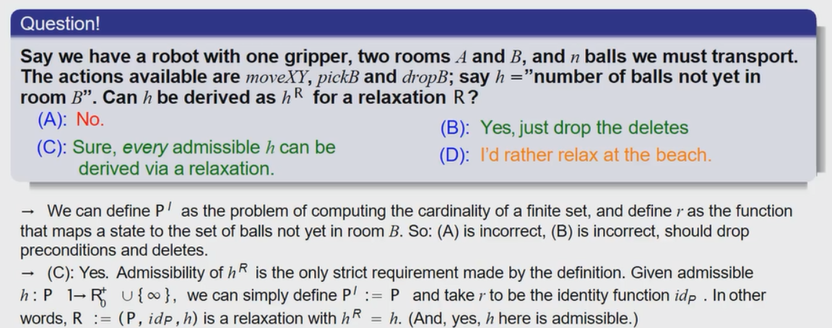

# Lecture 5: Delete Relaxation Heuristics

Delete relaxation is a method to relax planning tasks, and thus automatically compute heuristic functions h.

## Definition

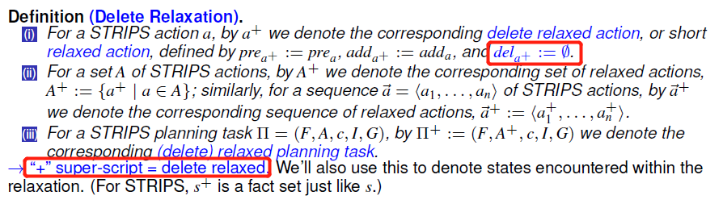

## Relaxed Plan

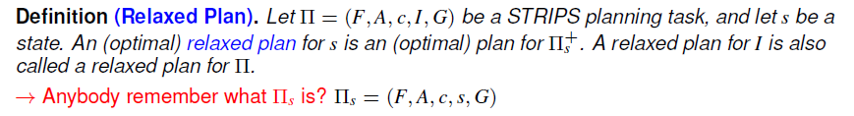

### E.g.:

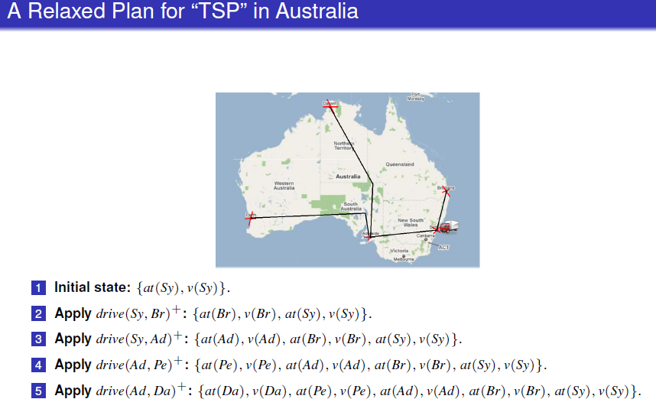

### State Dominance

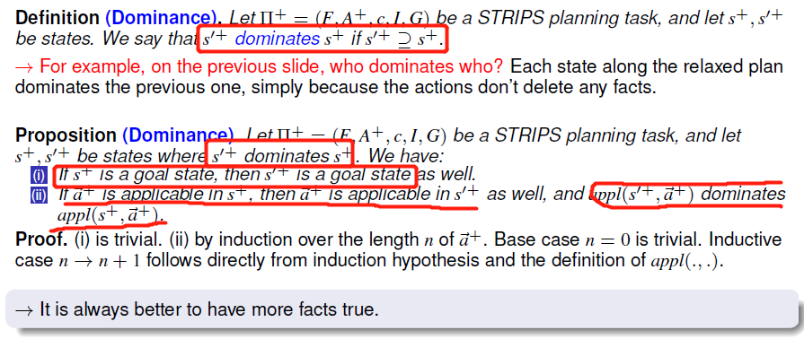

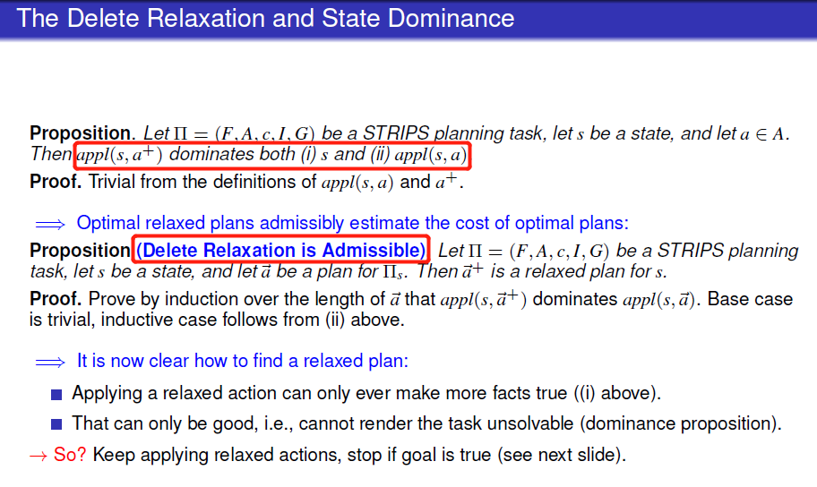

## Greedy Relaxed Plan

### Greedy Relaxed planning algorithm

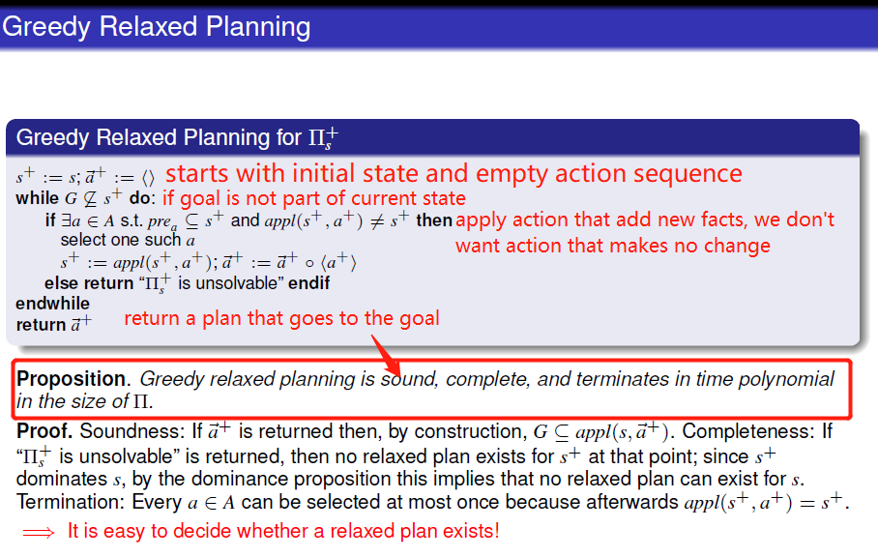

### Generate a Heuristic Function by Greedy Relaxed planning algorithm

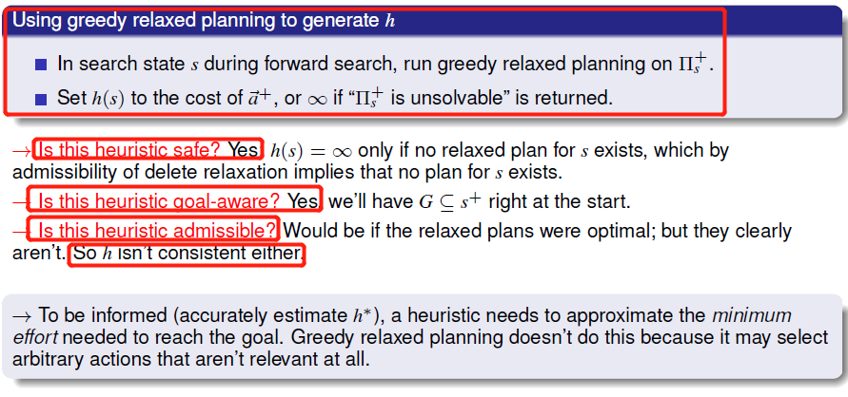not admissible

^

Not admissible

V

## Optimal Relaxed Plan

### h+: The Optimal Delete Relaxation Heuristic

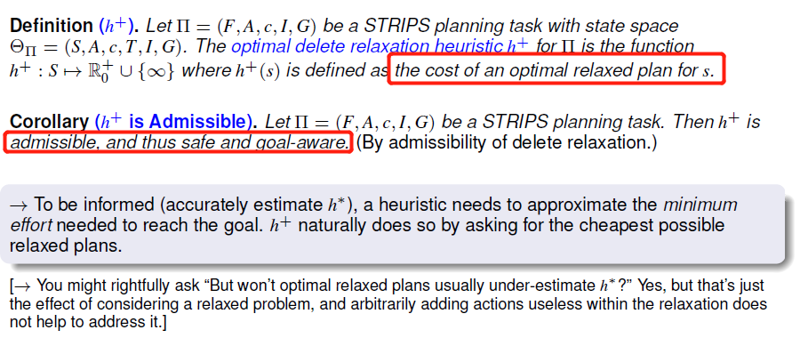 more informative than above one

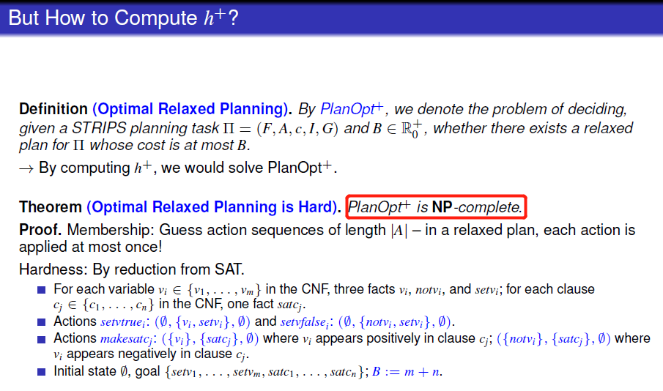

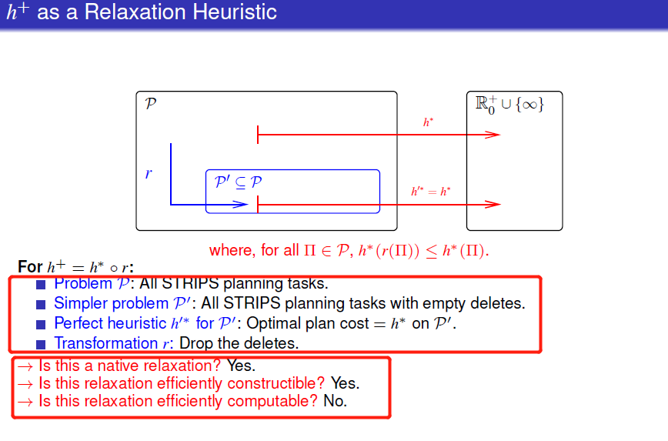

#### E.g.:

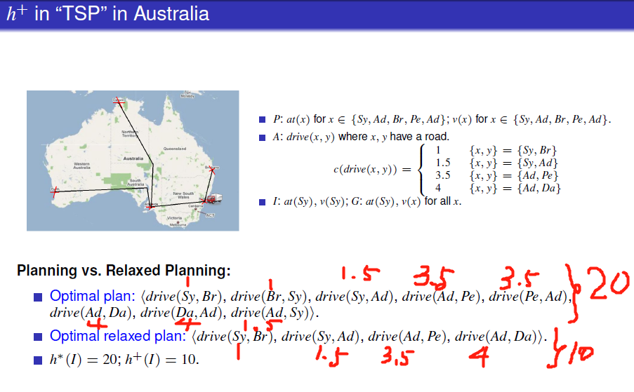



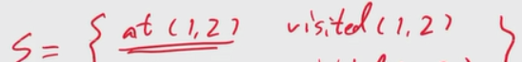-> 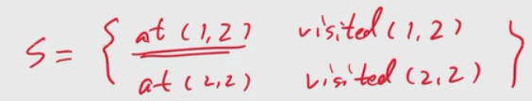with move((1,2),(2,2)) without delete at(1,2)

So after the move action we can move(1,3) in this case eventhuogh we are current at (2,2)

In this case, we have h minimum steiner tree which is a representation of h+

^



v

## The Additive and Max Heuristics

### Definition

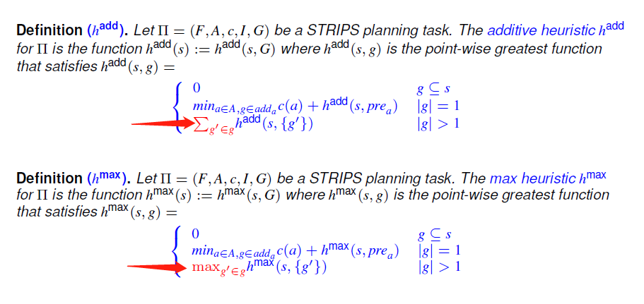

### Property

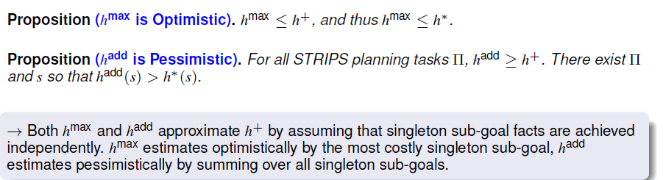 approximate h+

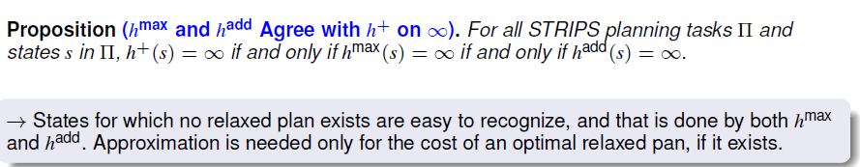

|  |  |  |
| --- | --- | --- |
|  | hmax | hadd |
| computed | fast | fast |
| admissible | Yes (too optimistic) | No (more informed)   * Overcounting too much! |
|  |  | |

### Bellman-Ford Algorithm

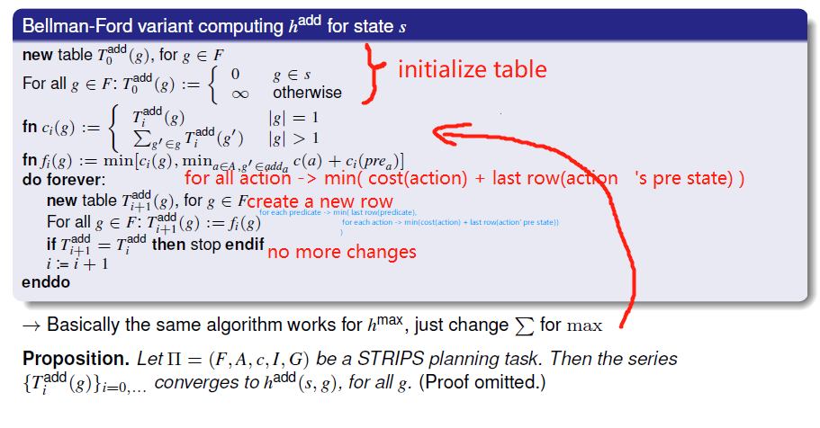

#### E.g.:

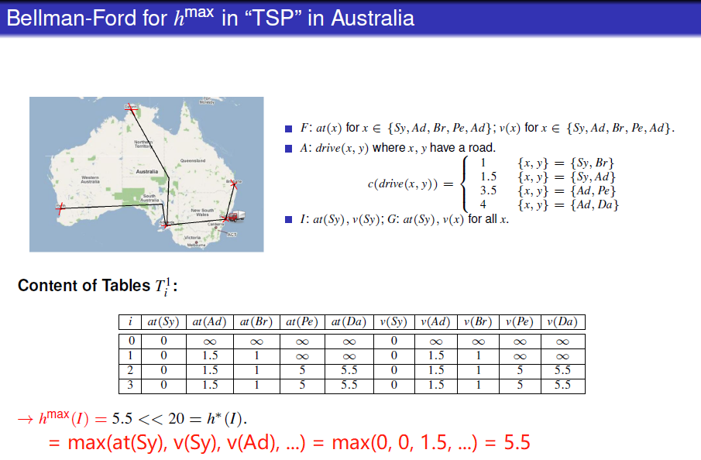 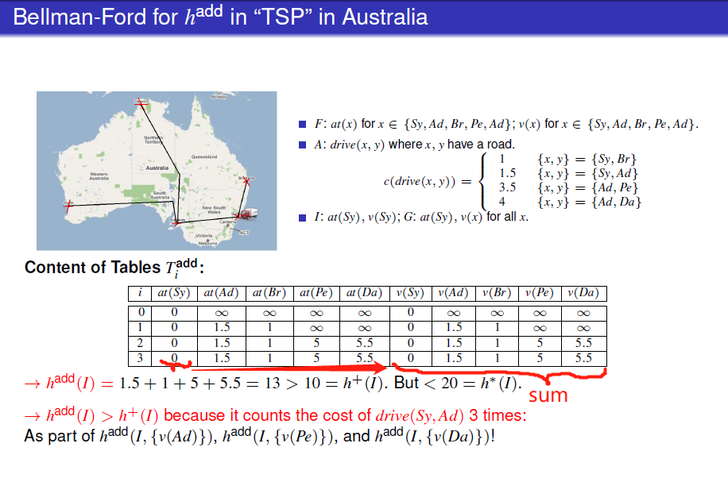

The two table are same here because the action’s pre state we input each time is with size=1 so just value in last row.

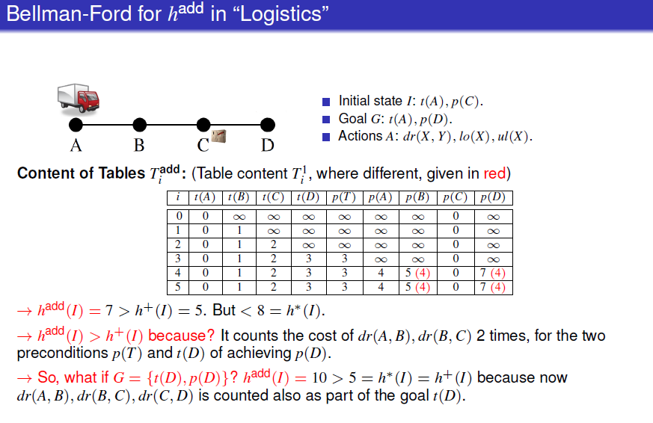

|  |  |
| --- | --- |
| add | f(p(B)) = min (pos inf, min( c(ul(B)) + sum( c(p(T)), c(t(B)) ) ) ) = 1 + sum(3, 1) = 5 |
| max | f(p(B)) = min (pos inf, min( c(ul(B)) + max( c(p(T)), c(t(B)) ) ) ) = 1 + max(3, 1) = 4 |

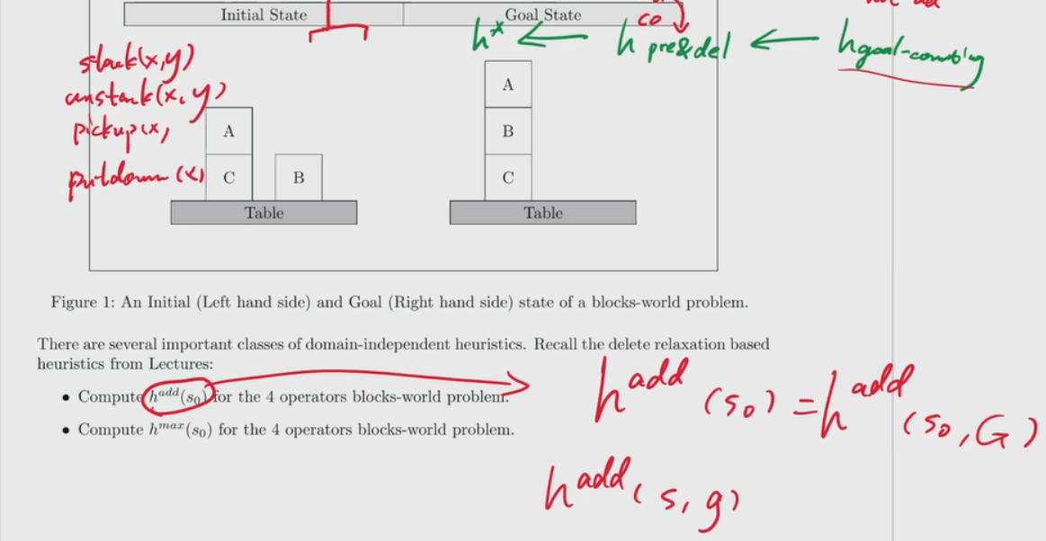Not specific goal state, so use final goal state

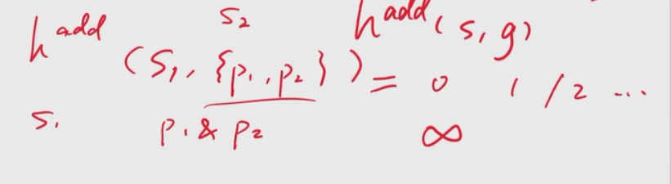can calculate how much actions need to make propositions p1, p2 true

hadd

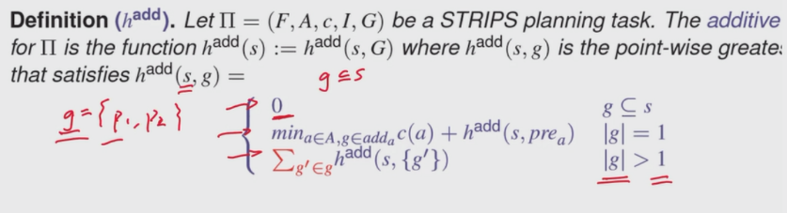

If g is a subset of s, we go to 1st line

If g = {p1, p2} is not in s, we go to 3rd line

If g = {p1}, we go to 2nd line

What happens on 3rd line is 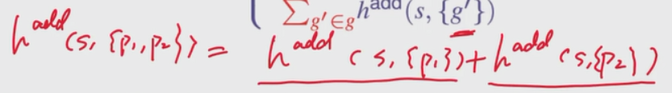

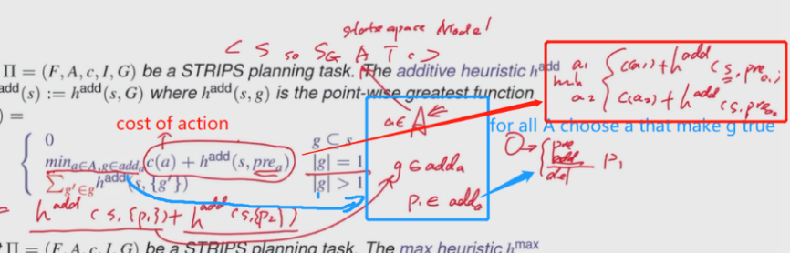

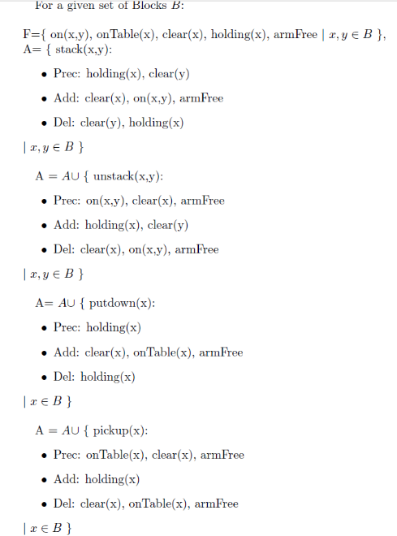hmax

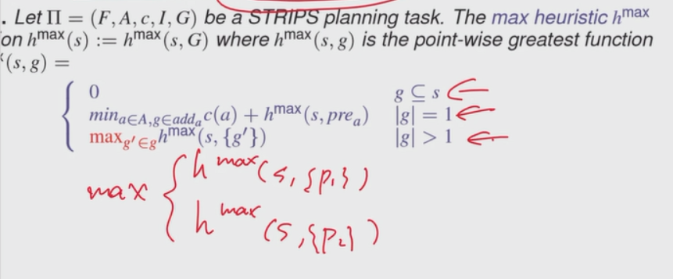

 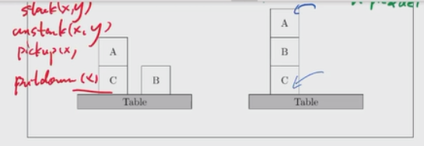

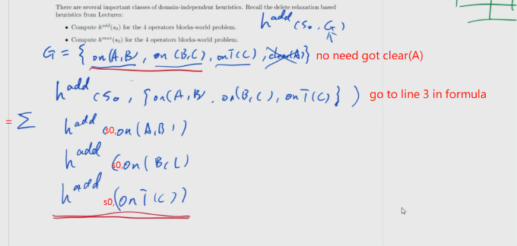A = {stack(x, y), unstack(x, y), pickup(x), putdown(x)}

hadd(s0, onTable(C)) = 0 because onTable(C) is already in s0

hadd(s0, on(A,B)) = MIN 1 + hadd(s0, prestack(A,B)) where prestack(A,B) = {holding(A), clear(B)}

= 1+∑{hadd(s0, holding(A)), hadd(s0, clear(B))}

However this calculation way is messy, so we use the calculation map

Stop updating when two iteration values are same

No need to **include** all predicates in the table, just **the ones we need for the calculation**.

**If you have 0, just copy it down**

If you want to plus hadd(s, {p}) then refer this from previous line in the table

For add and max table, if there is multiple non-zero preaction for one table entry, then there is going to be a change in two tables

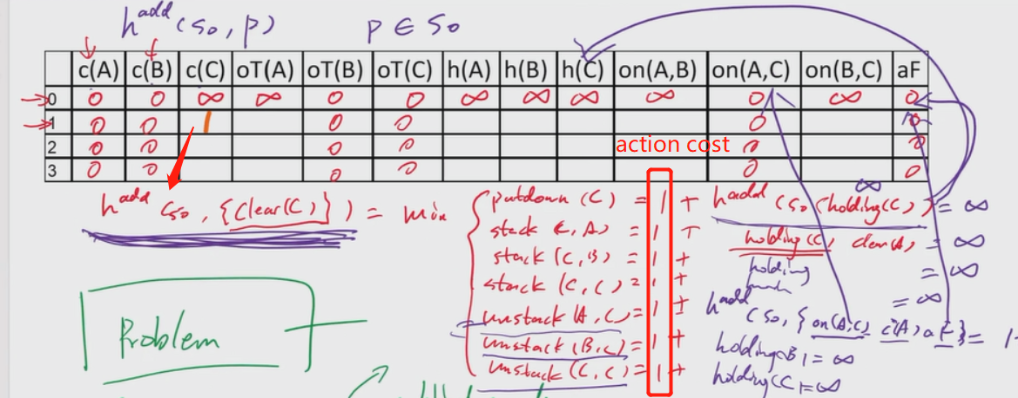

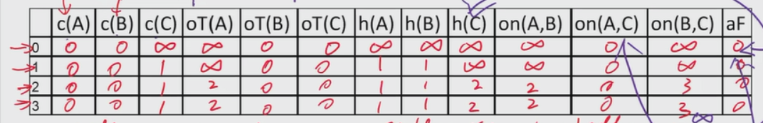

So hadd(s0, G) = hadd(s0, onTable(C)) + hadd(s0, on(A,B)) + hadd(s0, on(B,C)) = 0 + 2 + 3 = 5

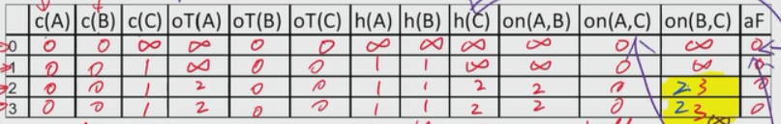

hadd(s0, on(B,C)) iter 2 = min(正无穷, min(c(stack(B,C)) + hadd(s0, {h(B), c(C)}) ) ) where a = stack(B,C)

= min(正无穷, min(1 + hadd(s0, h(B))+ hadd(s0, c(C)) ) )

= min(正无穷, min(1 + 1+ 1 ) )

= 3

hmax(s0, on(B,C)) iter 2 = min(正无穷, min(c(stack(B,C)) + hmax (s0, {h(B), c(C)}) ) ) where a = stack(B,C)

= min(正无穷, min(1 + max(hmax (s0, h(B))+ hmax (s0, c(C))) ) )

= min(正无穷, min(1 + max(1, 1) ) )

= 2

hmax(s0, G) = MAX( hmax (s0, onTable(C)), hmax (s0, on(A,B)), hmax (s0, on(B,C)) ) = max(0, 2, 2) = 2

^

Overcounting too much

v

## Relaxed Plan

### Relaxed Plan Extraction Algorithm

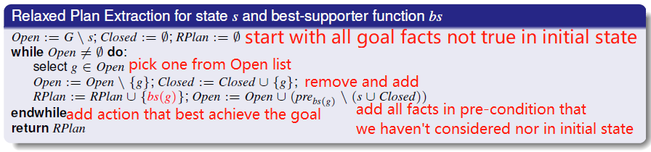 fast !!!

Assume

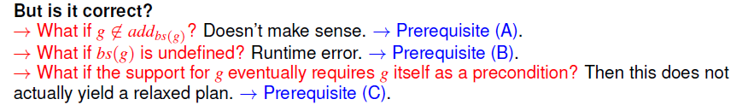

#### E.g.:

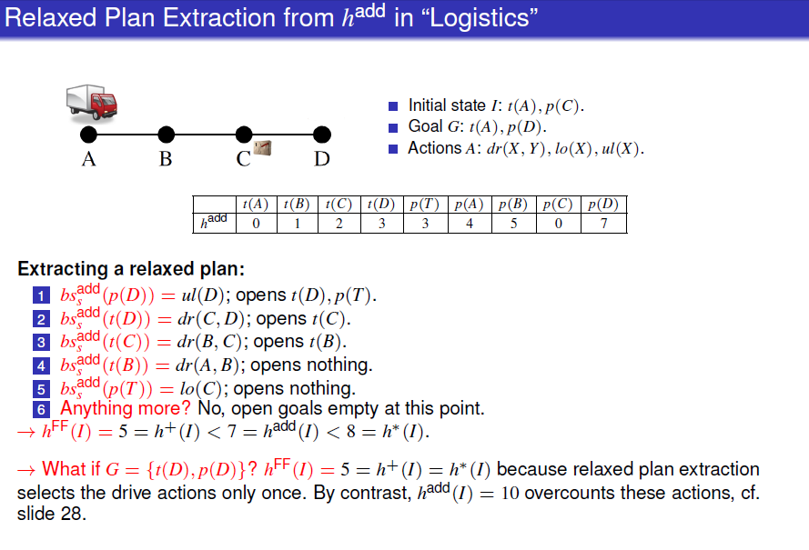

### Best-Supporter Functions

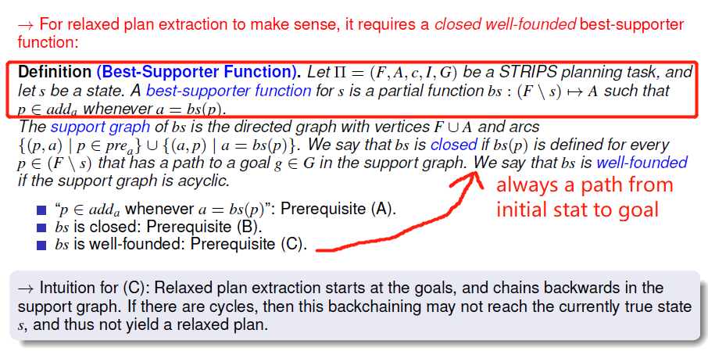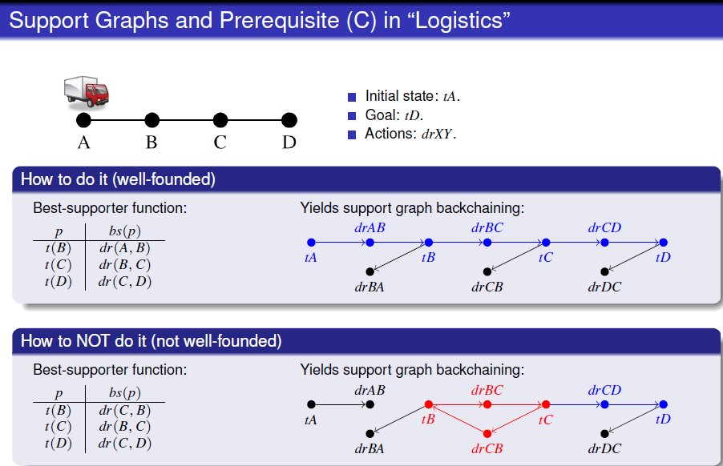

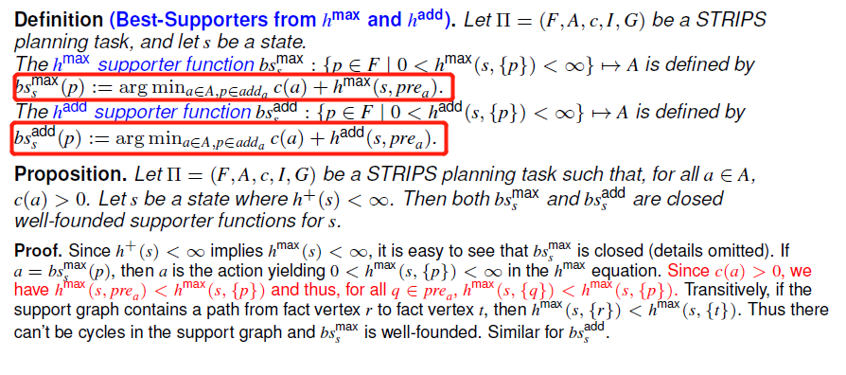

### The Relaxed Plan Heuristic

hff

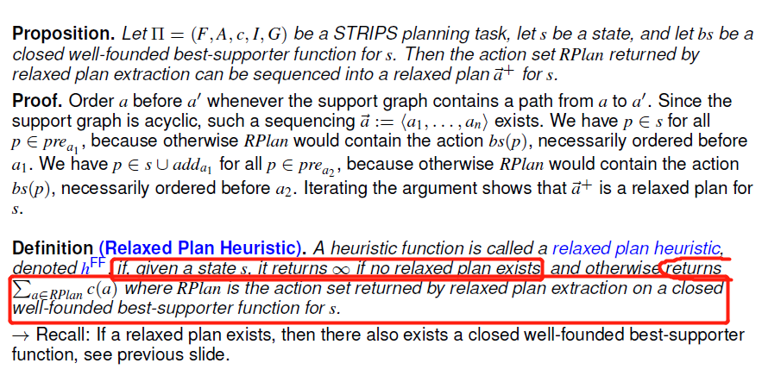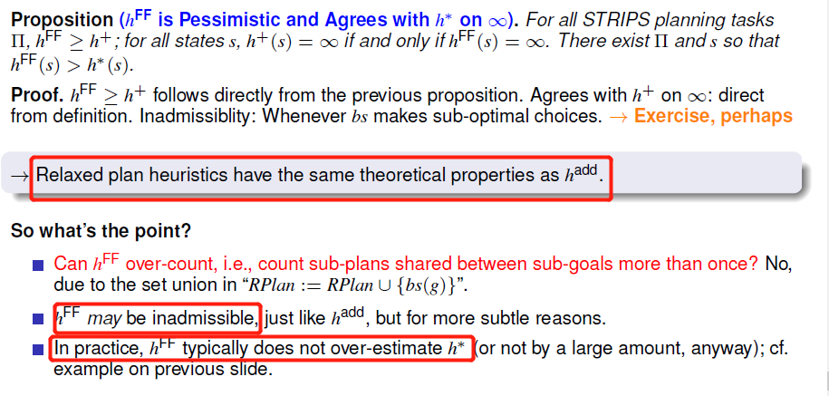

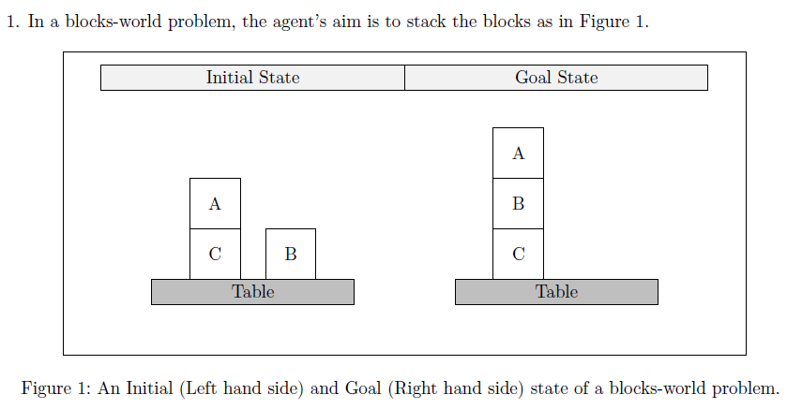

I = {on(A, C), onTable(B), onTable(C), clear(A) , clear(B), armFree}

G = {on(A, B), on(B, C), onTable(C), clear(A)}

Step 1: come up with a relaxed plan (with Relaxed Plan Extraction Algorithm)

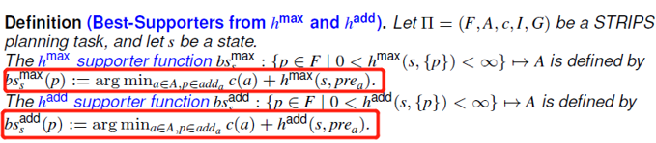

s is I in the case

bs(g) return the action that best make g proposition true

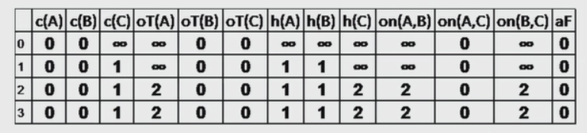

|  |  |
| --- | --- |
| Initialize | Open = {on(A, B), on(B, C)}, closed = {}, RPlan = {} |
| Iter 1 | Select on(A, B) from open  Open = {on(B, C)}, closed = {} U {on(A, B)}  bs(on(A, B)) = {stack(A, B)} # only one here, so just pick it  RPlan = {} U {stack(A, B)}  open = {on(B, C)} U {holding(A)} # prestack(A, B) = {holding(A), clear(B)} and only {holding(A)} is not in s U closed |
| Iter 2 | Select holding(A) from open  Open = {on(B, C)}, closed = {on(A, B)} U {holding(A)}  bs(holding(A)) = argmin {pickup(A), unstack(A, B), unstack(A, C), unstack(A, A)}  pickup(A): hmax(pickup(A)) = 1 + hmax(prepickup(A))  = 1 + hmax(onTable(A), clear(A), armFree)  = 1 + max(hmax(onTable(A)), hmax(clear(A)), hmax(armFree))  = 1 + max(2, 0, 0)  = 3  unstack(A, B): 3  unstack(A, C): 1  unstack(A, A): positive infinite where hmax(on(A, A)) = positive infinite as it is not in the table  RPlan = { stack(A, B)} U {unstack(A, C)}  open = {on(B, C) } U {} which are preunstack(A, C) = {on(A, C), clear(A), armFree} but all of them are in I so no added to open |
| Iter 3 | Select on(B, C) from open  Open = {}, closed = { on(A, B), holding(A)} U { on(B, C)}  bs(on(B, C)) = {stack(B, C)} # only one here, so just pick it  RPlan = { stack(A, B), unstack(A, C)} U {stack(B, C)}  open = {} U { holding(B), clear(C)} # prestack(B, C) = {holding(B), clear(C)} neither in s U closed |
| Iter 4 | Select holding(B) from open  Open = { clear(C)}, closed = { on(A, B), holding(A), on(B, C)} U {holding(B)}  bs(holding(B)) = { pickup(B)} from { pickup(B), unstack(B, A), unstack(B, B), unstack(B, C)}  pickup(B): hmax(pickup(B)) = 1 + hmax(onTable(B), clear(B), armFree) = 1 + max(0, 0, 0) = 1  no way to get one smaller than 1, so output pickup(B) here  RPlan = { stack(A, B), unstack(A, C), stack(B, C)} U { pickup(B)}  open = { clear(C)} U { } # prepickup(B) = { onTable(B), clear(B), armFree } all are in I |
| Iter 5 | Select clear(C) from open  Open = {}, closed = { on(A, B), holding(A), on(B, C), holding(B)} U {clear(C)}  bs(clear(C)) = { unstack(A, C)} from {putdown(C), unstack(A, C), unstack(B, C), unstack(C, C) , stack(A, C), stack(B, C), stack(C, C)}  unstack(A, C): hmax(unstack(A, C)) = 1 from iter 1  no way to get one smaller than 1, so output unstack(A, C) here  RPlan = { stack(A, B), unstack(A, C), stack(B, C)} U { unstack(A, C)}  open = { } U { } # preunstack(A, C) = { on(A, C), clear(A), armFree } all are in I  open is empty and terminate  RPlan = { stack(A, B), unstack(A, C), stack(B, C), unstack(A, C)}  hff = 4 |

Step 2: hff = sum cost(action) where action belongs to the relaxed plan; hff != size of relaxed plan unless c(a) = 1

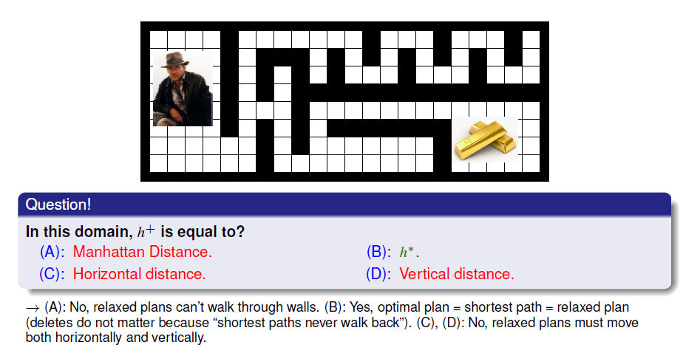

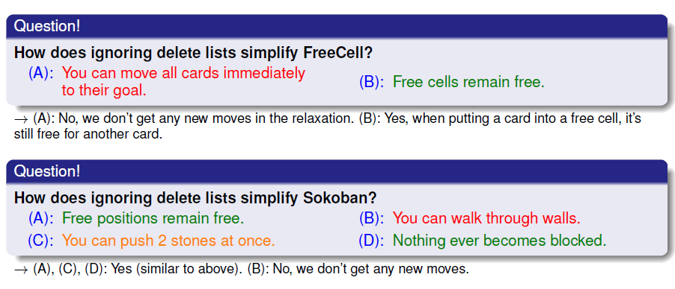

|  |  |  |  |  |
| --- | --- | --- | --- | --- |
| heuristic |  | Operation(O) | Admissible | Consistency |
| h closest |  |  |  |  |
| h furthest |  |  |  |  |
| h’=h pre&del | NP-hard | add | yes | yes |
| h goal counting = |G\s|  #propositions in state is false while it is true in G | Can be in various domains | Approximation of hpre & del | No if   1. cause p1 & p2 true where p1 & p2 ∈h goal counting 2. Action cost < 1 |  |
| h mst |  |  |  |  |
| h+ approximate h* | NP-hard approximate by hadd, hmax, hFF | pre & add | yes | yes |
| hadd |  |  | no |  |
| hmax |  |  | Yes |  |
| hff |  |  | Not, but generally it is difficult to make it not admissible |  |

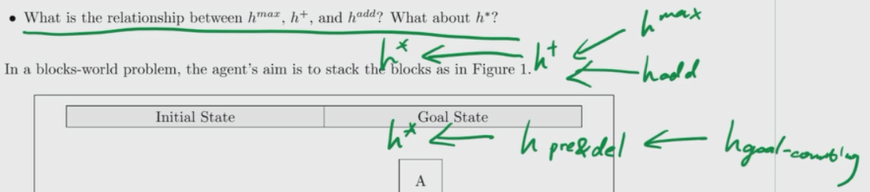



# Lecture 6: Width Based Planning

## Novelty

### Definition

the **novelty** w(s) **of a state** s is the size of the smallest subset of atoms in s that is true for the first time in the search.

### E.g.:

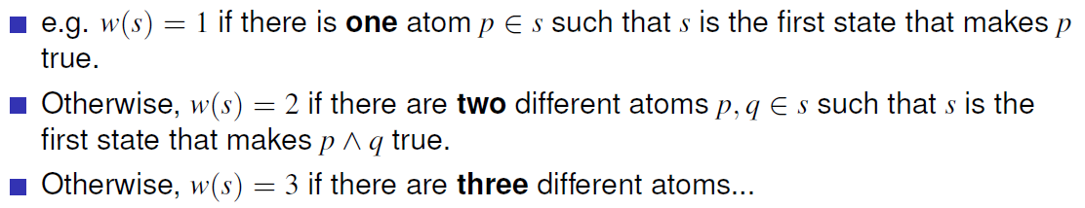

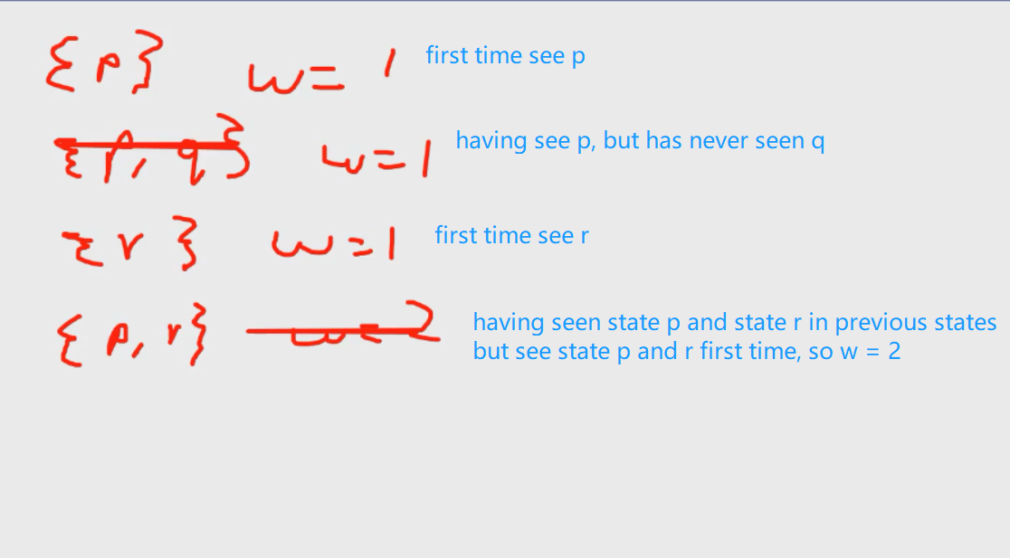lookup table = {}

lookup table = {p}

lookup table = {p, q}

lookup table = {p, q, r}

lookup table = {p, q, r, <p, r>}

## Iterated Width (IW)

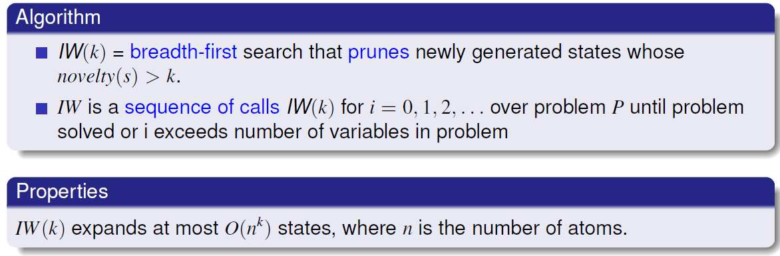

IW works well

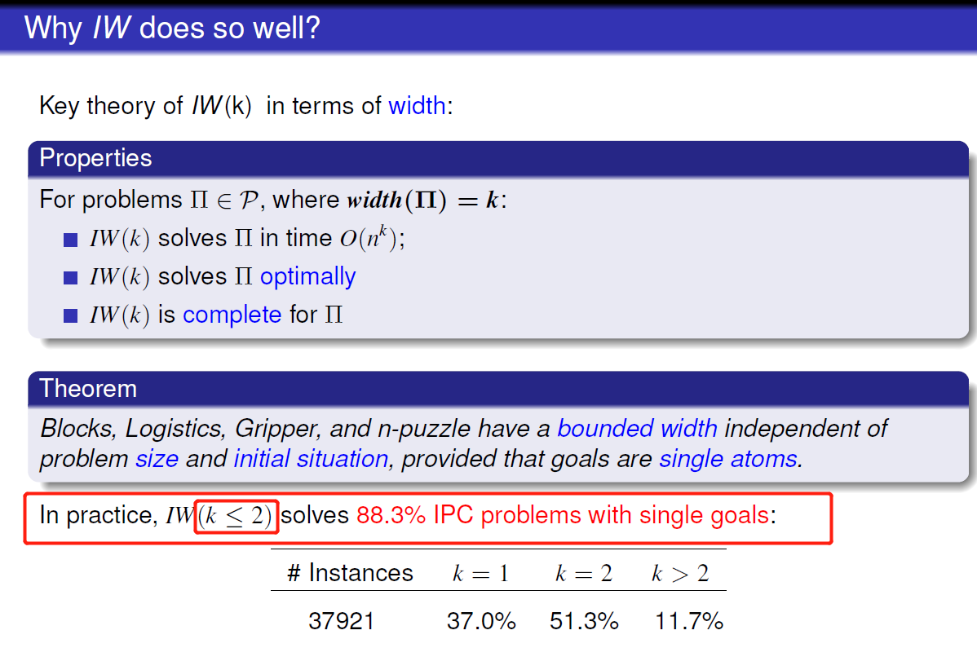

Algorithm:

For i in range(1, |F|):

Terminate when IW(i) found solution

Note: Optimal if i >= width(|P|)

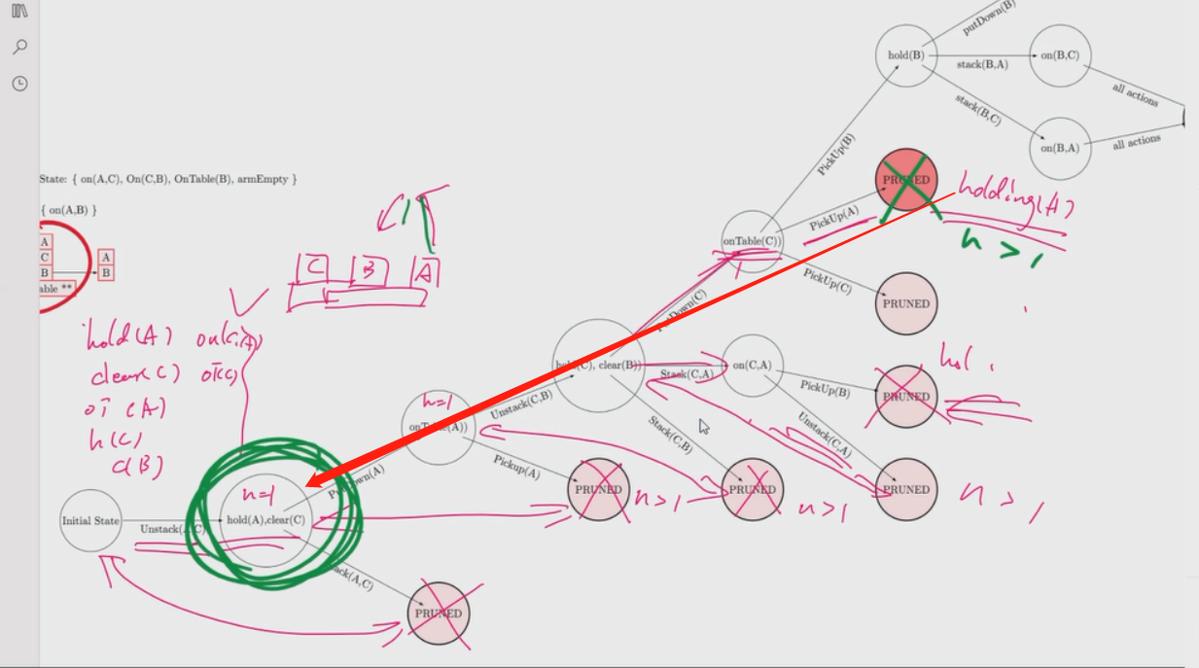

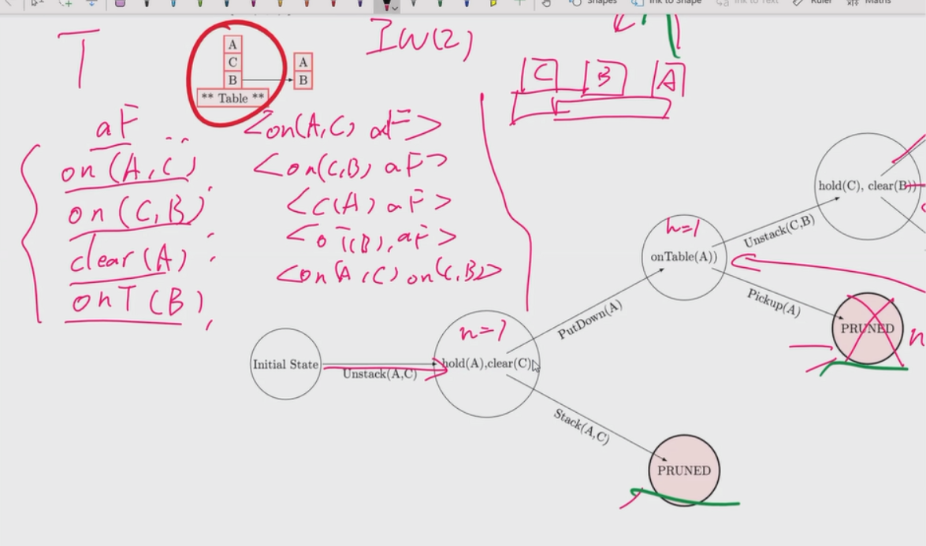IW(2) initial table has a permutation of pairs

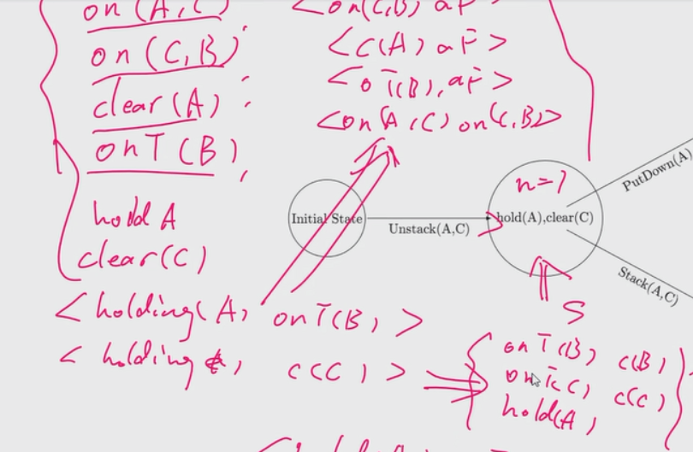IW(2) table update: proposition & pair permutation with size of I, generate pairs based on current state

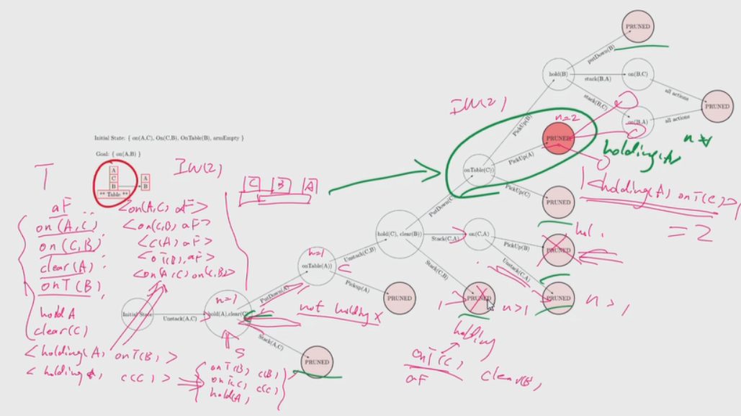

Each circle has the proposition from action’s add not in the table

novelty calculation

IW(1) example:

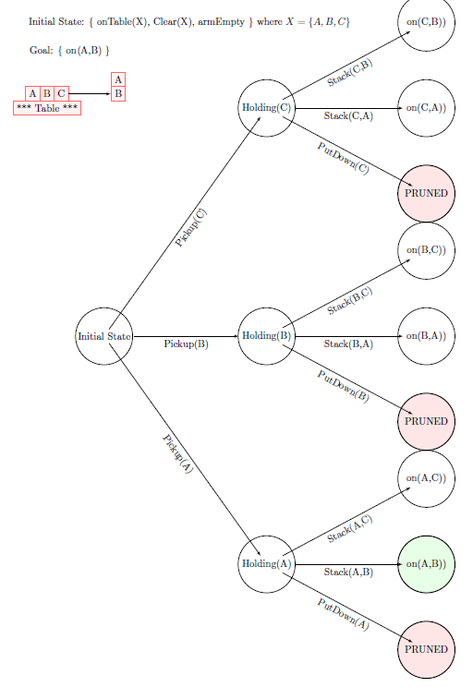

## Serialized Iterated Width (SIW)

### SIW and IW

IW solves atomic goals, how do we extend the blind procedure to multiple atomic goals?

### Algorithm

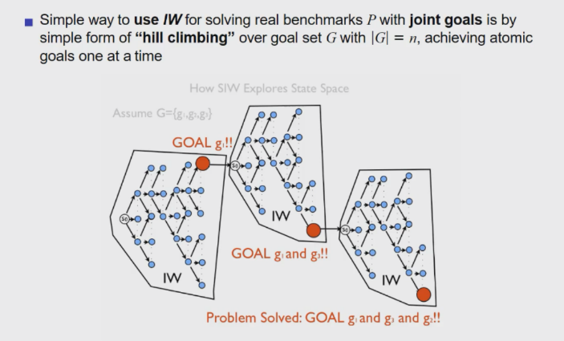Apply IW until find a sub goal and use this sub goal as initial state until finally finds the goal

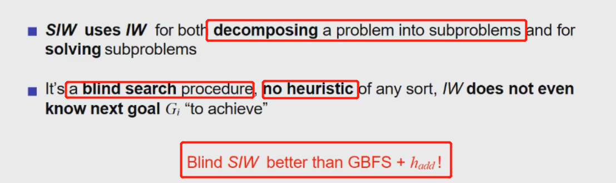greedy best first search

## Best-First Width Search (BFWS)

### Algorithm

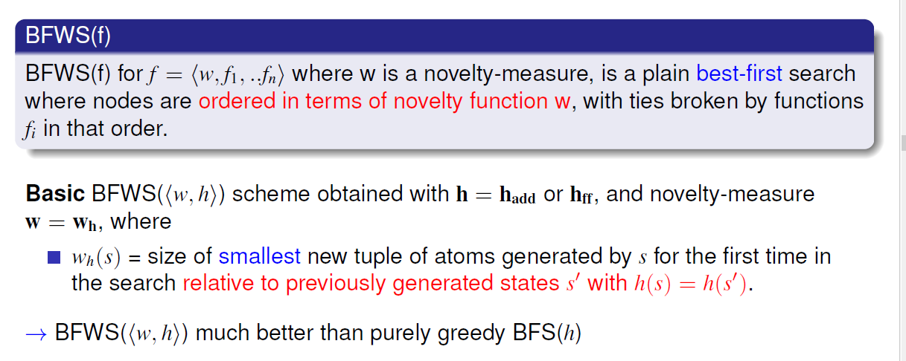

## Simulated BFWS

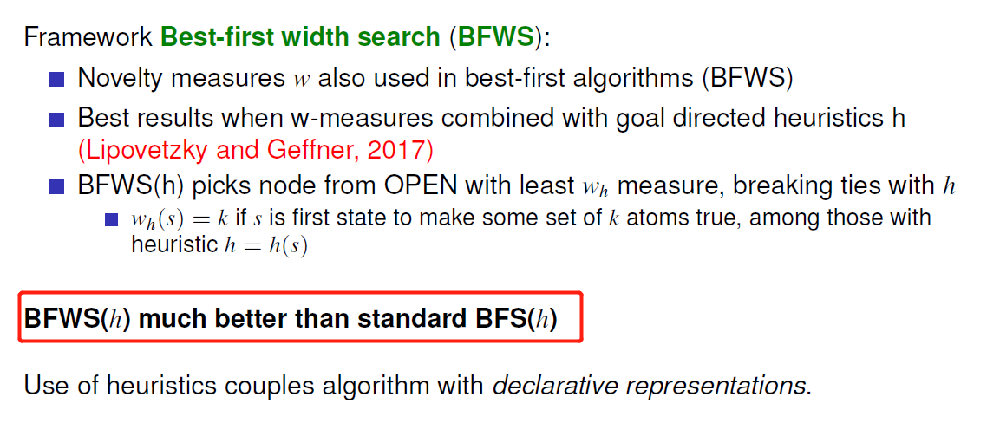

With the help of simulations, no need to consider the preconditions for different actions

### Classical Planning with Simulators

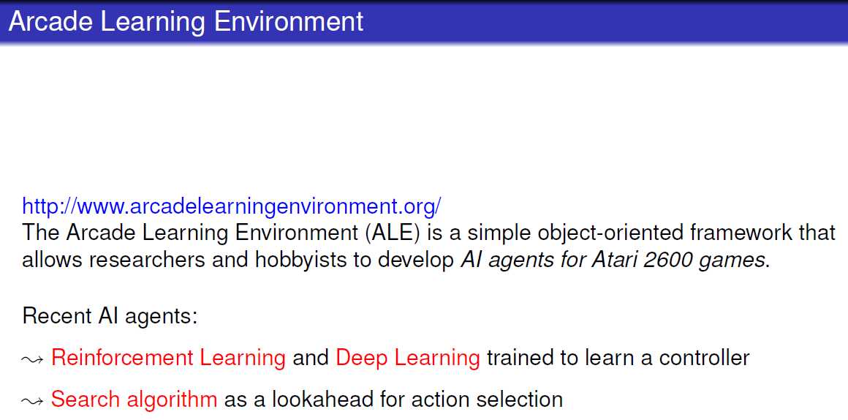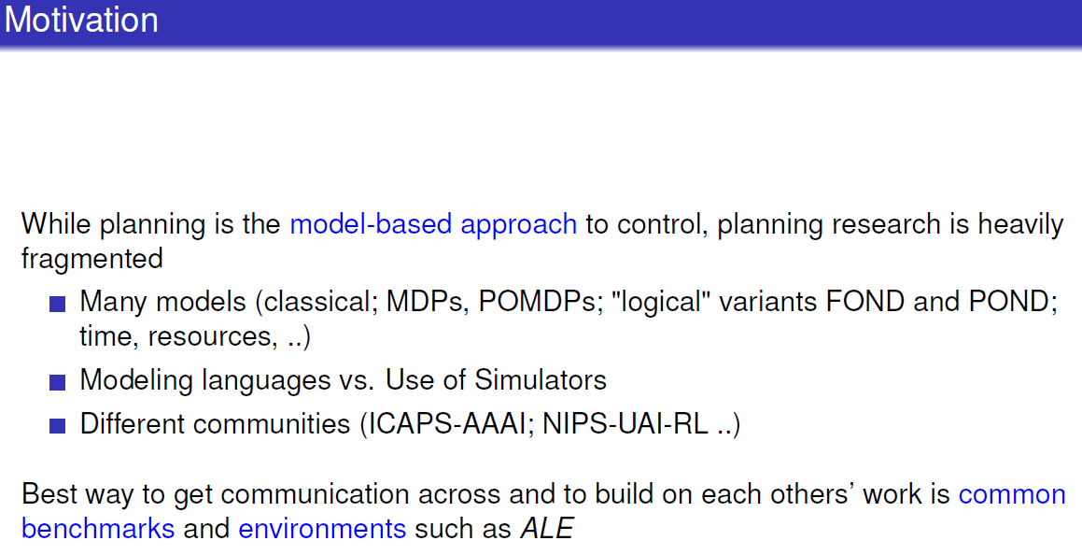

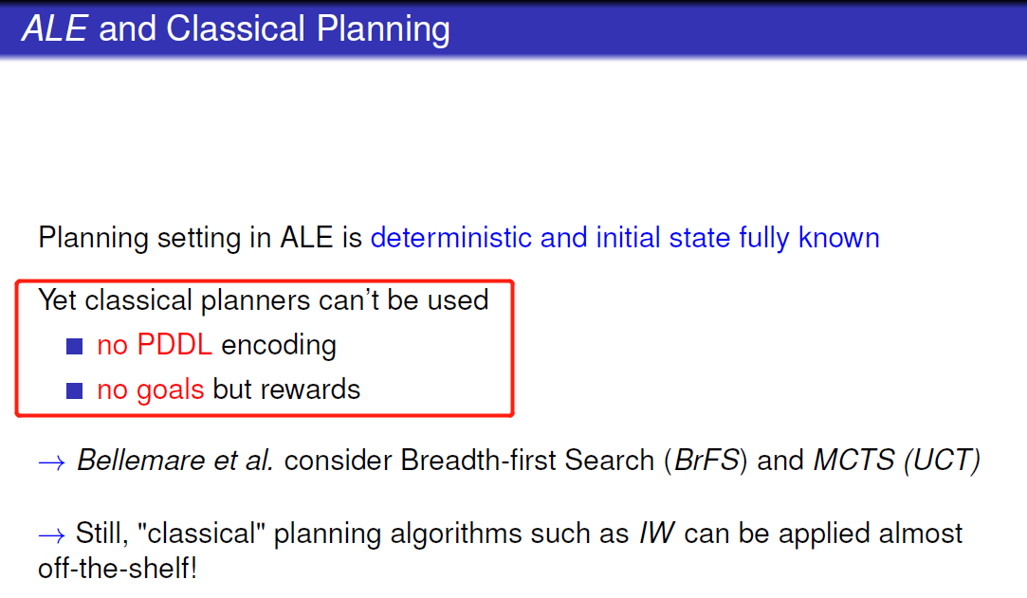

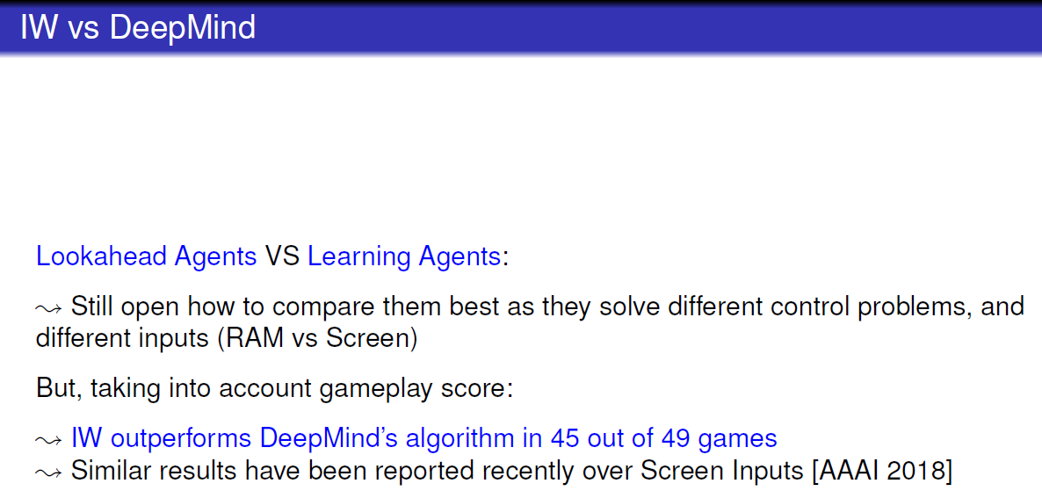

# Lecture 7: Plan & Goal Recognition

## A Theory of Common Sense

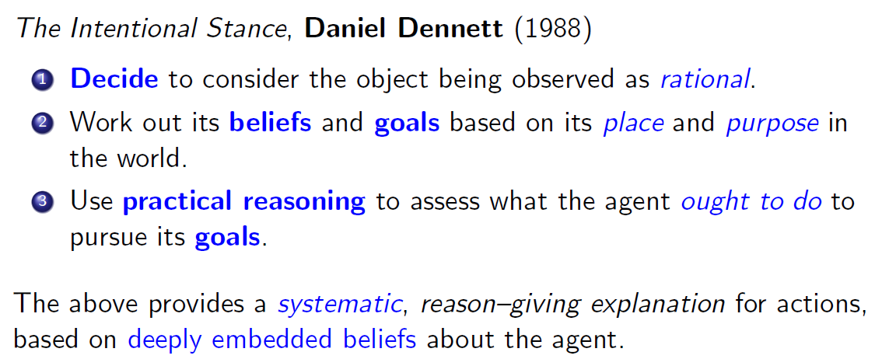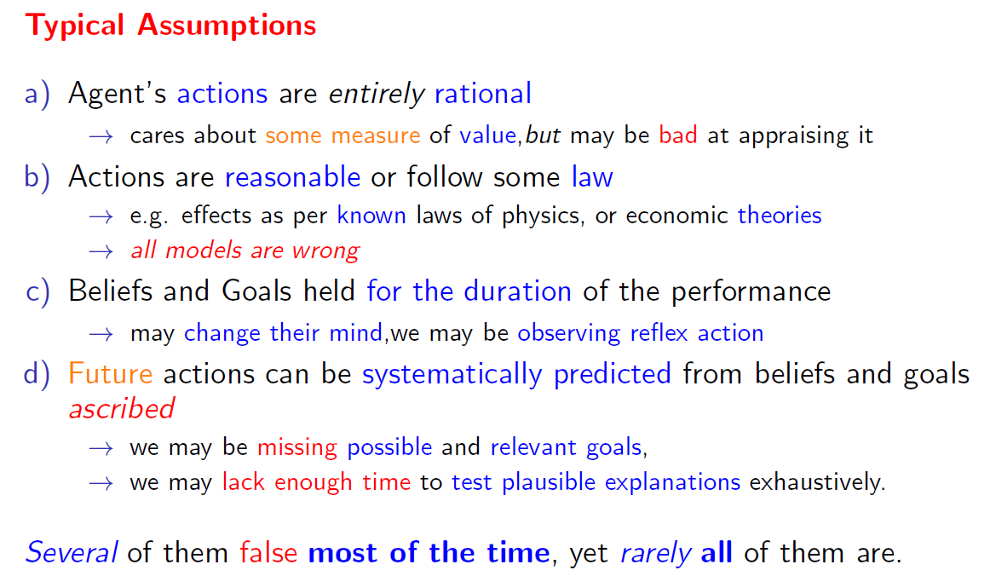

## Plan and Goal Recognition in Artificial Intelligence

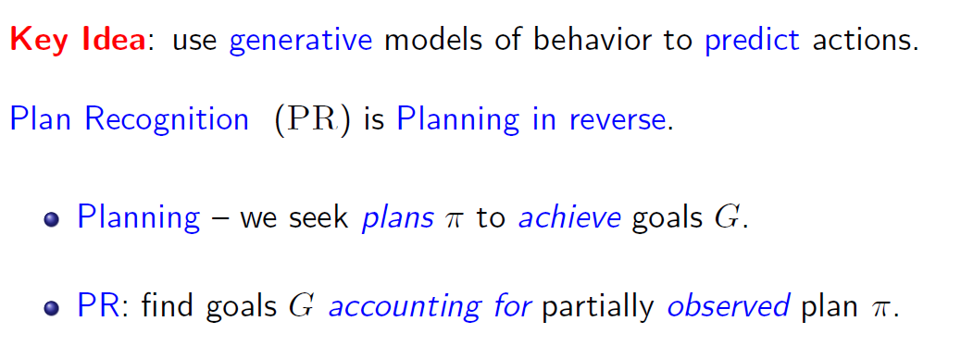

### Formalizing GR as a Multi-Agent Task

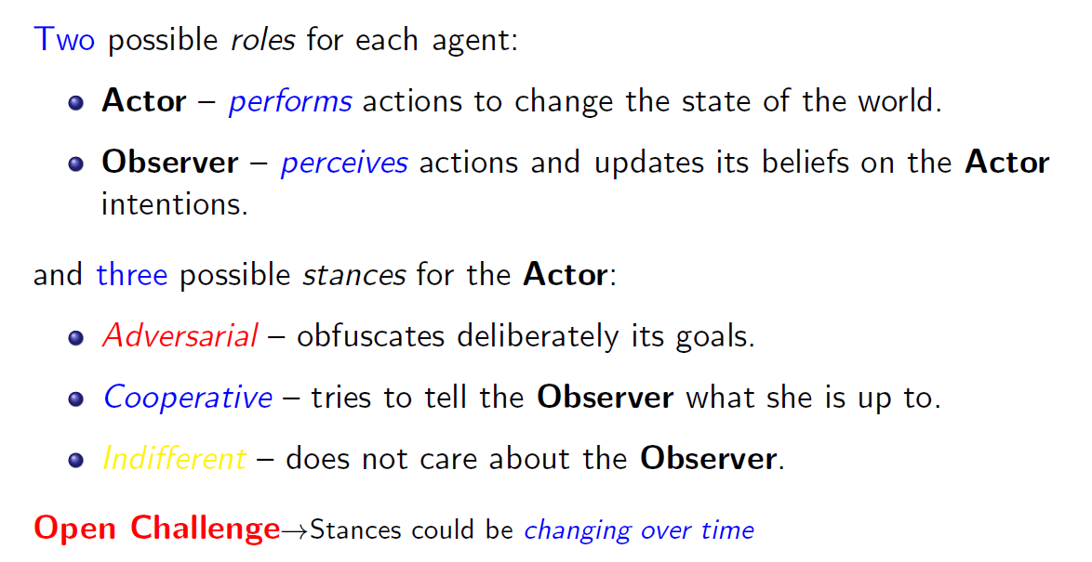

### Components of GR task

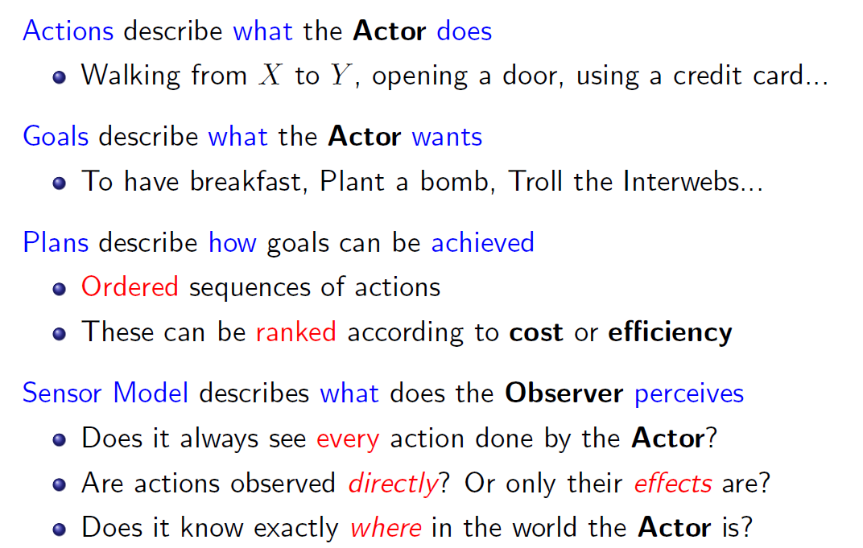

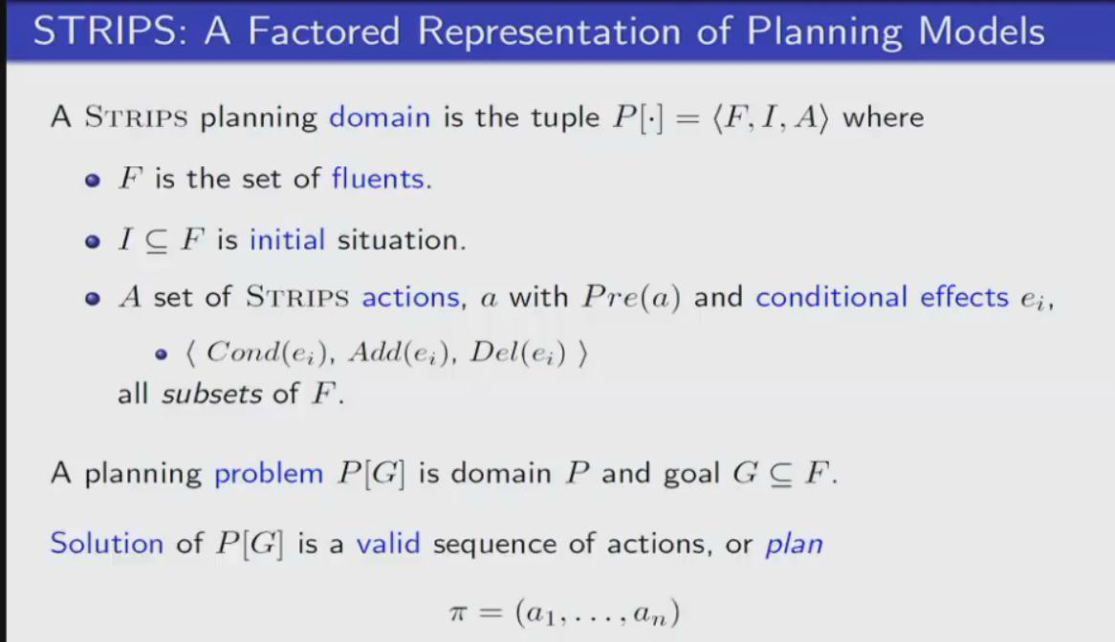

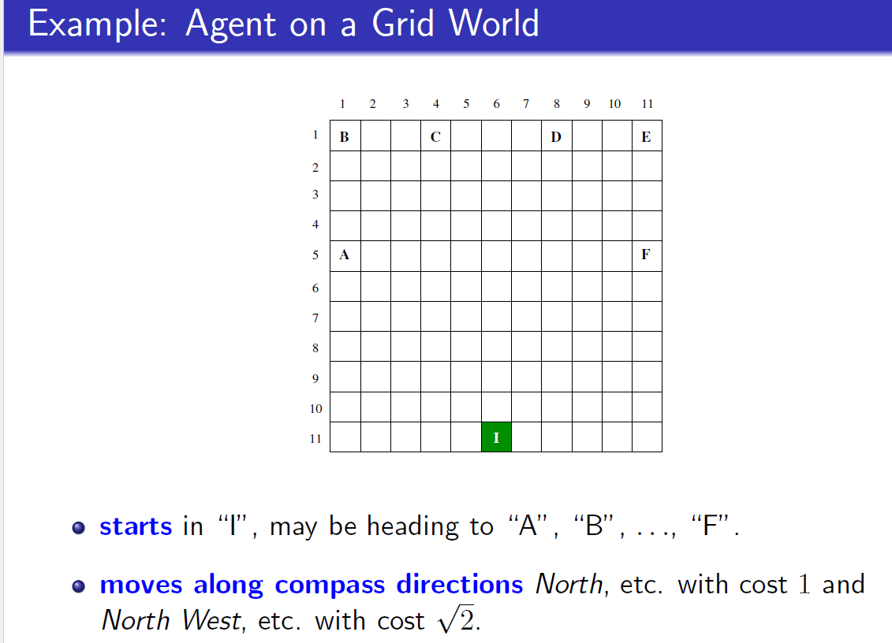

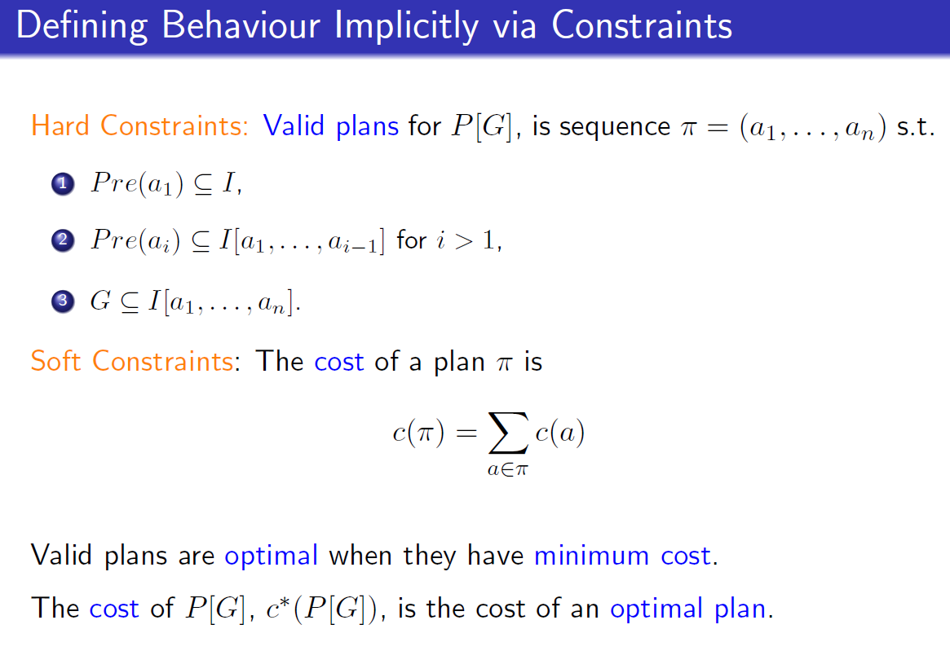

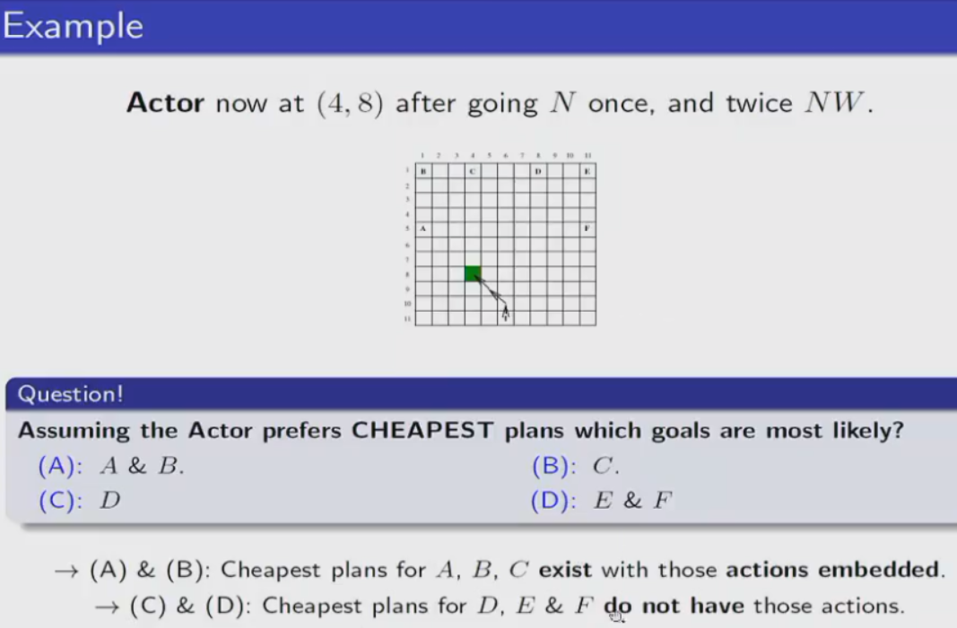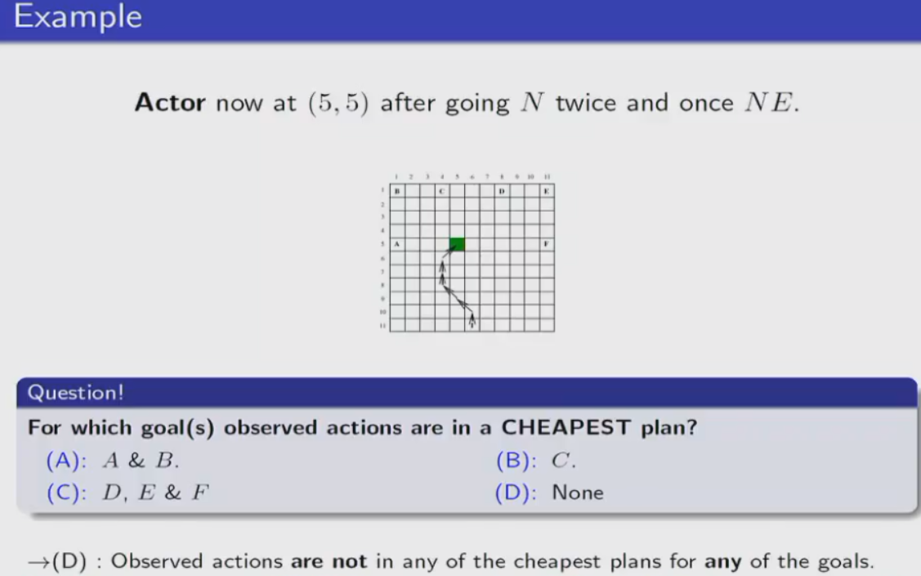

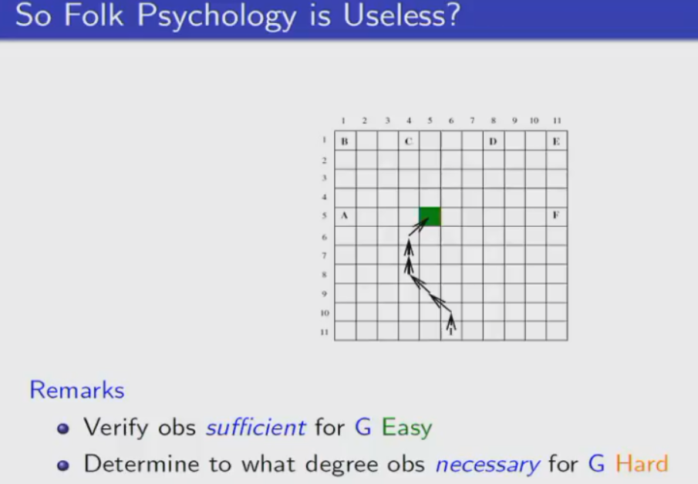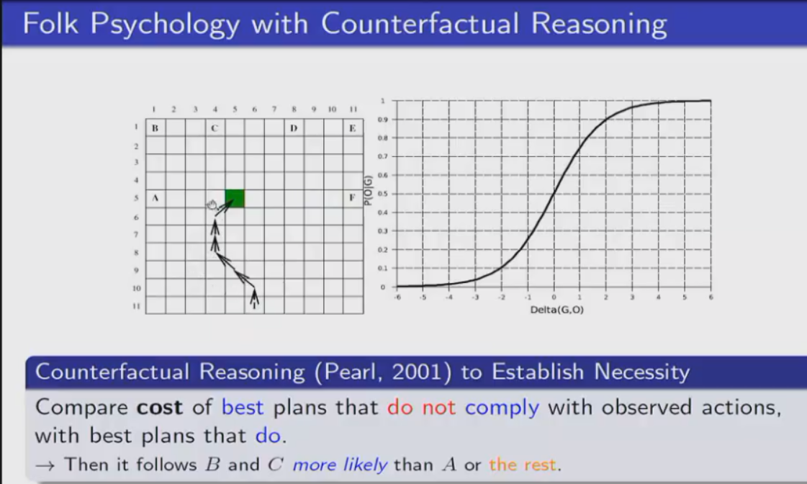

Because the overhead imposed by having to comply

with the steps have observed is greater than not doing so for choosing A

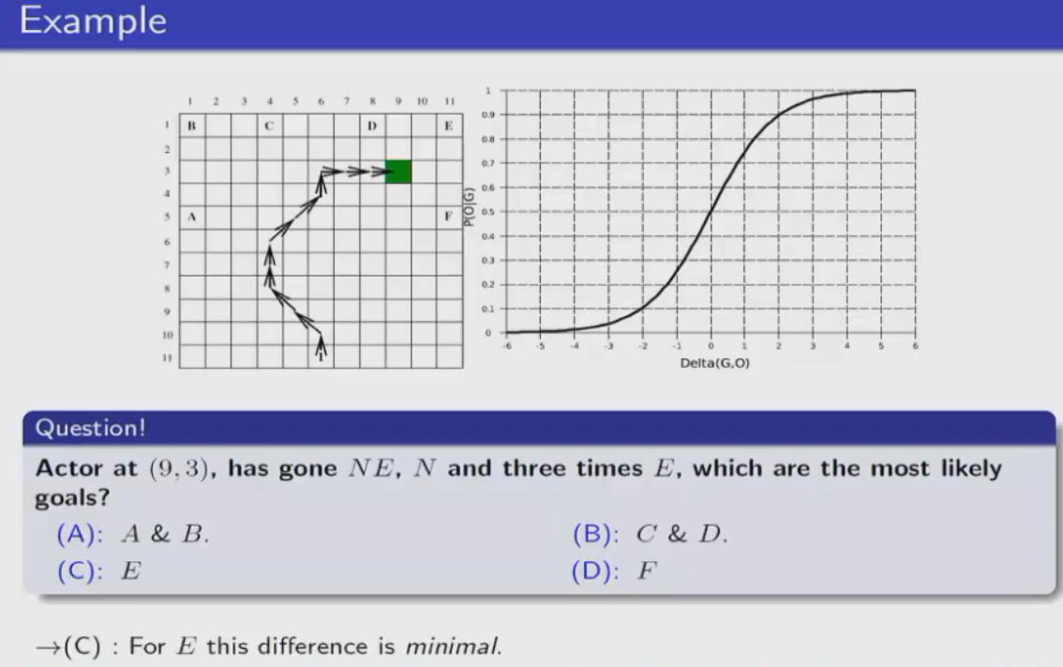

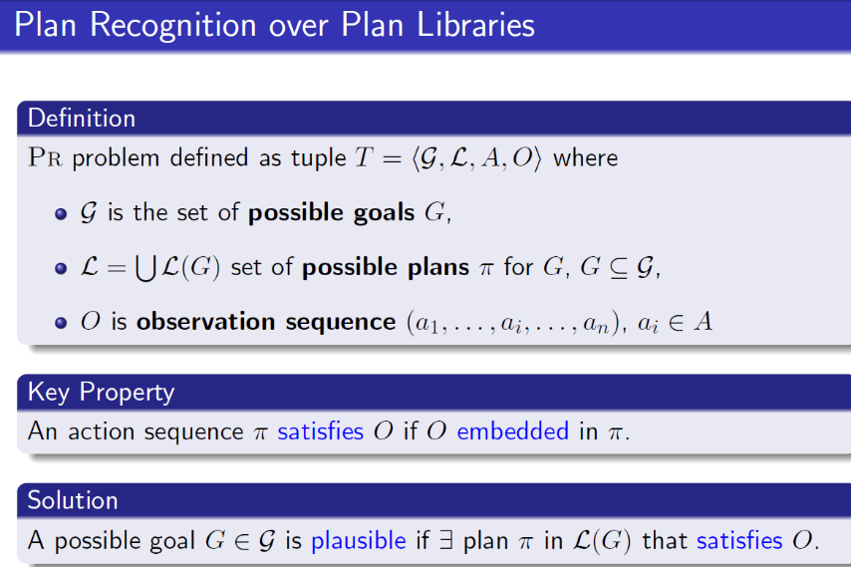satisfy means an autonomic mapping between the actions in the plan and the actions in the observation sequence

That means all the actions in the observation sequence need to be in the plan and they have to happen in the same order as they happen in the observation.

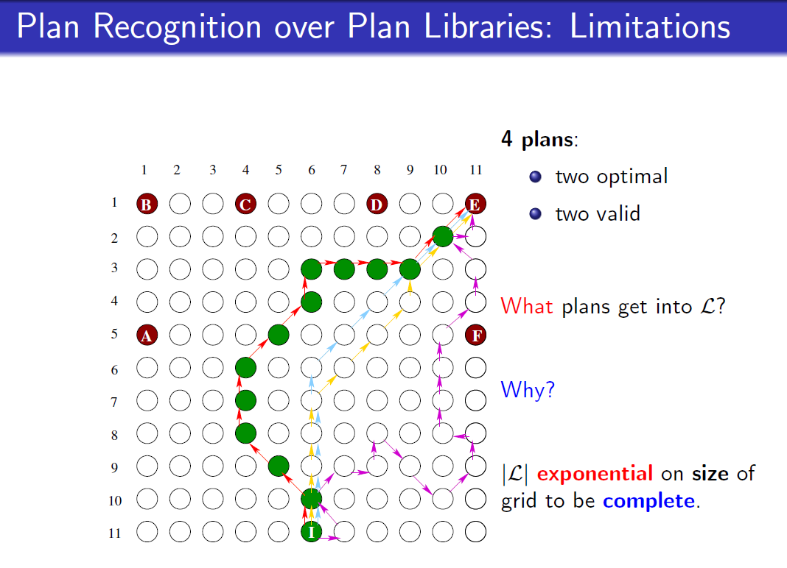all of them

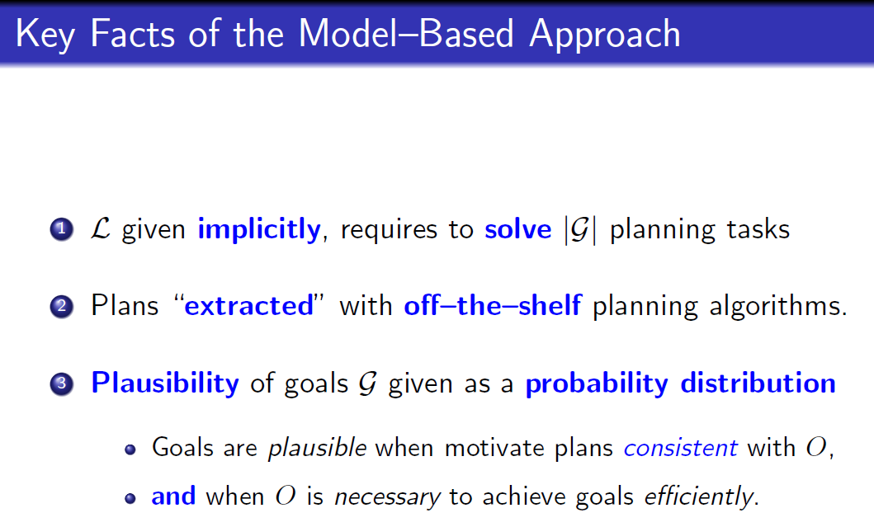

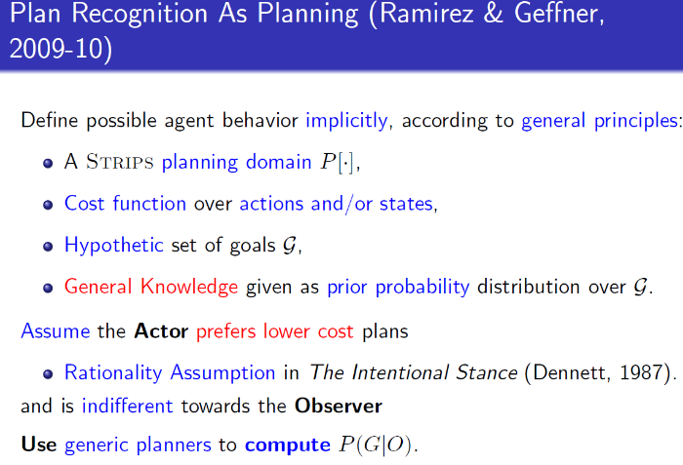

Planning domain tells possible agent actions

Cost function gives preference

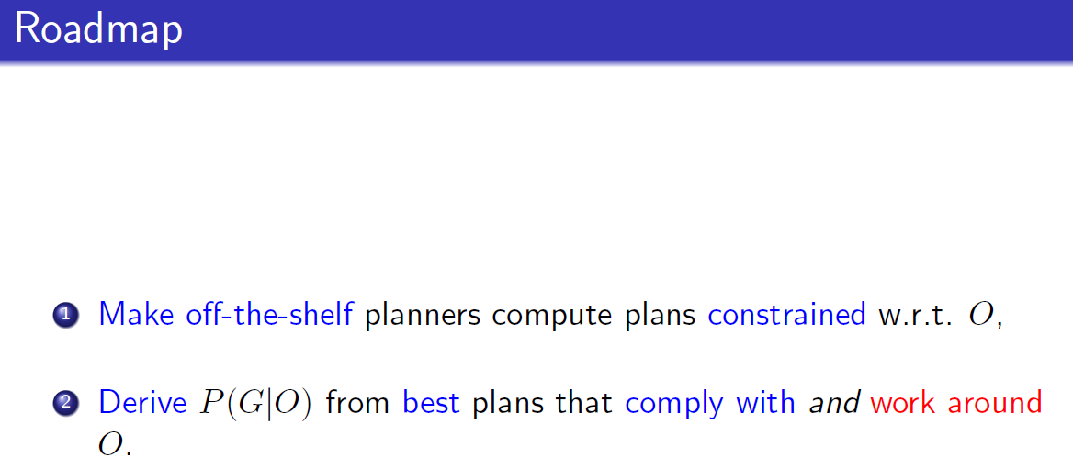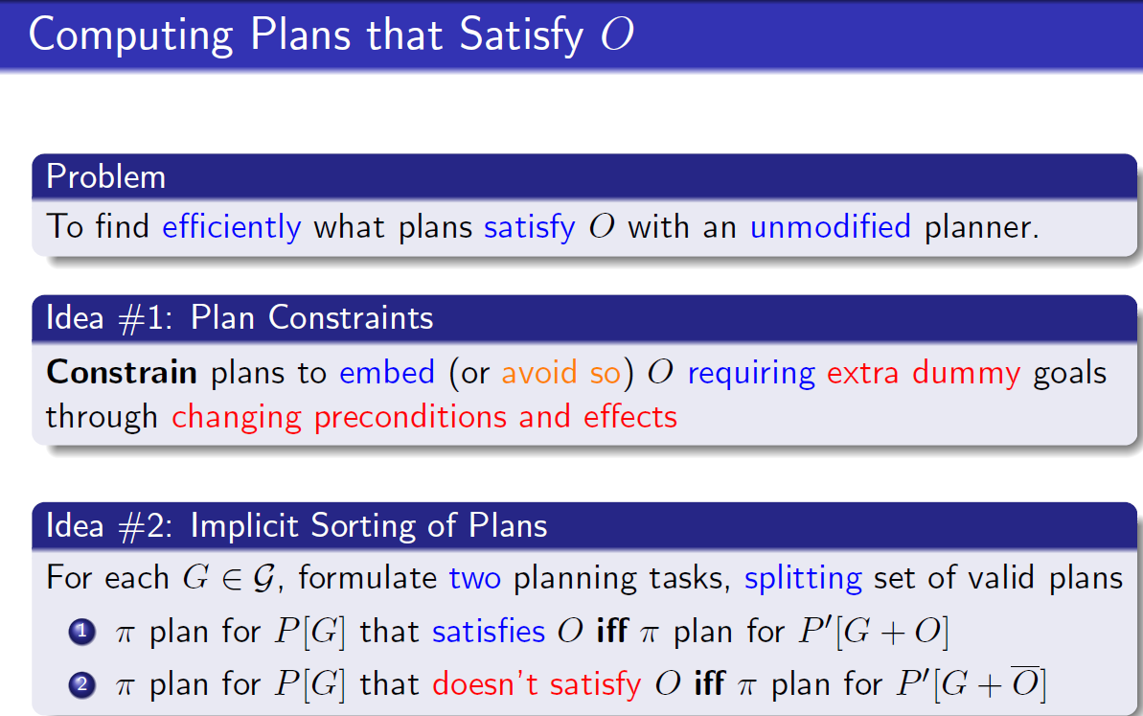O dash: inconsistent observation

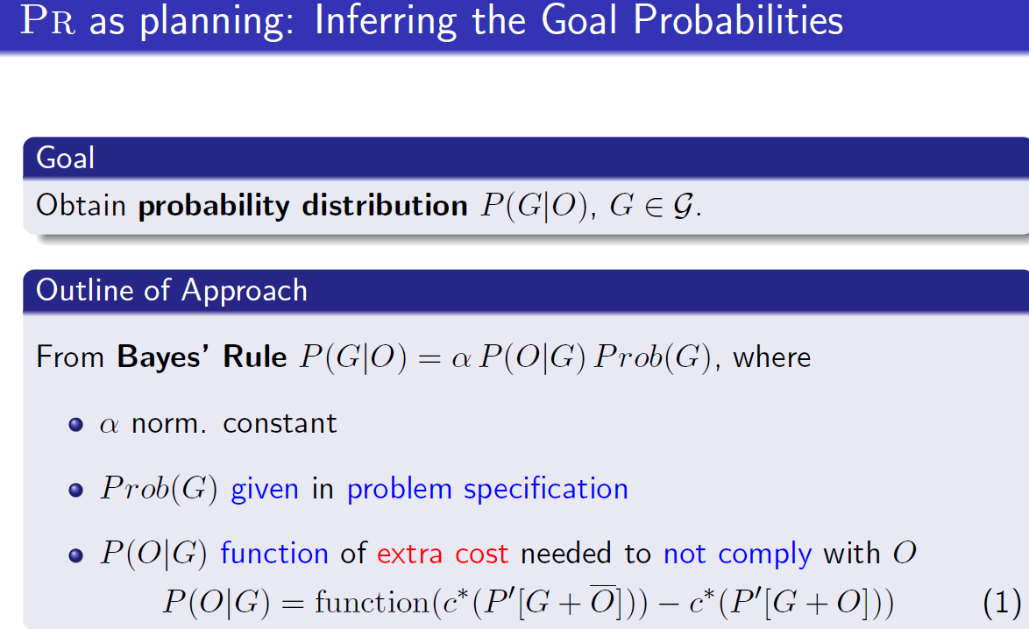likelihood

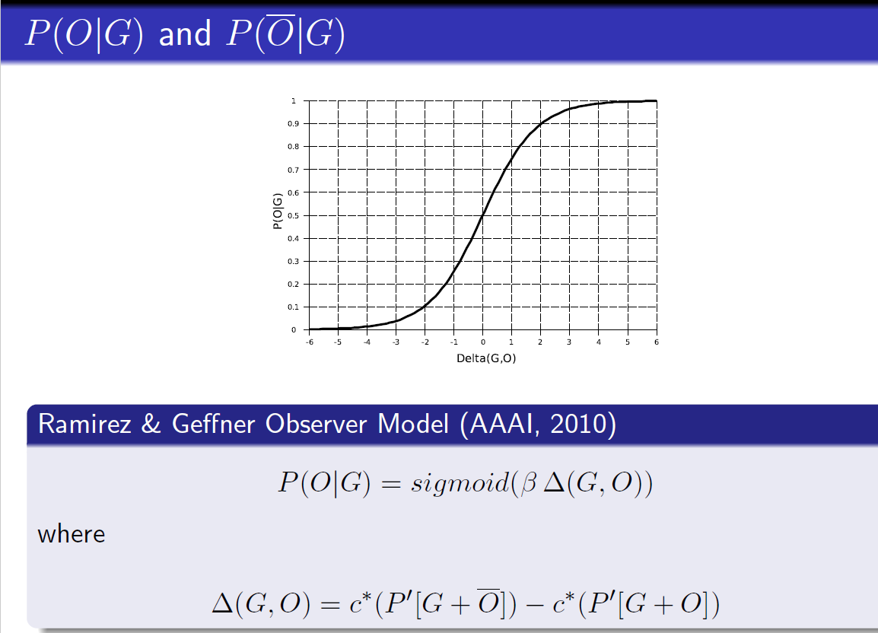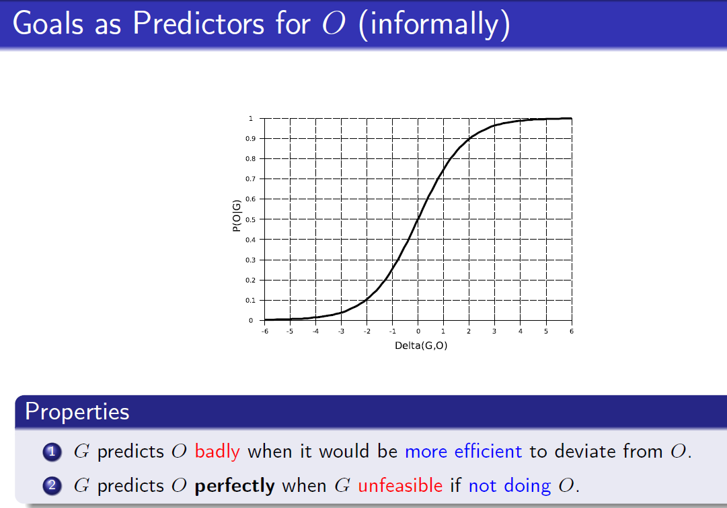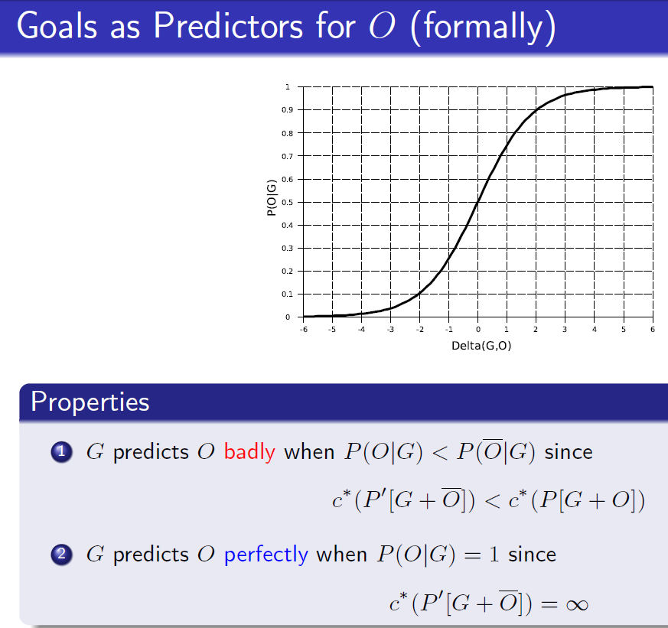

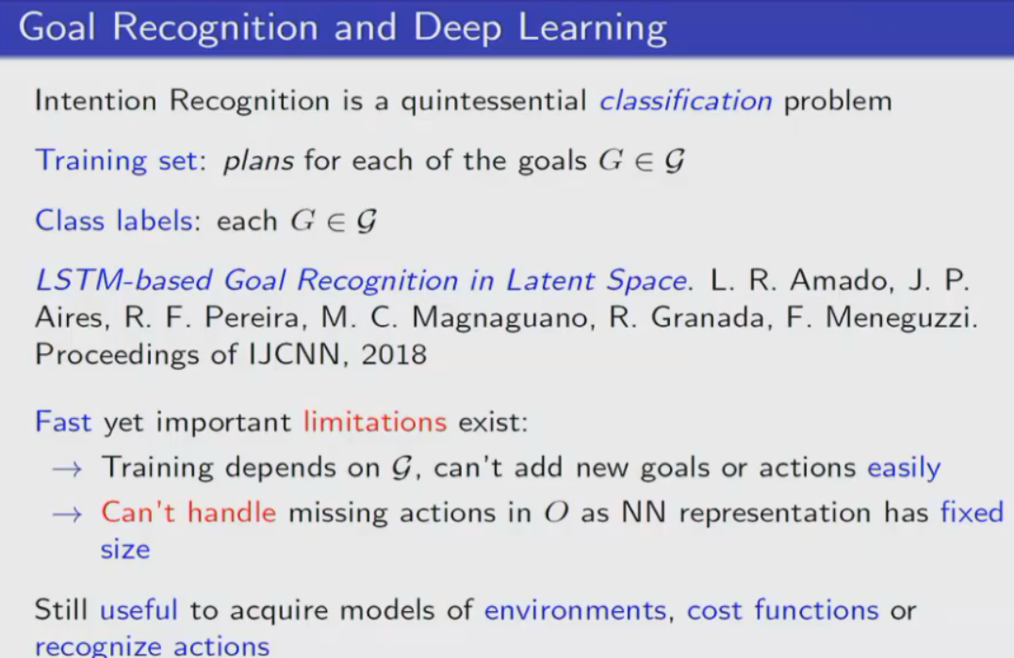

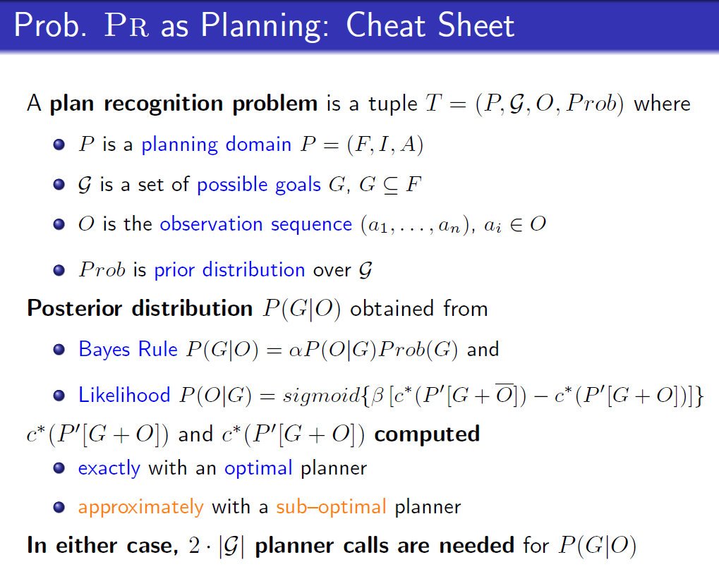

# Lecture 8&9: Markov Decision Processes (MDPs)

MDPs are **fully observable, probabilistic** state models.

## formulation of MDPs: *Discounted-Reward* Markov Decision Process

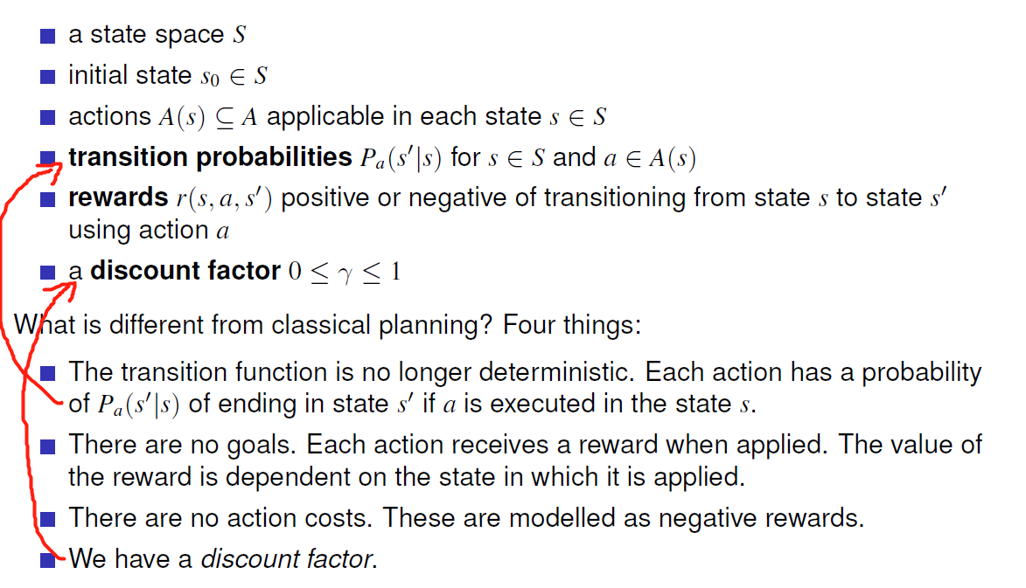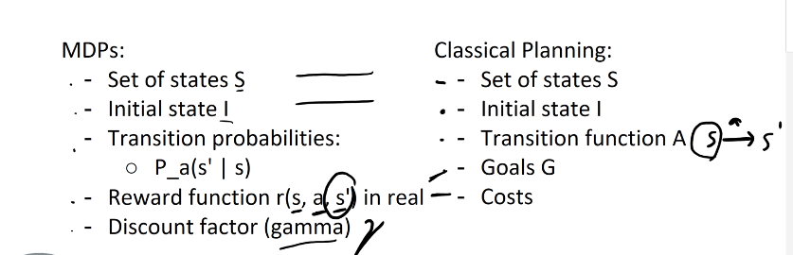

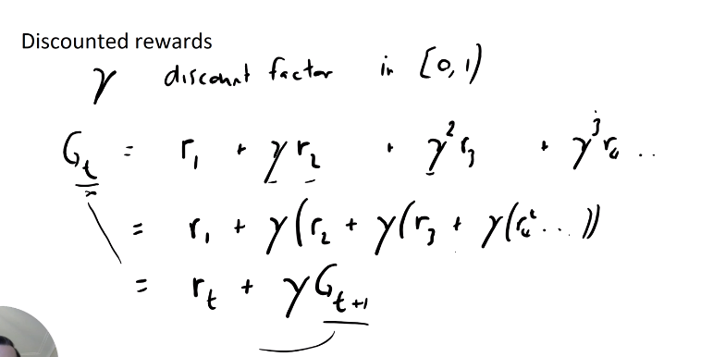

## Solutions for MDP problems: policies

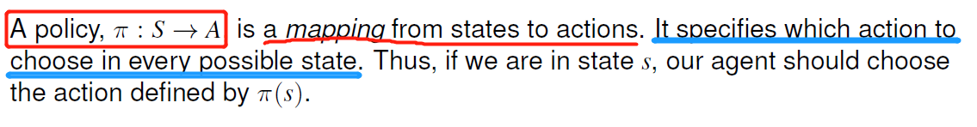

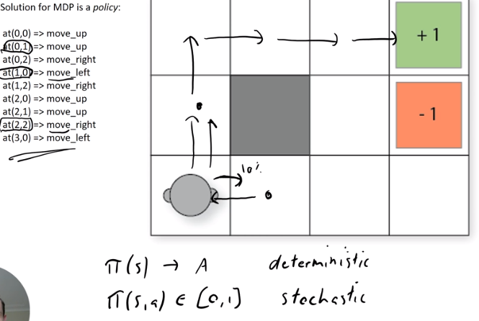stochastic not discussed in this subject

## Bellman equations (Discounted-Reward MDPs[1])

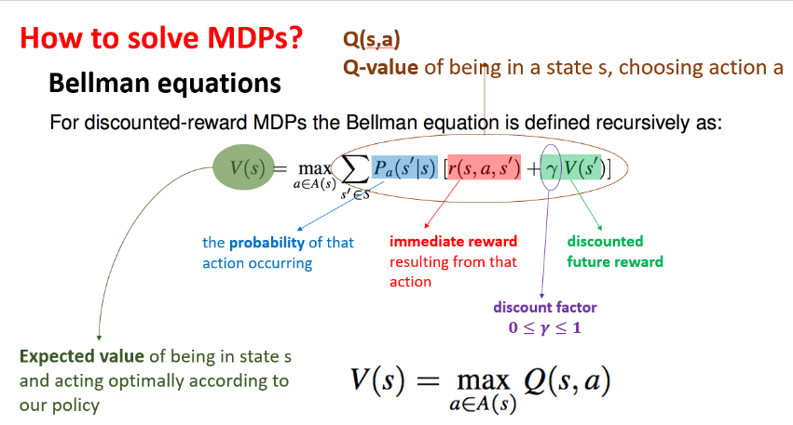Q(s, a): expected reward of taking action a

### Value iteration

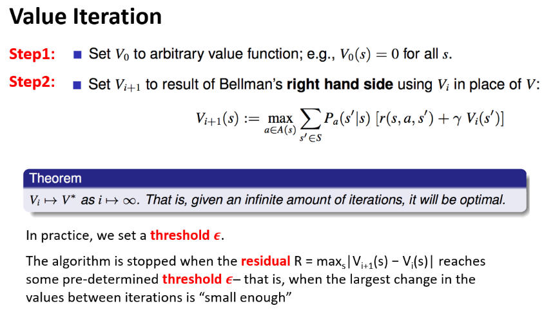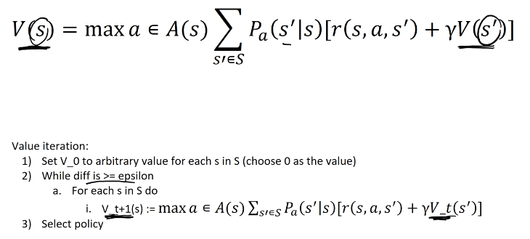select is argmax(Q(s,a))

Complexity: O(|S|2|A|)

### Policy iteration

Decide how to act

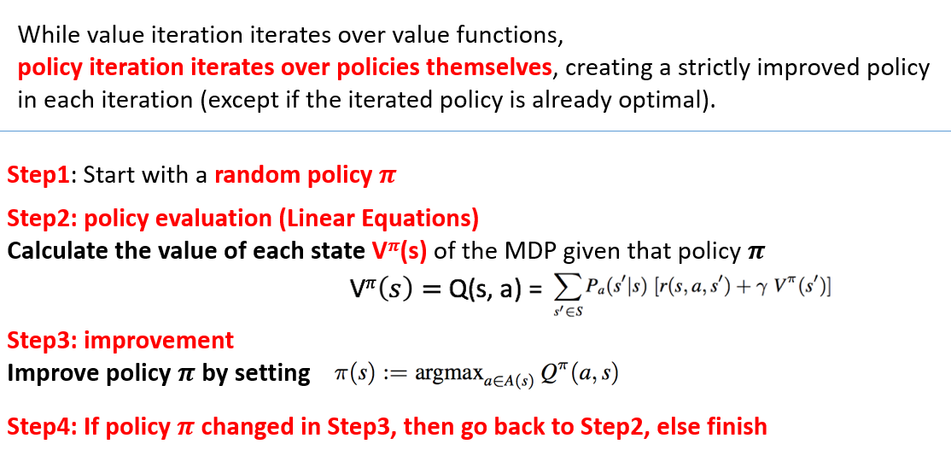Vpi(s) is not the same as V(s), set them as variable and solve a linear equation

Complexity: O(|S|2|A| + |A|3)

### Policy iteration V.S. value iteration

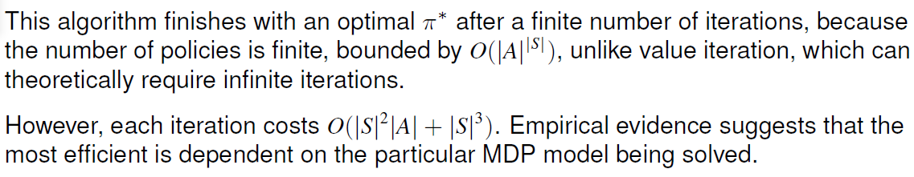

# Lecture 10: Monte Carlo Tree Search(MCTS)

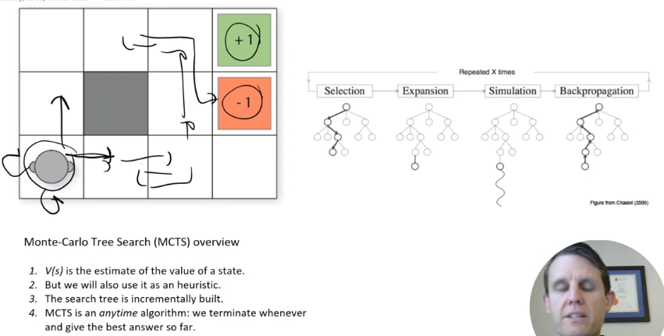

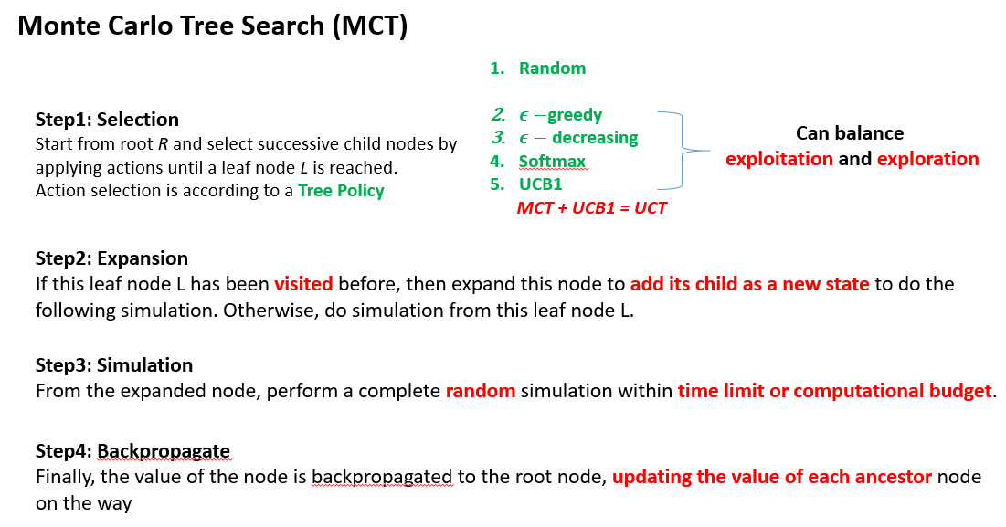

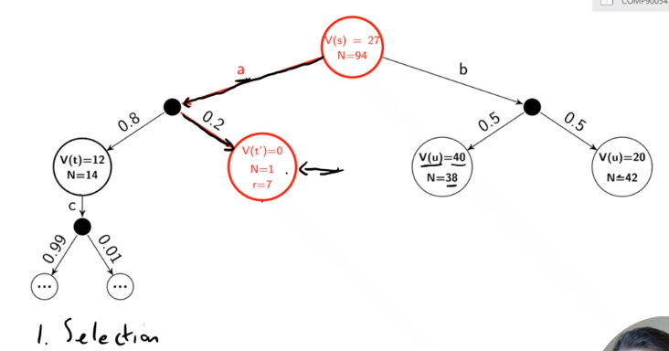

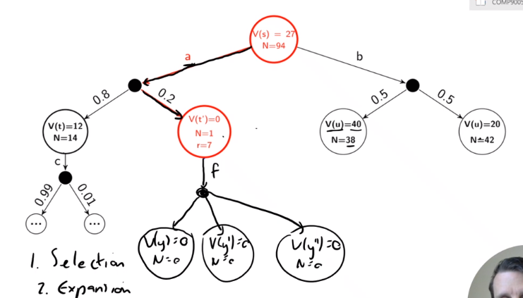

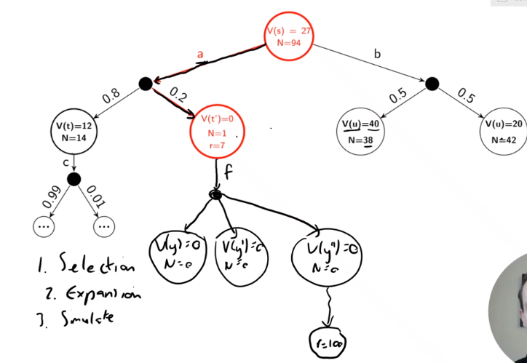

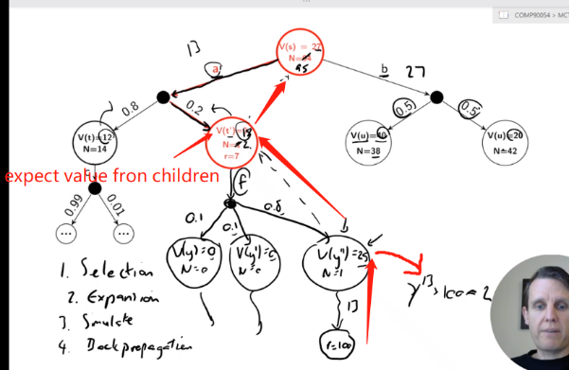**update V(s) by bellman equation**

**for each action node:**

**Q(s, a) = sum Pa(s’|s)[r + gamma * V(s’)]**

**V(s) = max(Q(s, a))**

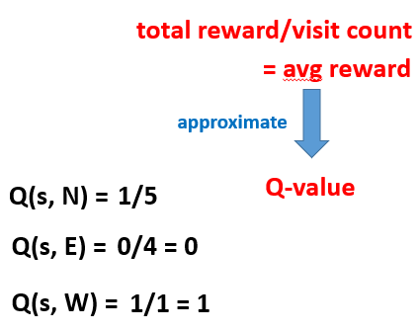

**Epsilon, softmax, UCB**

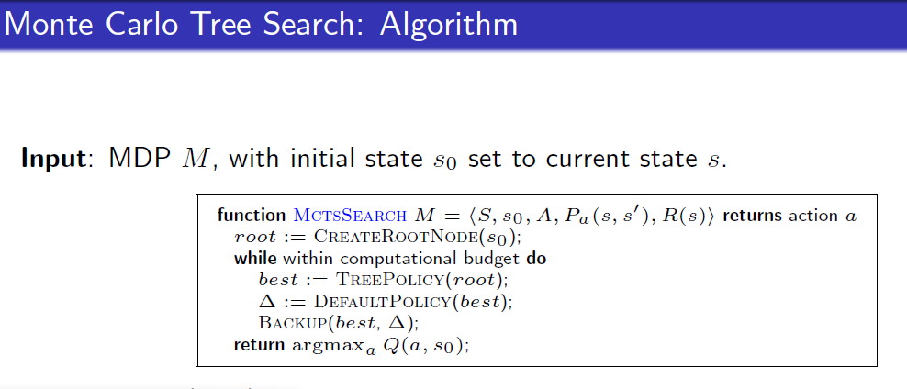

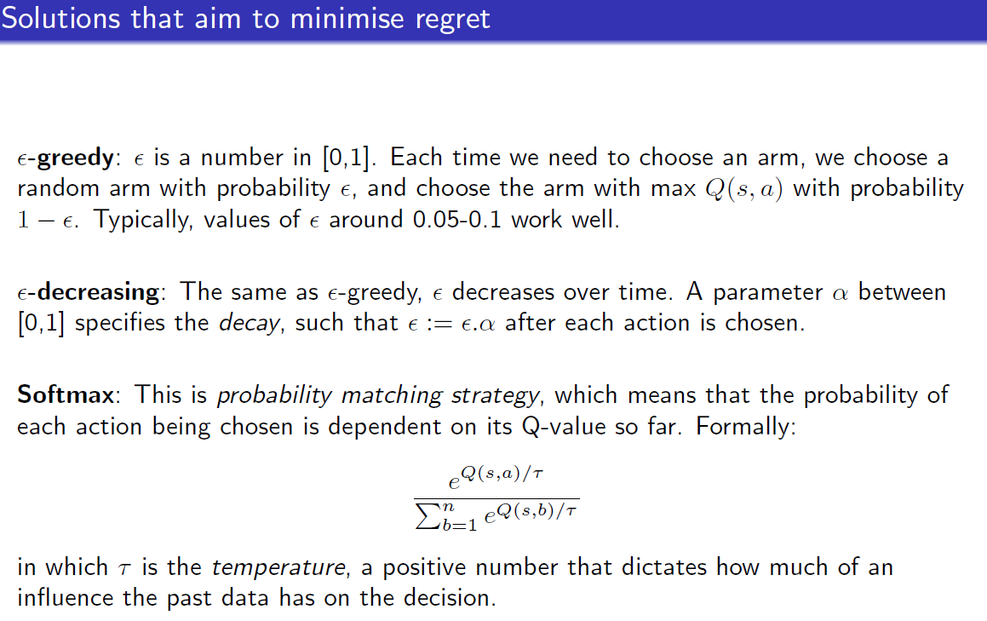

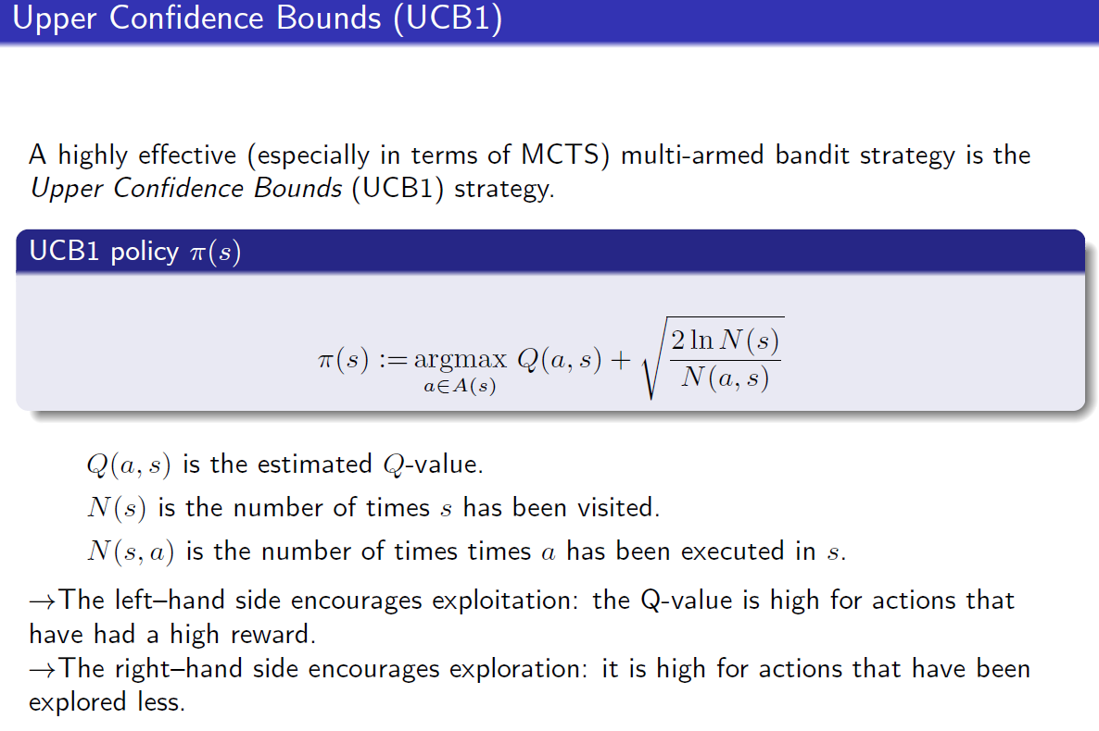

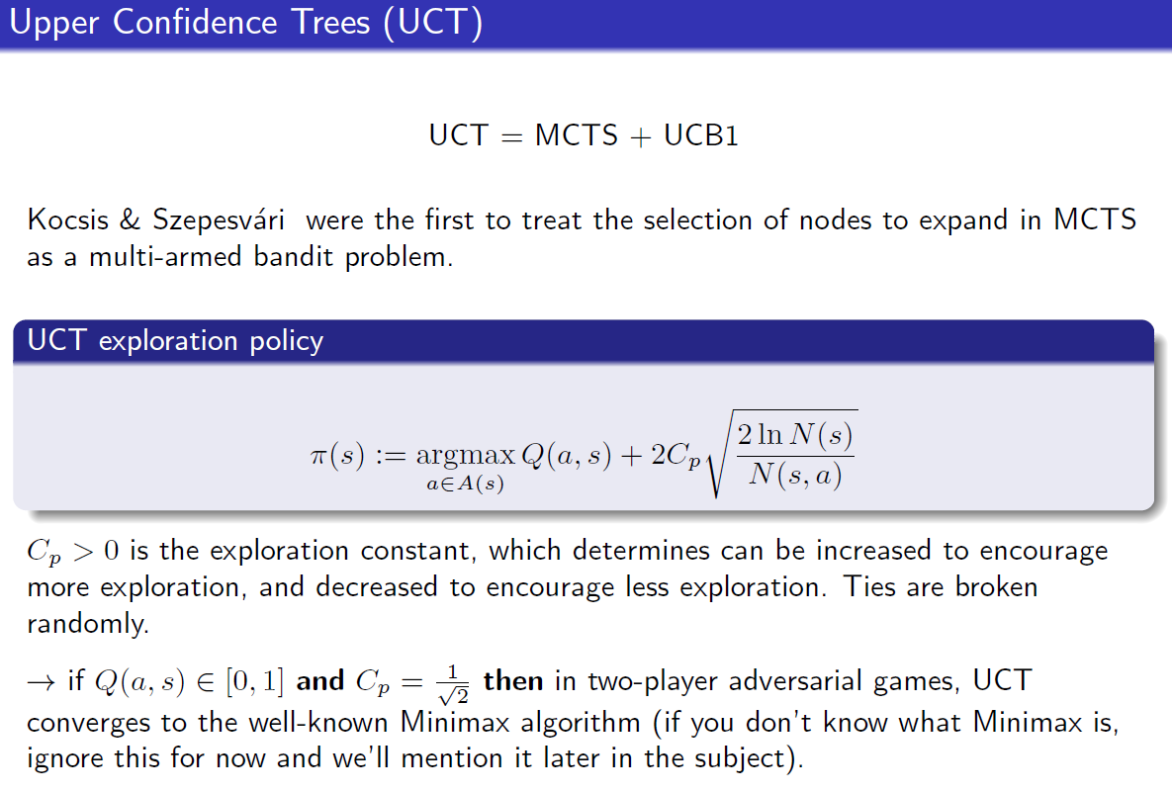**argmax (Q(a, s) + 2* …)** !!!

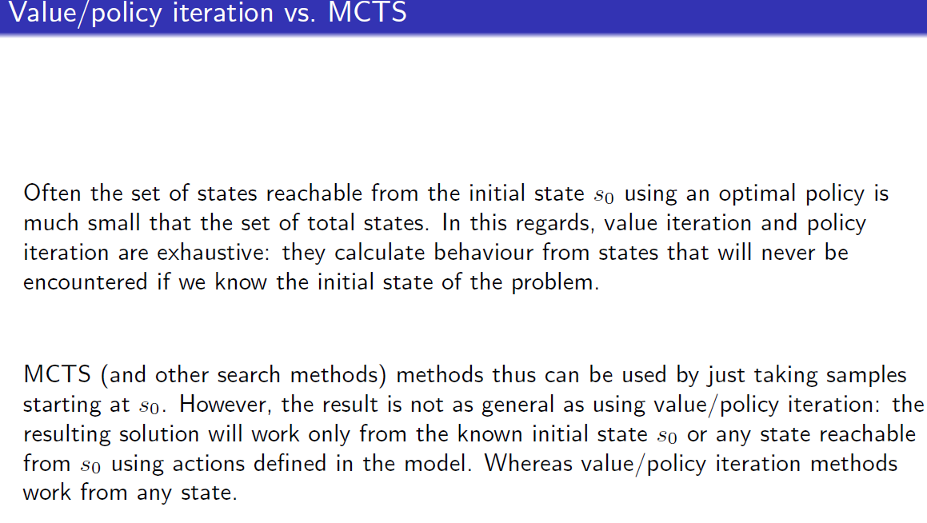

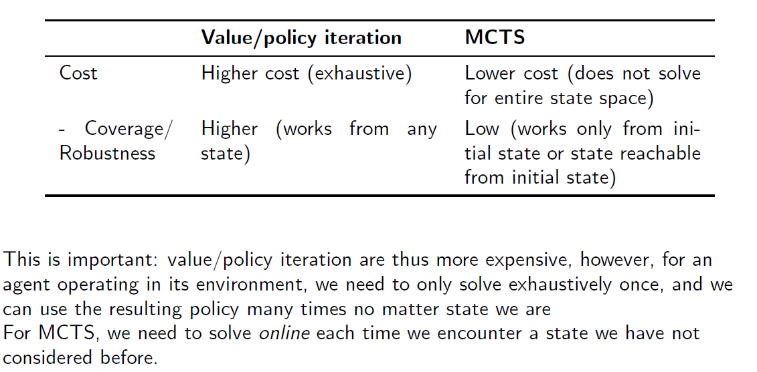

# Lecture 11: Reinforcement learning (TD)

## Comparison

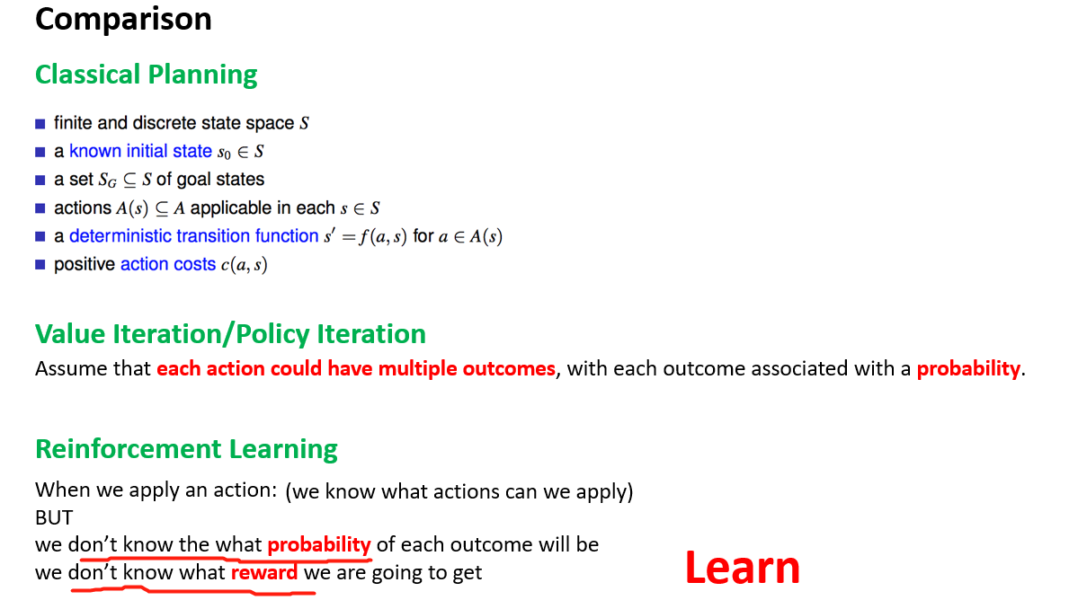

## RL

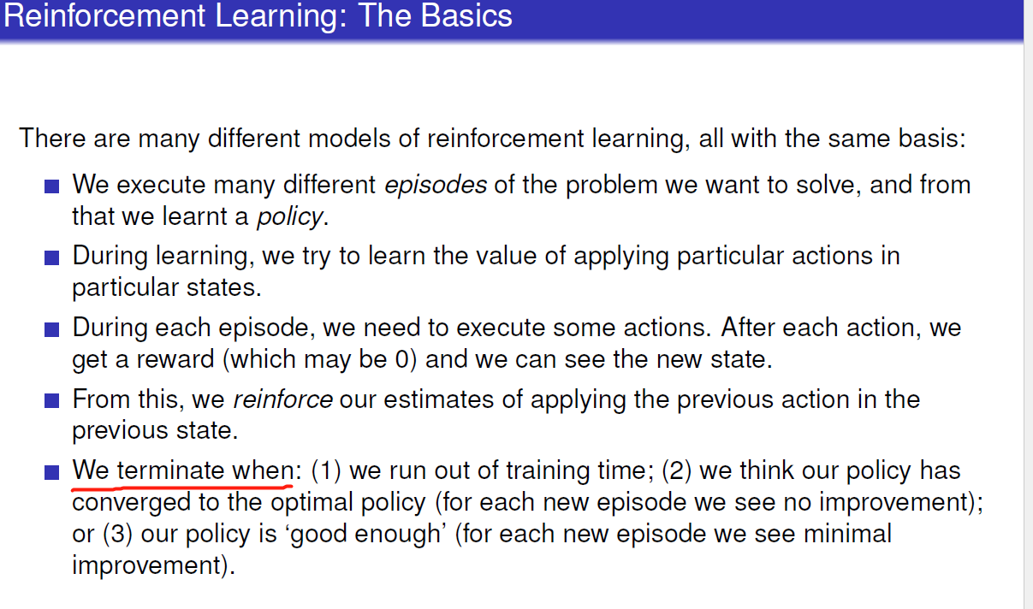

## Q learning

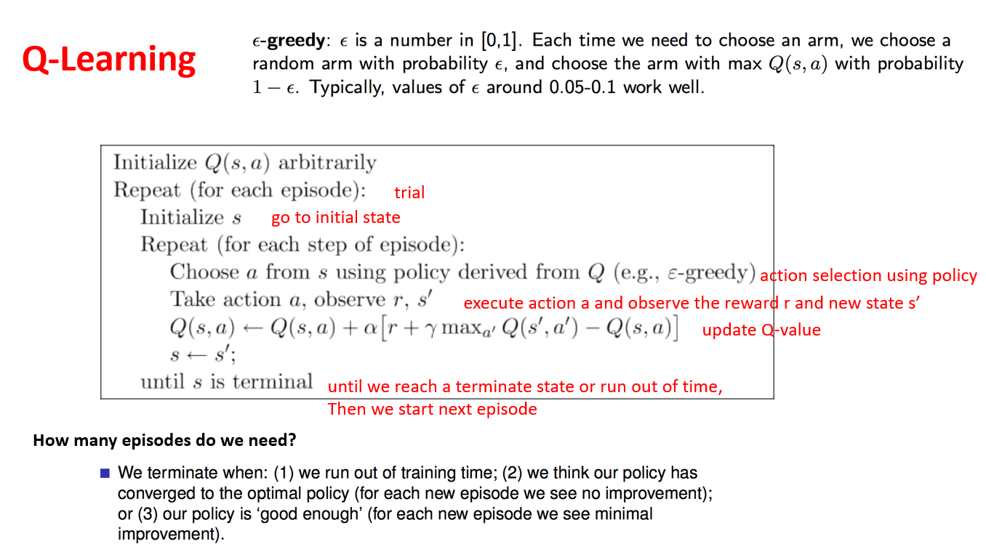

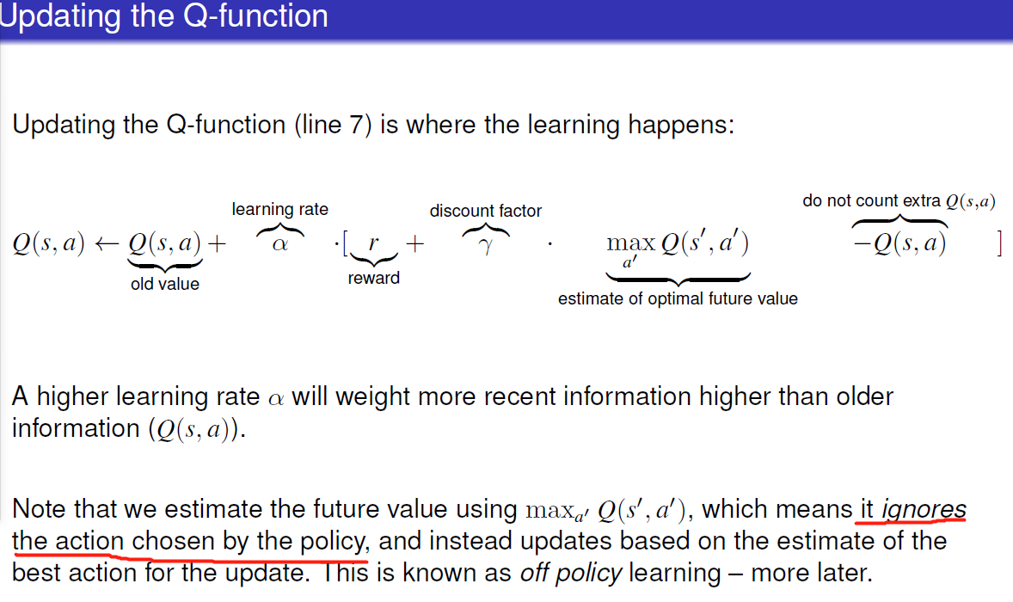future value = future reward

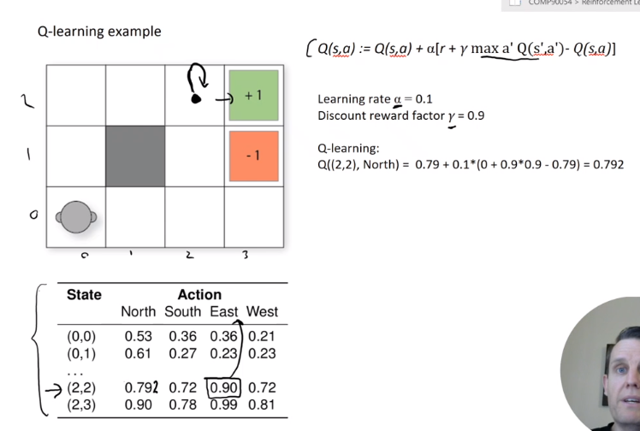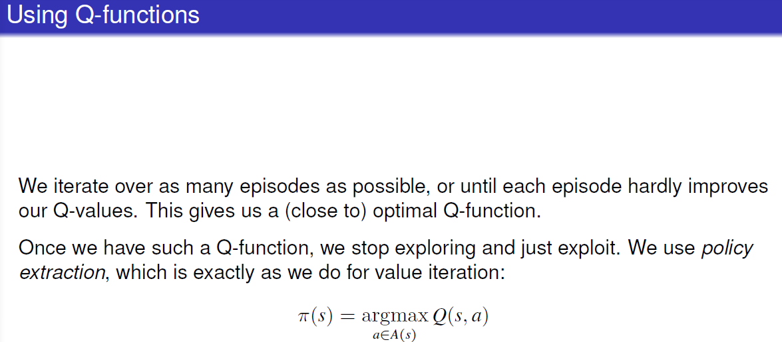

## SARSA

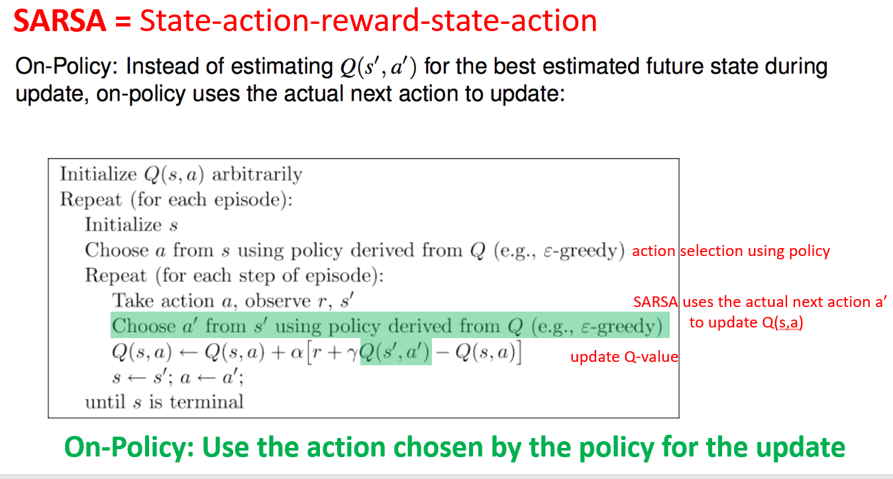

Choose a’ by policy not by max in Q-learning

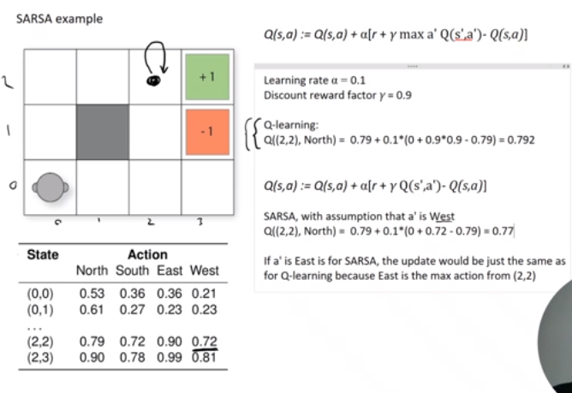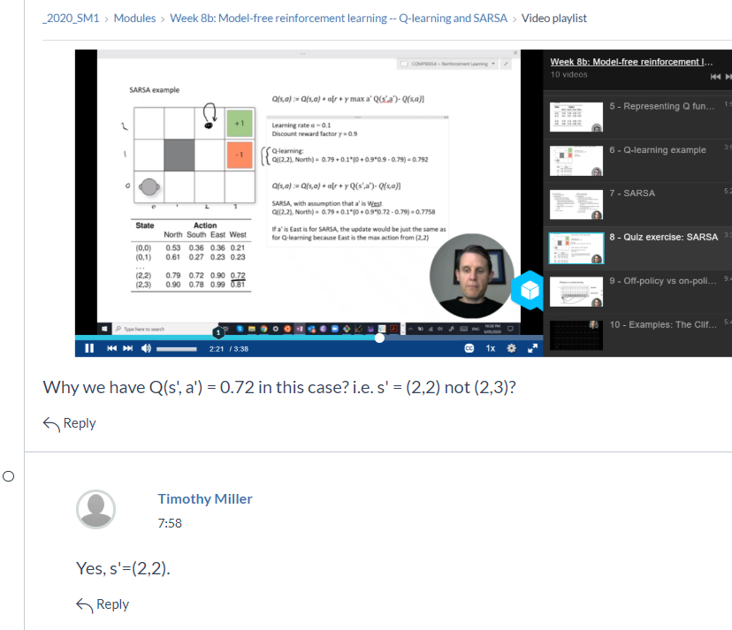

# Q-learning vs. SARSA

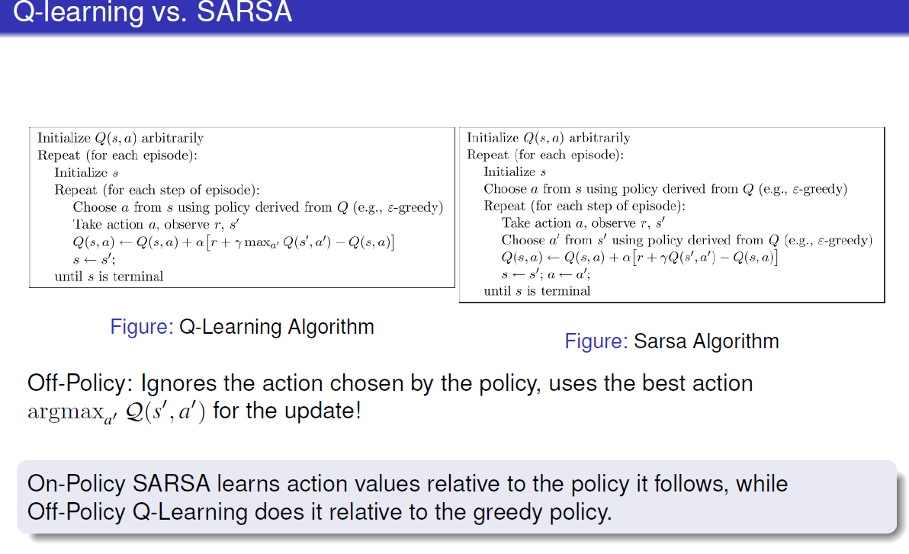

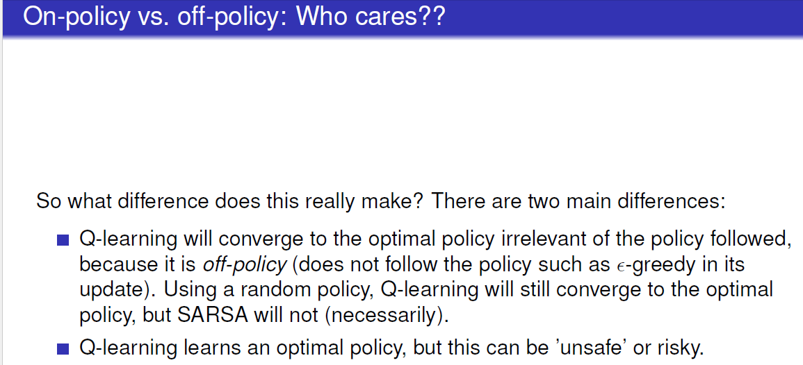

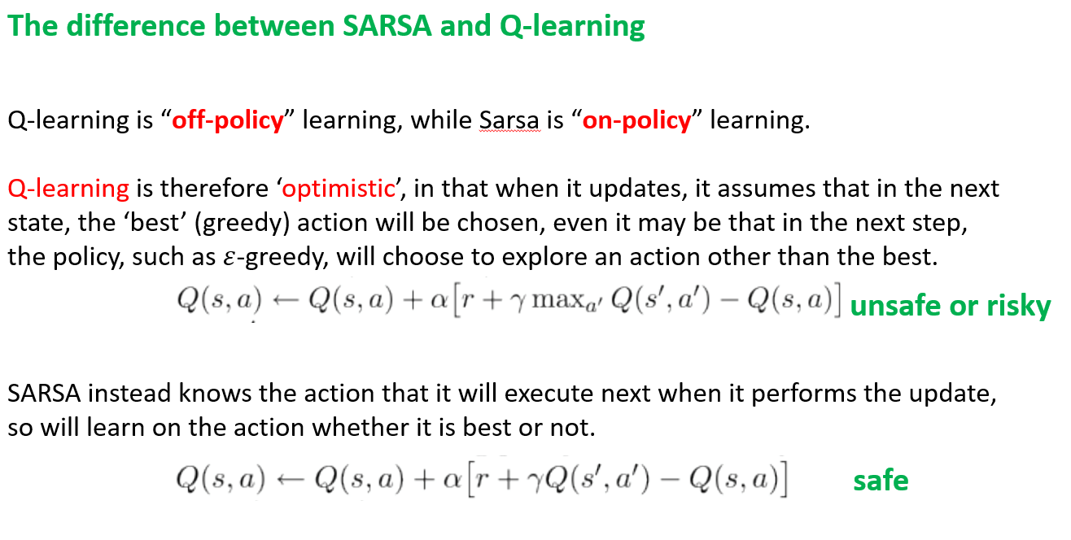

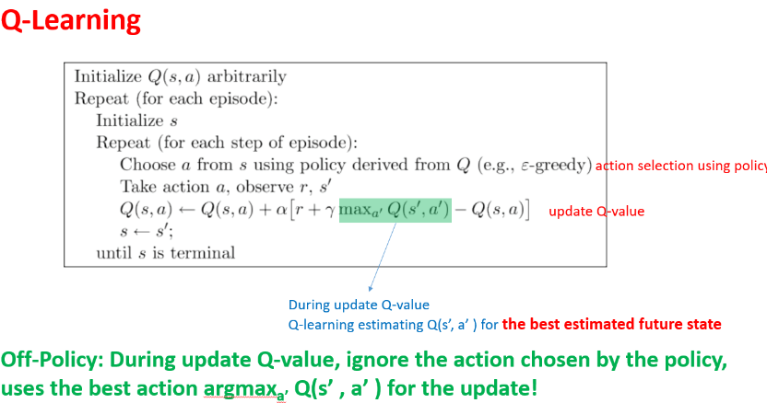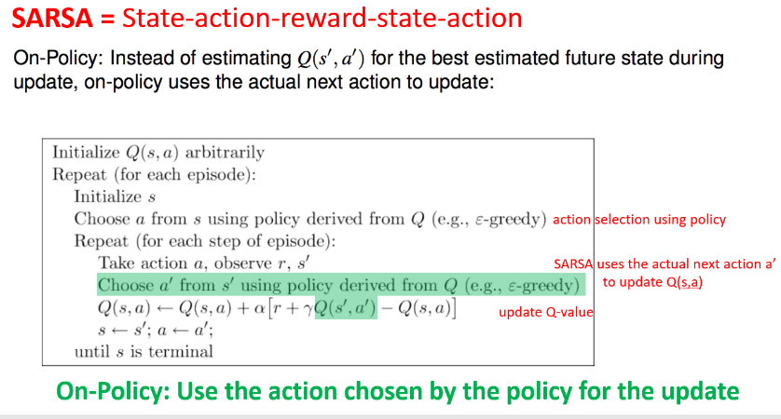

### Which to be used?

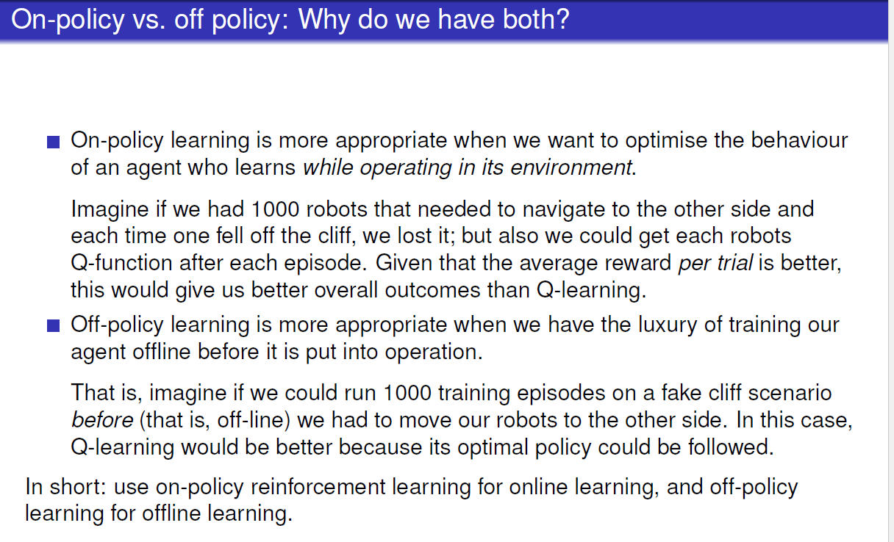

## weakness

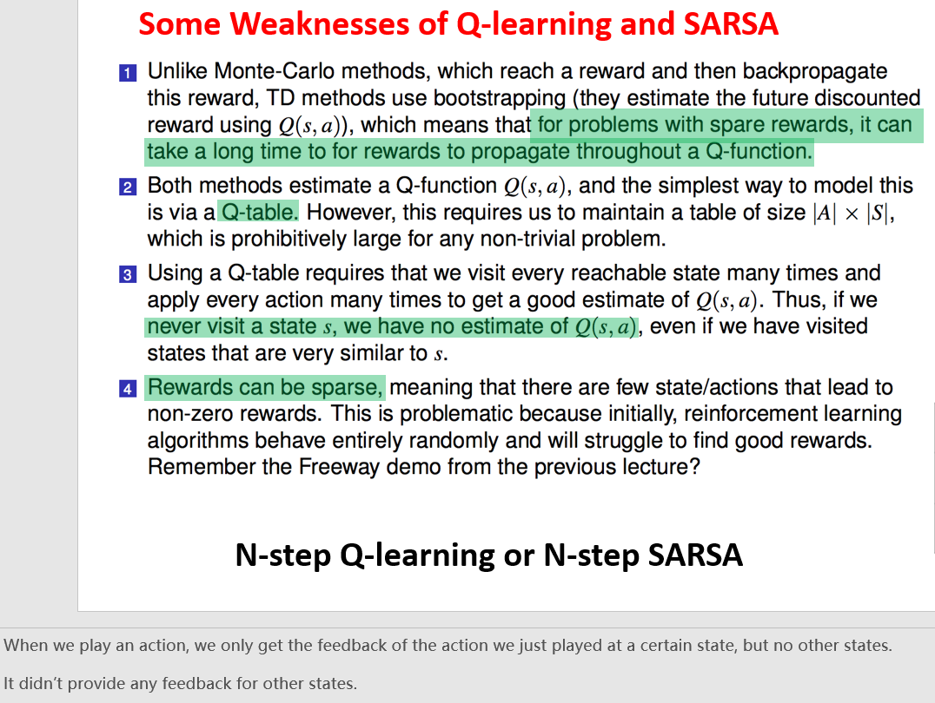

# Lecture 12: Faster Reinforcement Learning

## Linear function approximation

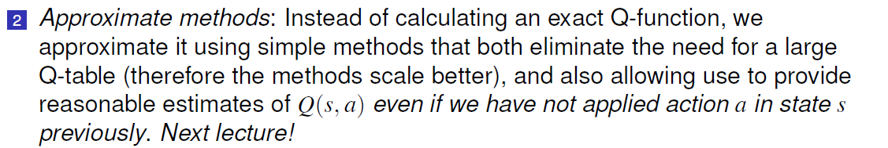

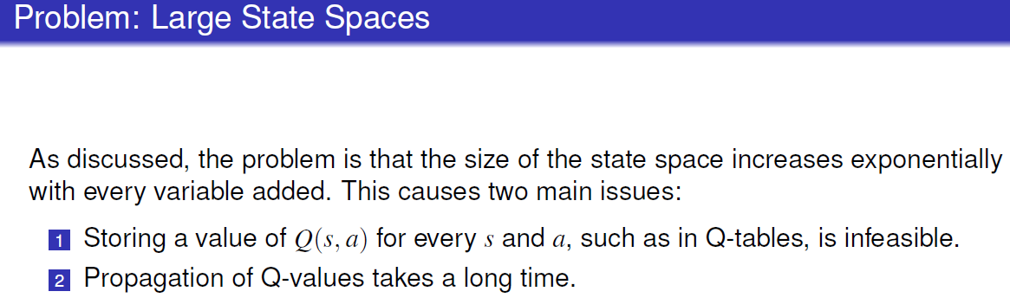

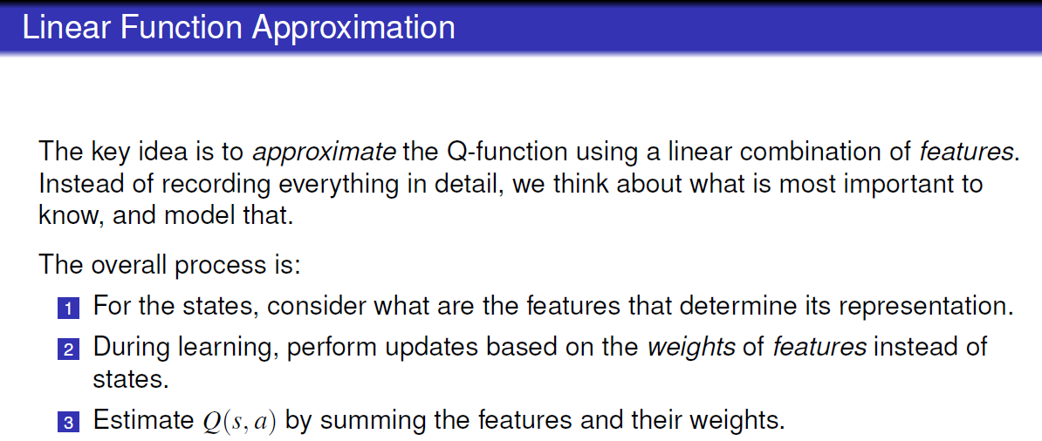

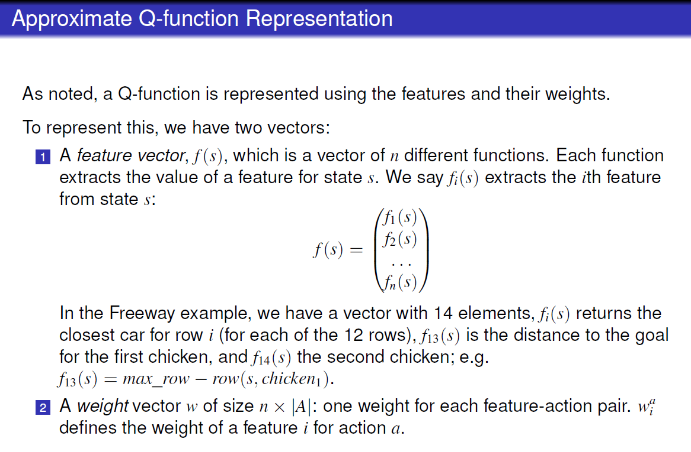

### Q-value

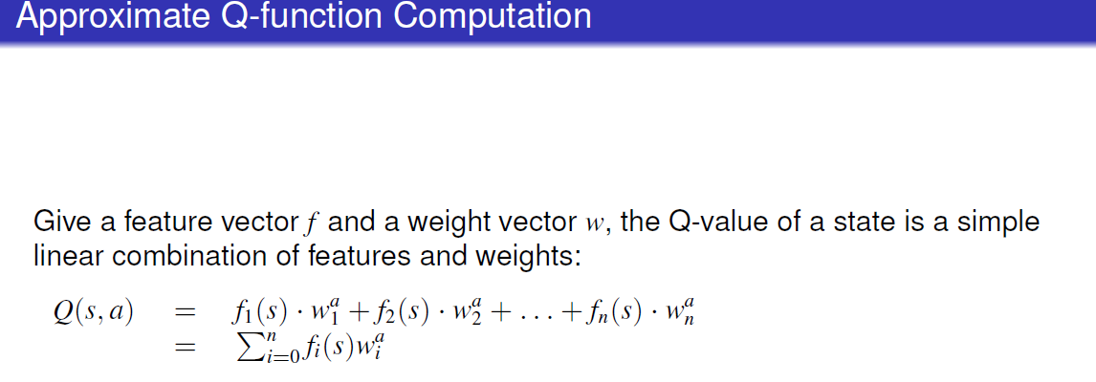

### Update rule

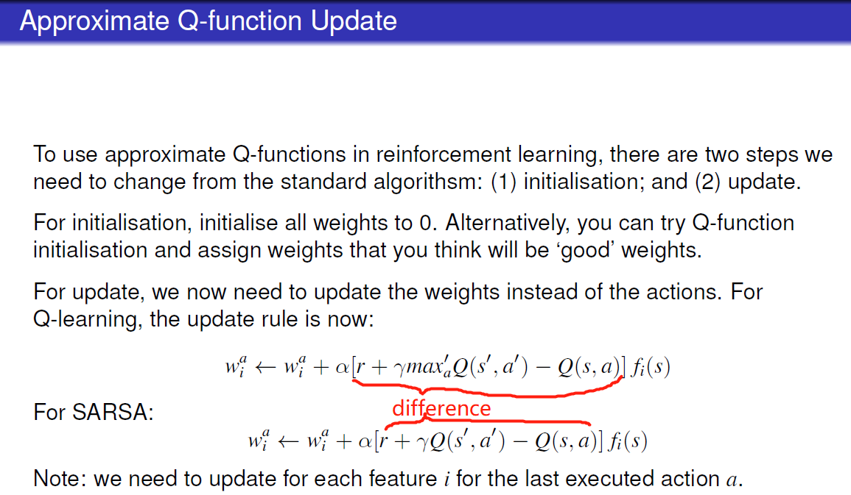

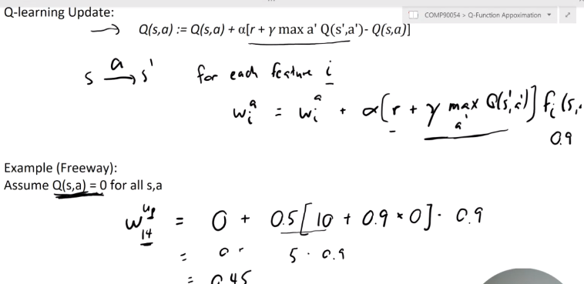

### Neural network

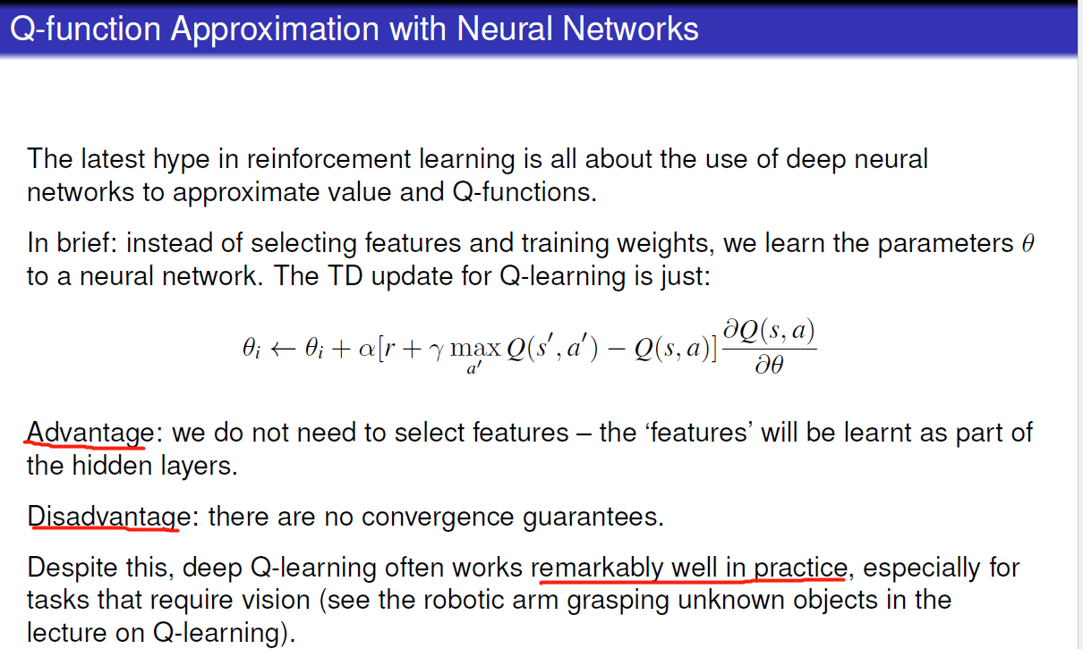not examinable gradient decent

### Strength & limitation

|  |  |  |  |
| --- | --- | --- | --- |
| Strength |  | Limitation |  |
| Compact representation | Store parameters not whole state in the table | approximation | No convergence guarantee |
| Q-value propagation | When Q-value can be propagated, can approximate state that have not seen before |  |  |

|  |  |  |
| --- | --- | --- |
| Linear approximation | Deep q learning |  |
|  | Advantage: No feature selection | Feature engineering can be hard |
|  | Disadvantage: data hungry |  |
| Has convergence guarantee | Disadvantage: no convergence guarantee |  |

## Reward shaping

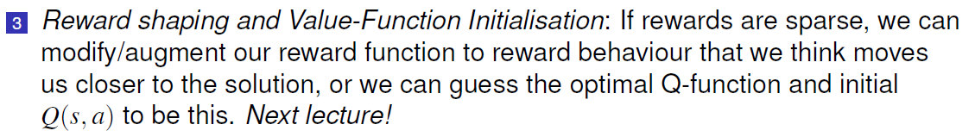

### What is it?

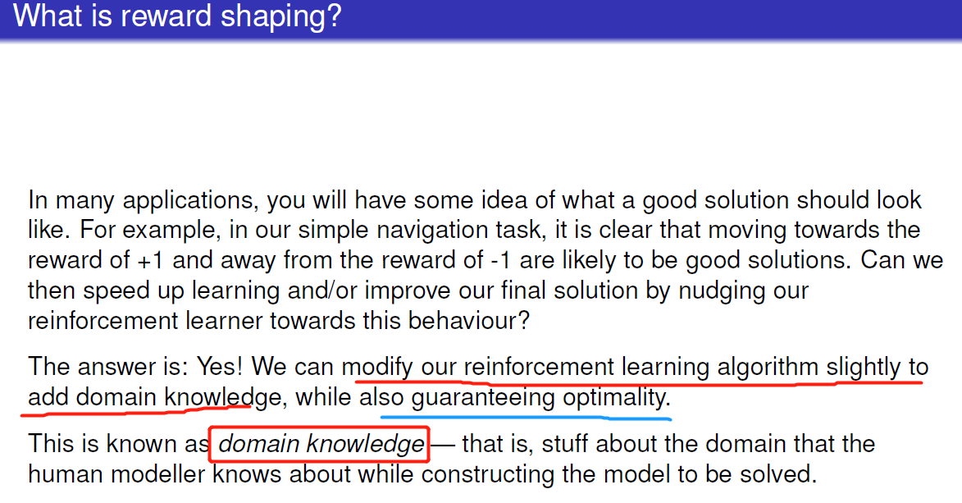

### How to do it?

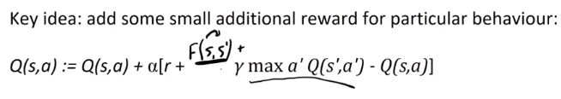

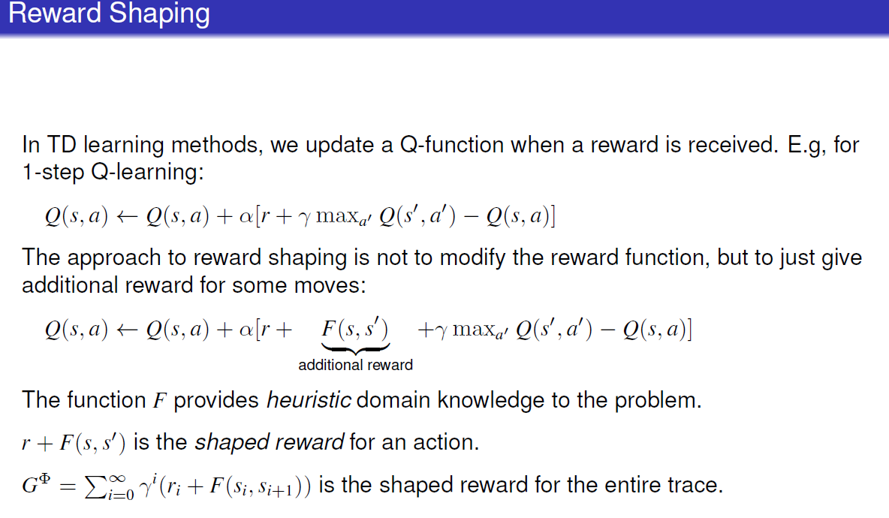

### Technique - Potential-based Reward Shaping

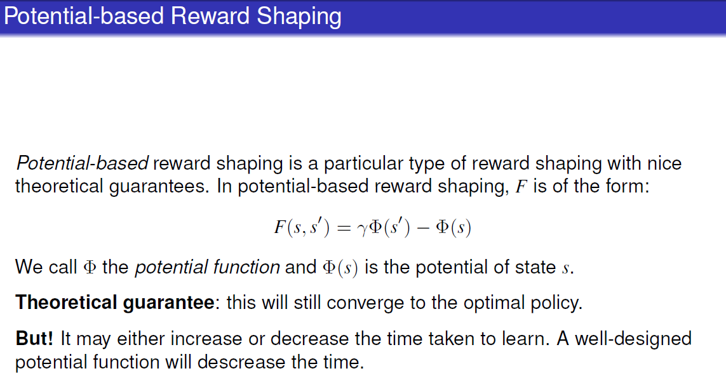

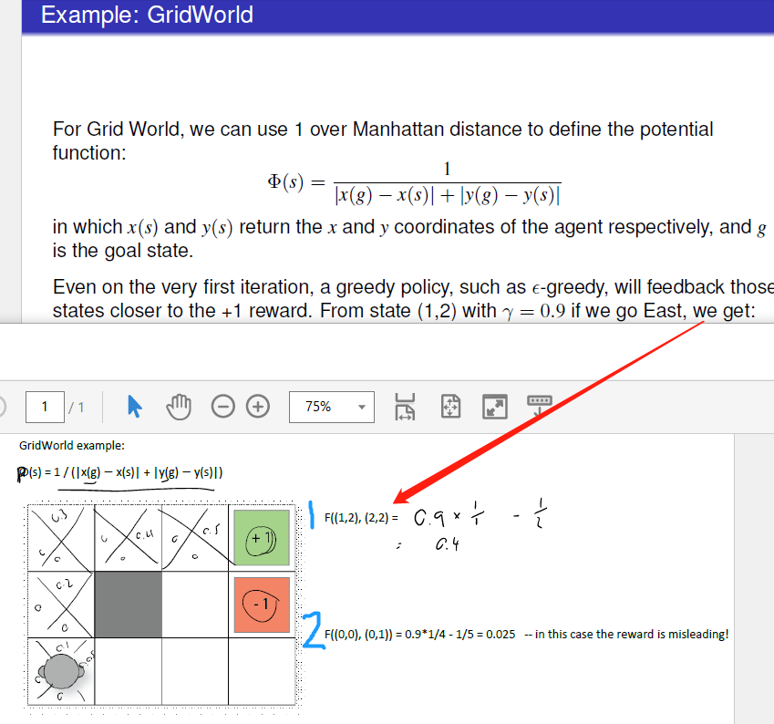

### Q-function initialization

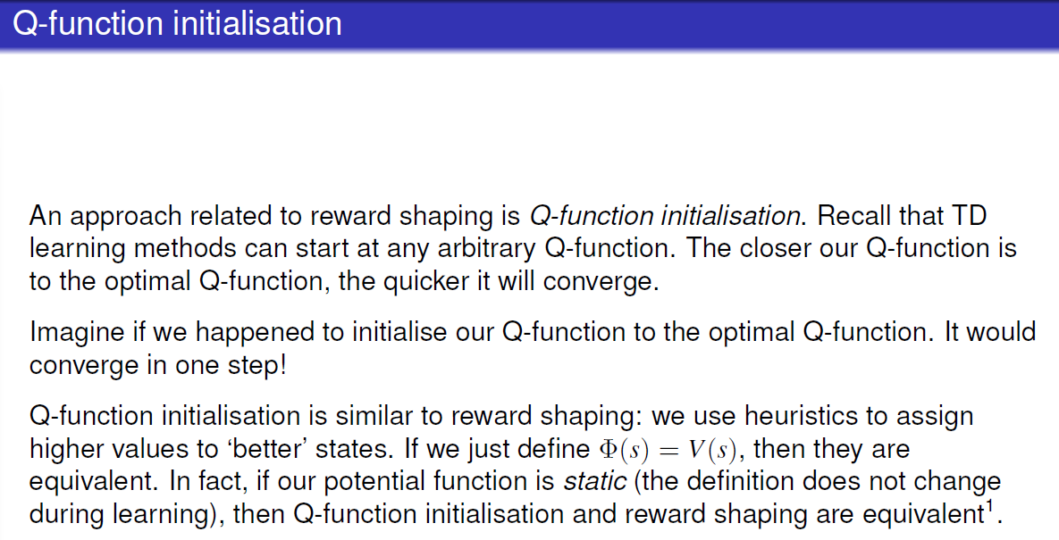

# Lecture 13: n-step temporal difference learning

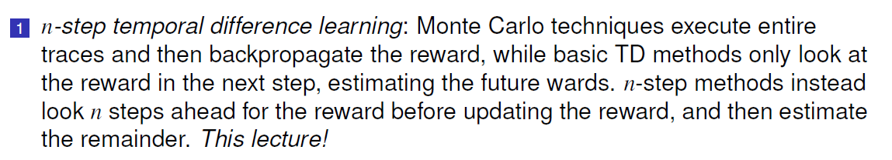

## Discounted reward G

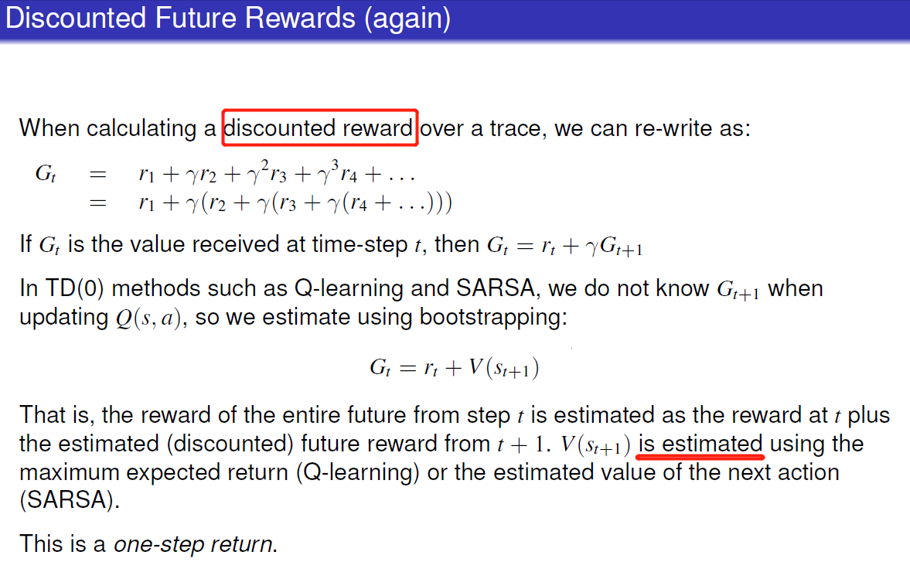

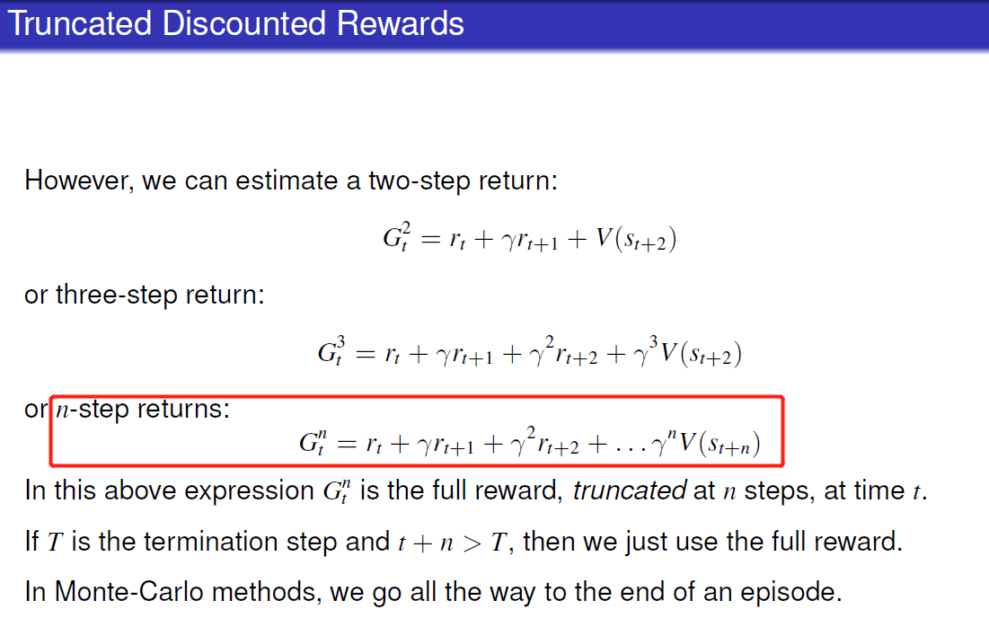

## n-step TD

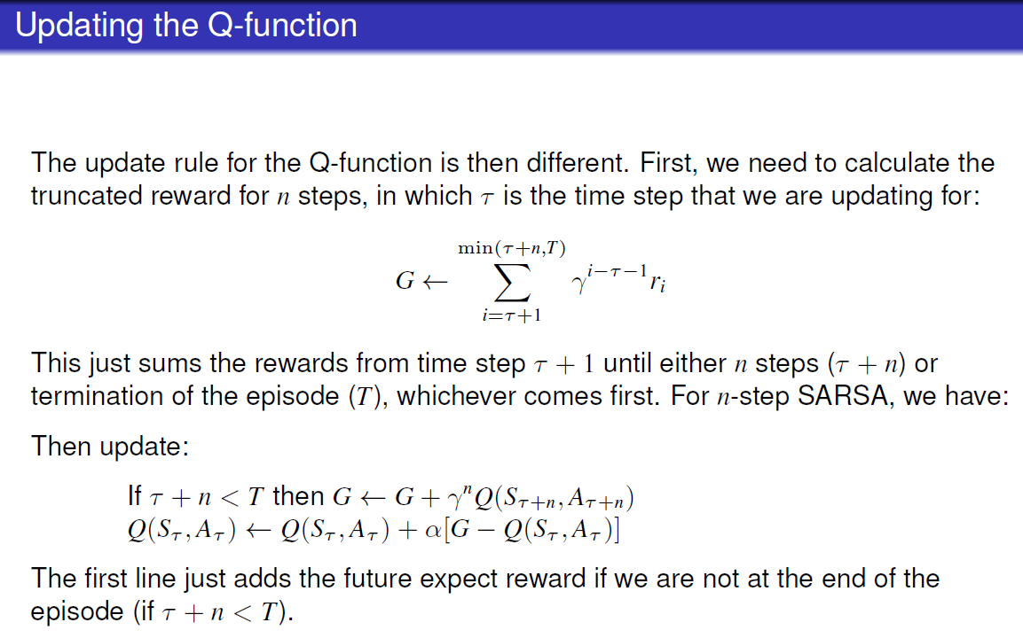

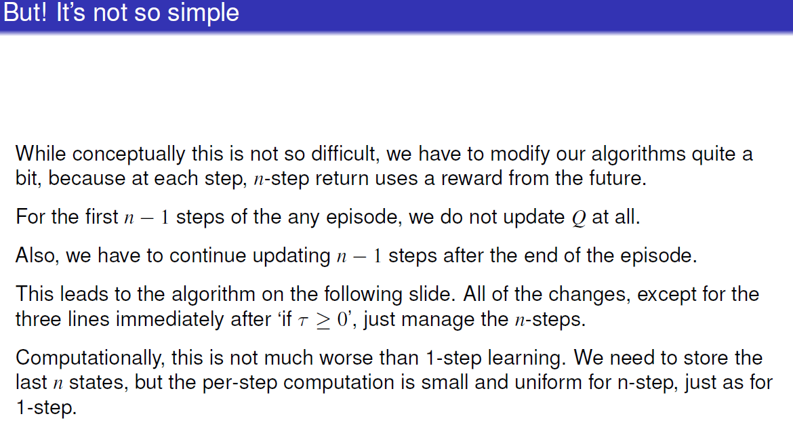

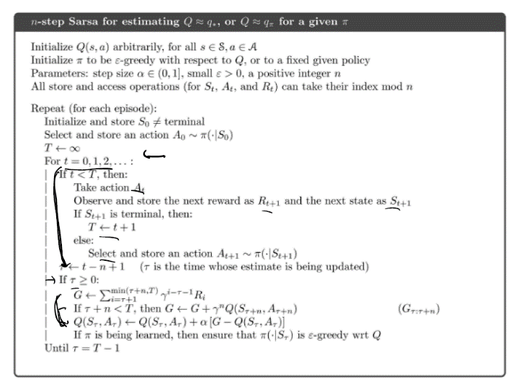 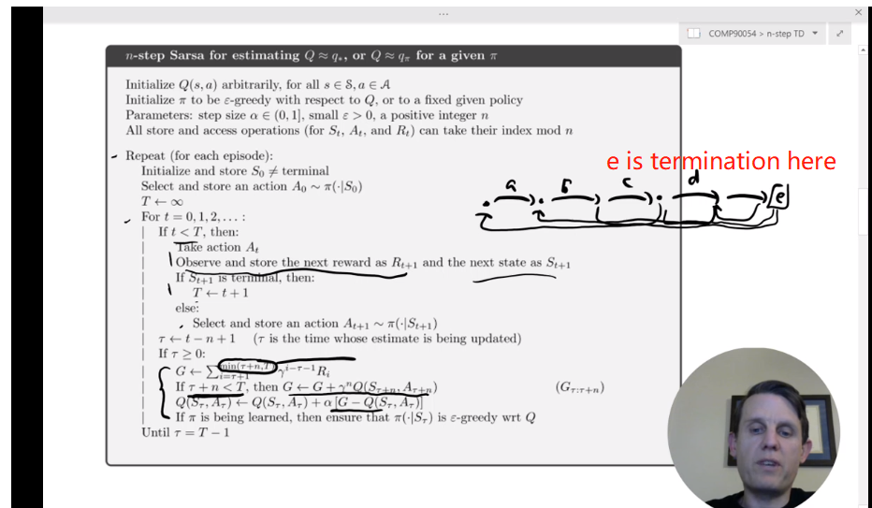

### E.g.:

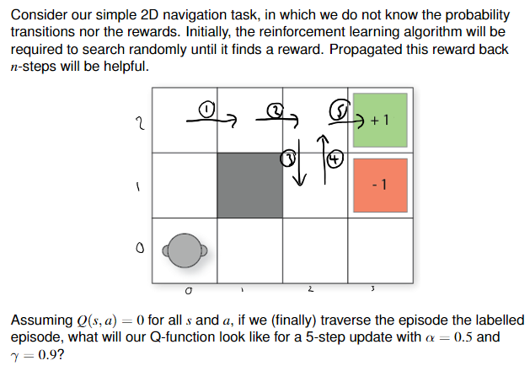 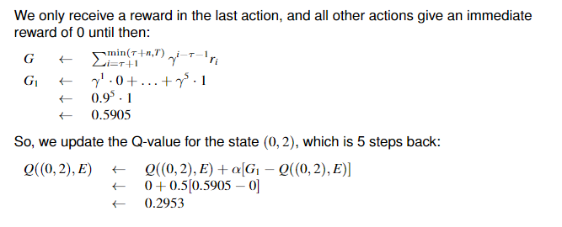

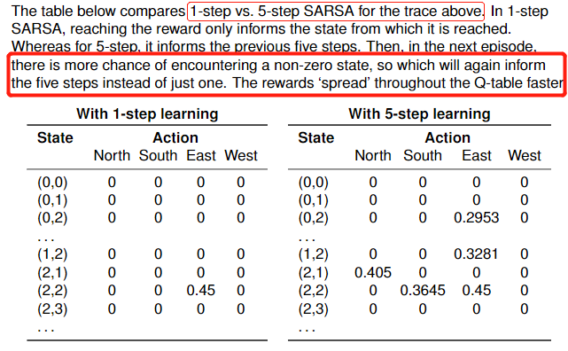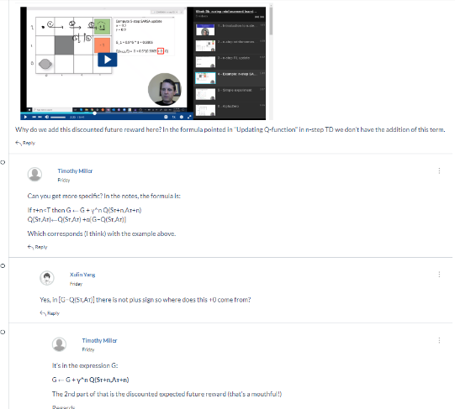

Allows Q table to propagate earlier compared to the normal one

# Lecture 14 Game Theory

## Normal form game:

Normal form games are often represented by a table.

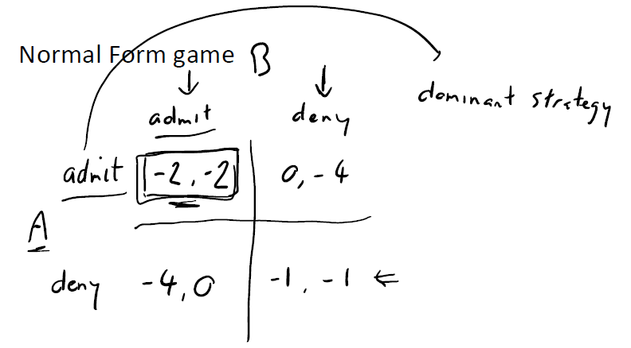 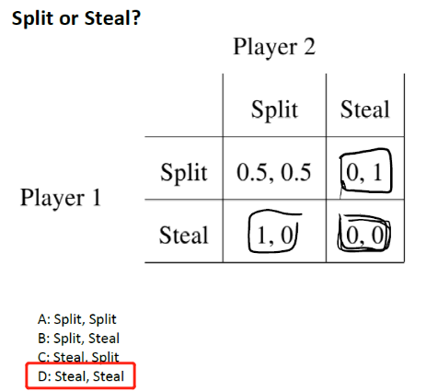Three nash equilibrium in this case

### Assumption:

1. Opponent is rational to calculate optimal strategy, sp we can play dominant strategy or mixed strategy

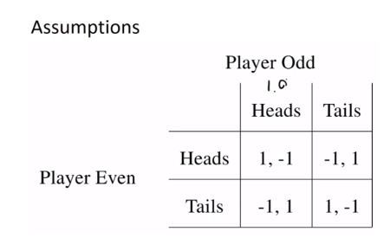

Opponent play heads p=1.0 then an indifferent strategy of 0.5 is not optimal

1. Self-interested: everyone is keen on maximizing their own payoff
2. Game contains perfect information: payoff is known for all players; know payoff of each other’s
3. Simultaneous moves: can’t known other’s decision before own decision

## Dominant strategy

Dominant strategy: produces the highest payoff of any strategy available for every possible action by the other players

对于被选中的策略，修改任意别的玩家的选择不会带来**更好的**value

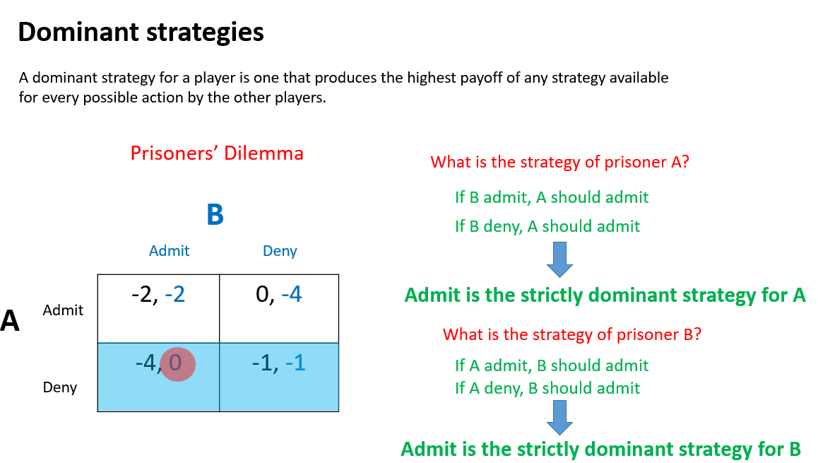

Strictly dominant strategy: player’s action payoff is larger than all opponent’s payoff given player’s choice

Weakly dominant strategy: has other non-dominated strategy with equal payoff with this choice

* B **strictly dominates** A: choosing B always gives a better outcome than choosing A, no matter what the other players do.
* B **weakly dominates** A: choosing B always gives at least as good an outcome as choosing A, no matter what the other players do, and there is at least one set of opponents' action for which B gives a better outcome than A. (Notice that if B strictly dominates A, then B weakly dominates A. Therefore, we can say "B dominates A" as synonymous of "B weakly dominates A".)
* Strategy B is **strictly dominant** if strategy B *strictly dominates* every other possible strategy.
* Strategy B is **weakly dominant** if strategy B *dominates* all other strategies, but some (or all) strategies are only *weakly dominated* by B.

## Nash Equilibrium

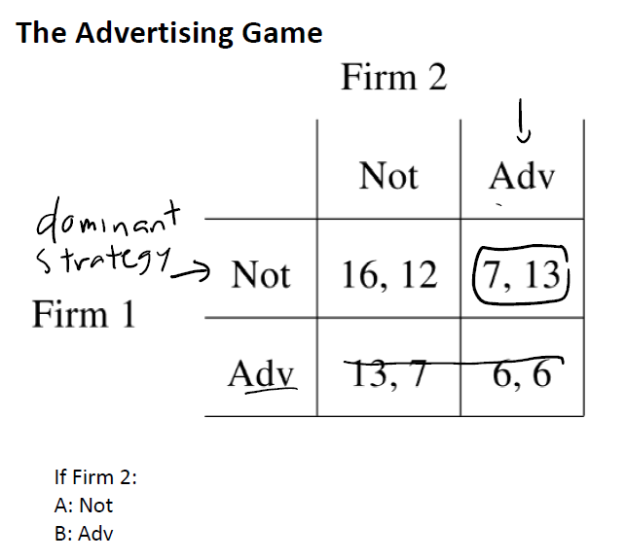

No incentive to change strategy assuming other players don’t change theirs

equilibrium: (7, 13)

can eliminate Firm’s Adv strategy as it is dominant by Not strategy

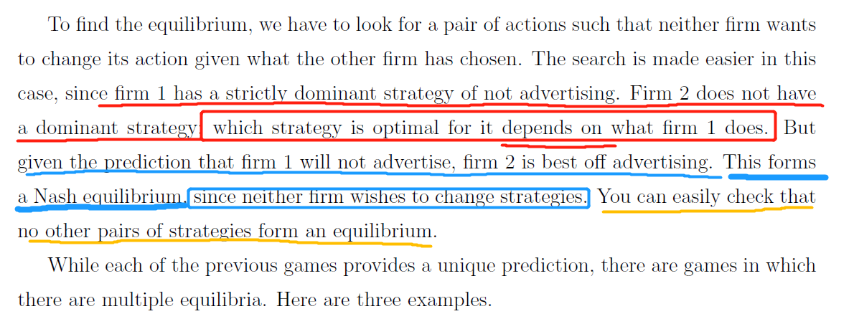

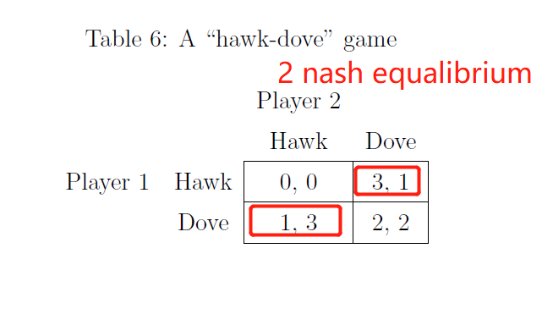

## Randomization and Mixed Strategies

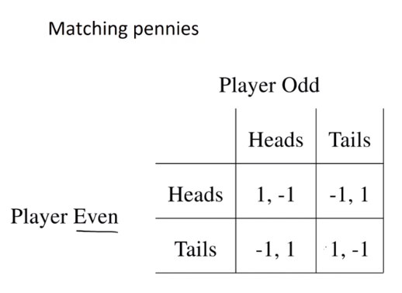no nash equilibrium

No pure Nash equilibrium strategy exits, to choose randomly between strategies which is called **mixed strategy**

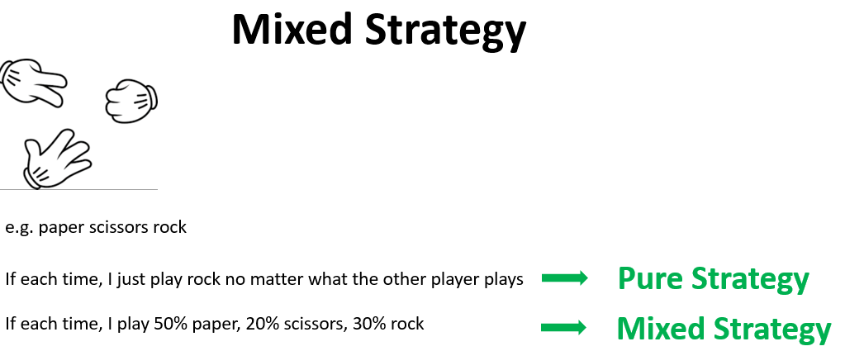

In equilibrium, a player should randomize their selection to make their opponent indifferent between

their own strategy

calculate expected payoff

Indifference: EDefender(T1)= EDefender(T2)

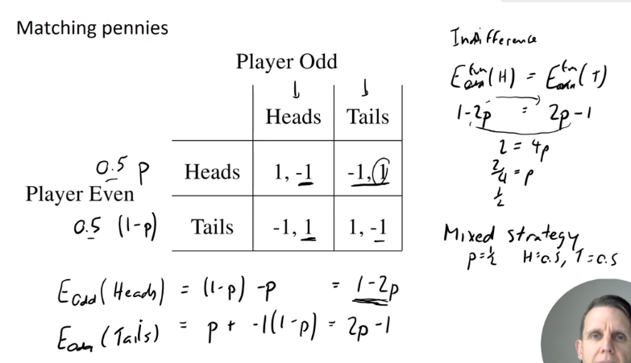

### e.g.: 解题思路

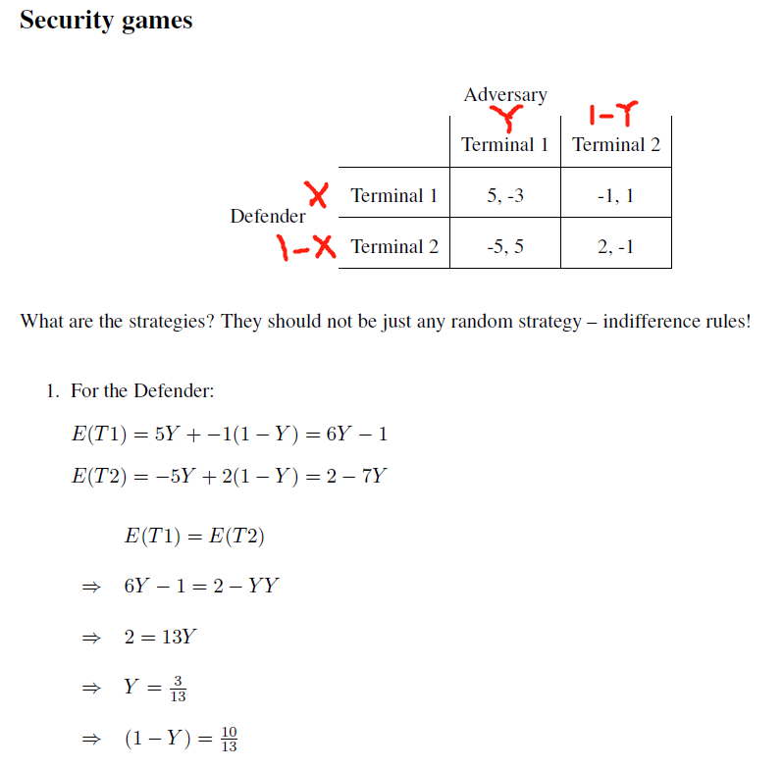 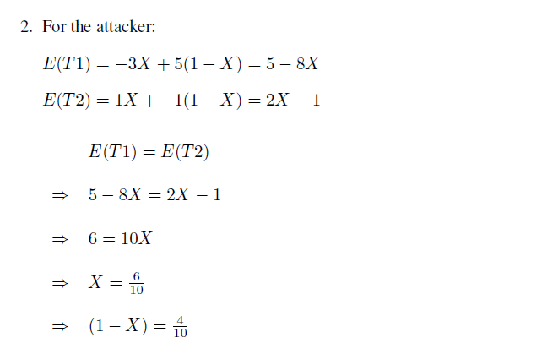注意，乘的概率是对方的

If more more than 2*2 matrix: set [y1, y2, 1-y1-y2] for player2 <https://www.youtube.com/watch?v=D-MGyNhI9jY>

Or drop player’s dominated strategy to prune matrix size

### Mixed and pure equilibria can both exists

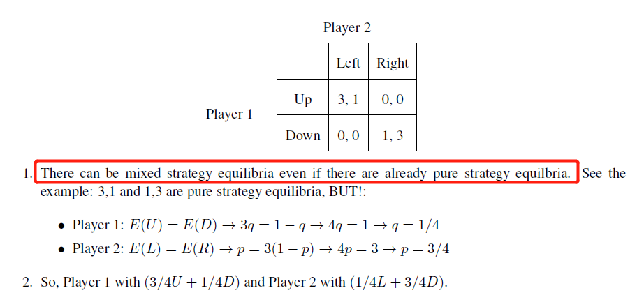mixed equilibria

Pure equilibria: (3, 1) and (1, 3) because no matter player changes their strategy, won’t improve their payoff assuming opponent doesn’t change

## Extended form game

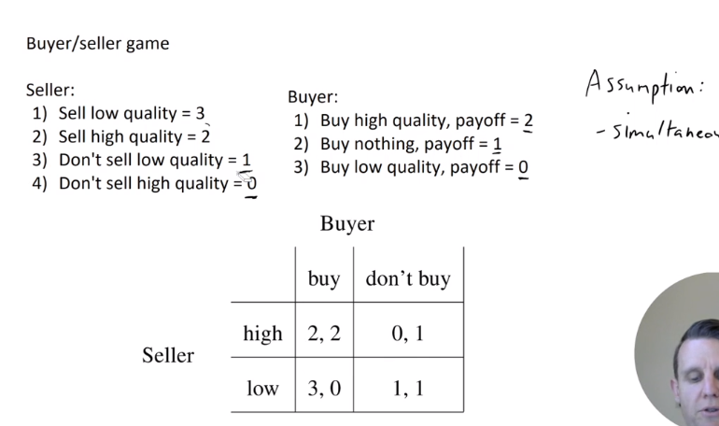Seller has low strategy as dominant strategy

No simultaneous assumption: as seller always moves first

Backward induction: we can look at each decision node that has no successor and start by making predictions at those nodes. Given those decisions, we can roll the game backward and decide how players will act at next-to-last decision nodes, anticipating the actions at the last decision nodes, and then iterate.

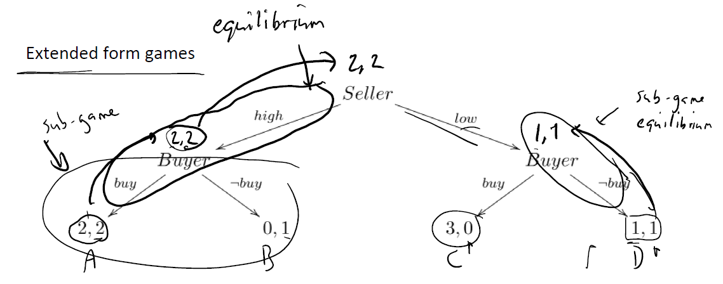

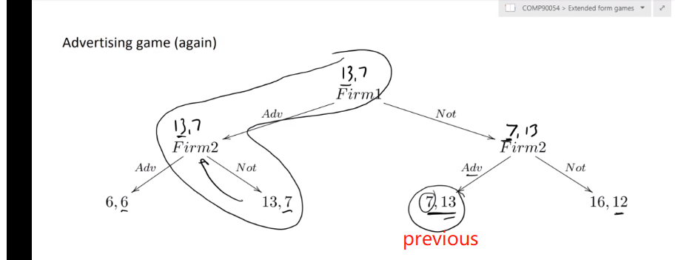firm 1 goes first has improvement

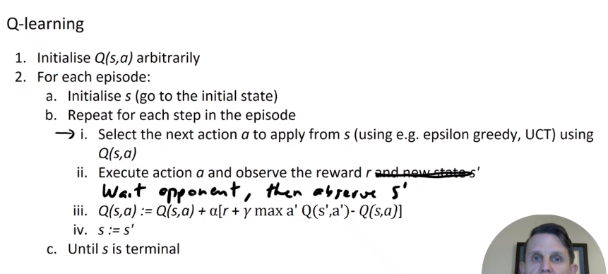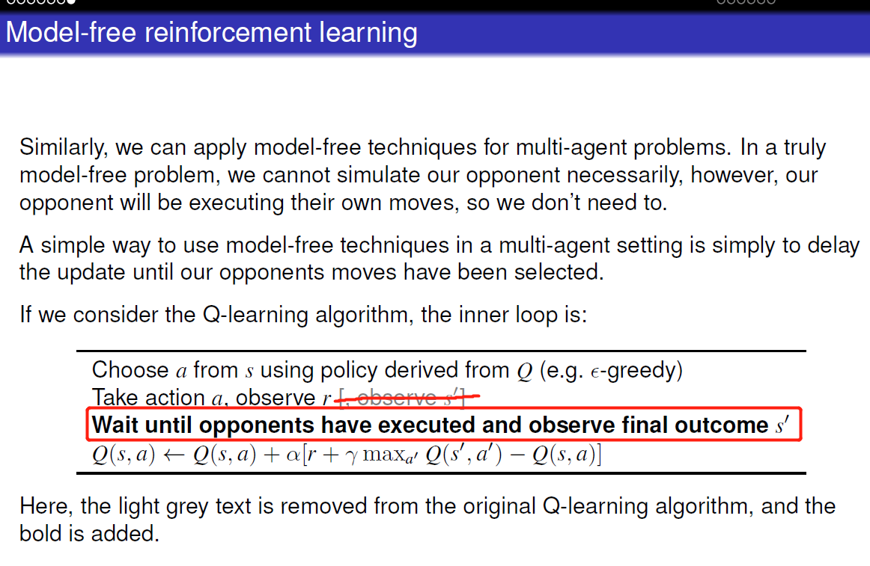

As long as opponent does not modify their strategy, this is fine. Otherwise, we need to keep learning.

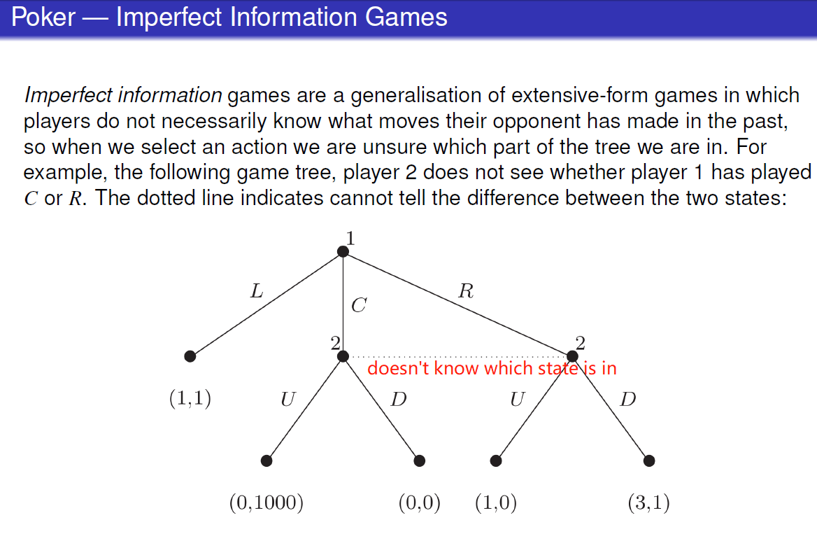

1. 注意编程时value function在计算时不要modify,一轮计算完再替换